13

**SCIENCE LESSON NOTES**

**EXTEND YOUR HORIZONS**

**PRIMARY SEVEN**

**WEEK ONE (LESSON ONE)**

**Topic 1: MUSCULAR – SKELETAL SYSTEM**

**VOCABULARY // New words.**

* **Skeleton Posture**
* **Hinge joint Ball and socket**
* **Pivot joint Gliding joint**
* **Voluntary muscles Involuntary muscles**

**Muscular – Skeletal System (lesson one)**

It is a system that gives animals the ability to move. It is a composition of bones and muscles

**A SKELETON**

It is the body part that forms the supporting structure of an organism.

**HUMAN SKELETON:** It is the frame work of bones in the body.

An adult human being has about 206 bones.

**TYPES OF SKELETONS.**

1. **Exo skeleton**. The hard material is formed on the outside part of the body.

Examples of organisms with exo skeleton are: insects and crustaceans.

These animals grow by **ecdysis / moulting.**

1. **Endo skeleton**. The animals have bony skeletons within their bodies.

Examples of organisms with endo skeleton are: people, cow, etc.

1. **Hydrostatic skeleton**. This is where the pressure of the fluid and action of the surrounding muscles are used to change the shape of an organism and produce movement.

Examples of organisms with hydrostatic skeleton:

**snails**, **earth worms**, **slugs, star fish, jelly fish, sea urchins** etc.

**questions**

1. **Briefly explain the term:**
2. **Skeleton b) Human skeleton**
3. **How many bones does a normal human being posses?**
4. **Write down the three types of skeleton.**
5. **How is ecdysis important to insects?**
6. **What type of skeleton do the following have:**
7. **A snail b) a slug c) a tortoise**

**STRUCTURE OF HUMAN SKELETON.**

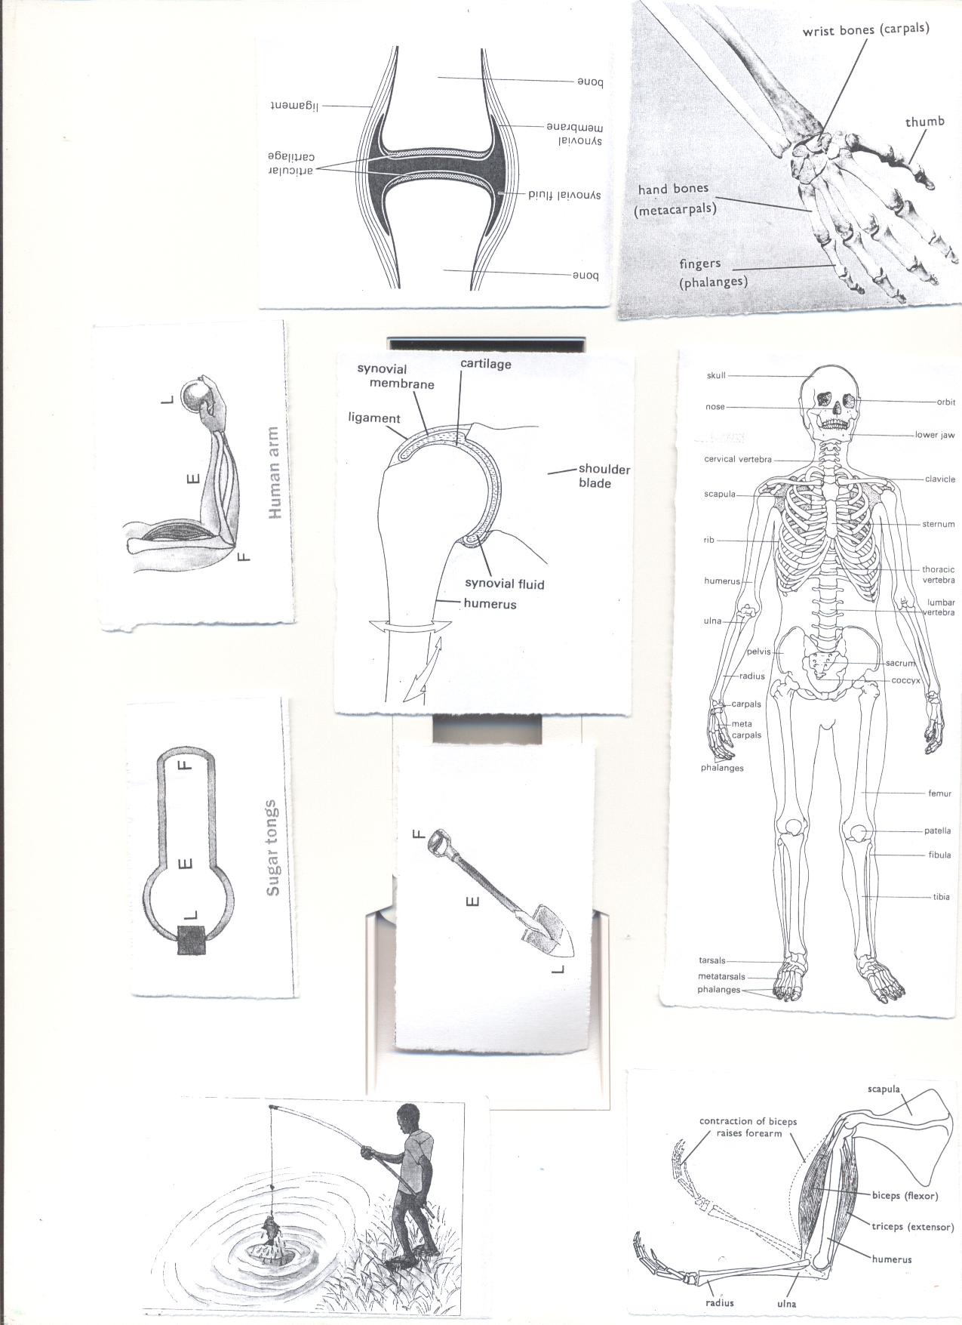

**Classifications of bones.(lesson two), WEEK TWO**

1. **Long bones**-e.g. **femur**, **tibia**, fibula, **humerus, radius, ulna**.

They contain the **white** bone marrow used to produce **white blood cells.**

2. **Short bones**- e.g. sternum, cranium, vertebra, ribs

They contain **red bone marrow** usedto produce **red blood cells.**

**Red blood cells** are **destroyed** in the **liver or spleen**.  
3. **Flat bones** -e.g. **shoulder blade**, **cranium (**[**skull**](http://en.wikipedia.org/wiki/Skull)**),** [**rib cage**](http://en.wikipedia.org/wiki/Rib_cage)**, and** [**scapula**](http://en.wikipedia.org/wiki/Scapula)**.**

4. **Irregular bones -**Bones of the neck **vertebr**a, sacrum.

Question.

1. Briefly explain the term bone.
2. Write down the three types of bones in one’s body.
3. Why do babies have many bones than adults?
4. State any examples of each of the bones below
5. Long bones b) irregular bones

4. How are the bone marrows important to us?

**JOINTS(lesson three) WEEK TWO**A joint is a place in a body where two or more bones meet.  
**How is a joint adapted to a friction free movement?.**  
-It contains synovial fluid which reduces friction at the joint.  
-The bones are covered with cartilage at the ends.

**Structure of a joint.**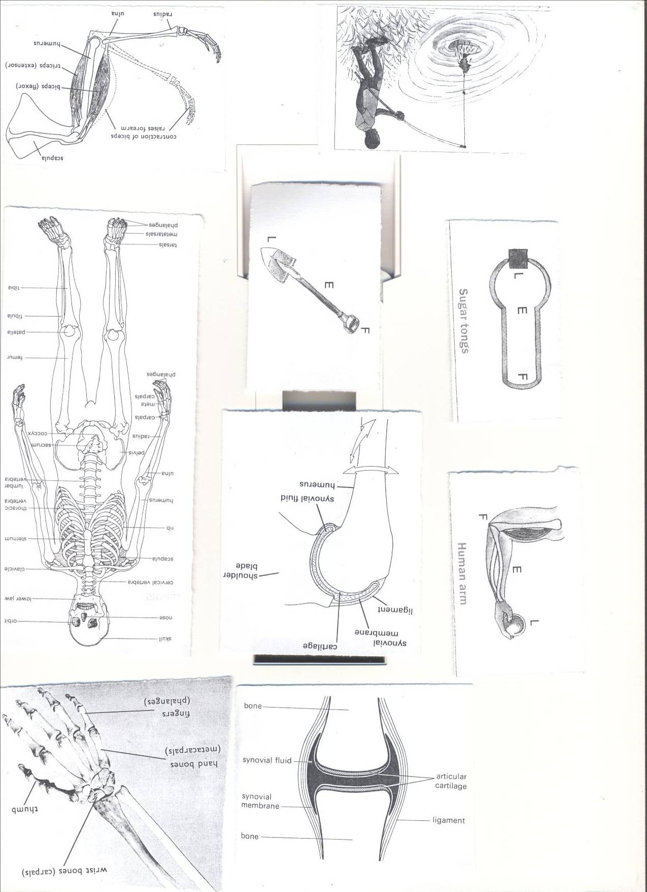

**A Tendon** is a tough fibrous tissue that connects muscles to bones.  
**A Ligament** is a fibrous elastic tissue that joins a bone to a bone.

**Cartilage** prevents the bone ends frictional damage after rubbing directly onto each other.  
Inside a joint is **a lining of synovial membrane** which secretes **synovial fluid.**  
**Synovial fluid** reduces **friction** in a joint.

**Classification of joints:**

**Types of joints**  
Joints may be either Movable, immovable or slightly movable

However, the principle types of joints are: Ball and socket joints, hinge joint, pivot joint, gliding joint.

**Examples of movable joints**

1. **Hinge joint**-It allows movement in one plane e.g. knee, elbow, knuckle
2. **Ball and socket**- It allows movement in three planes e.g. shoulder, hip



1. **Gliding joint-** They allow flat bones to slide over one another.eg wrist/ ankle



1. **Pivot joint**- e.g. the neck.

**Example of immovable joint**.

Suture joints in the skull.

**Questions**

1. How are joints important to a boy of 4 years?
2. What is a joint?
3. Write down one way joints are similar to muscles.
4. Write down any one example of a hinge joint.
5. Why is a shoulder joint said to be a movable joint?
6. State the substance in the human body that helps to reduce friction.

**Muscles (lesson five , week two)**

* A muscle is an elastic bundle of flesh under the skin that is attached to bones.
* A muscle is a special elastic tissue that contracts and relaxes to produce movement.

**There are two types of muscles.**  
i. Voluntary muscles.

ii. Involuntary muscles.

**Voluntary muscles / skeletal muscles.**

Voluntary muscles are **muscles** whose action is normally controlled by an individual's will.

**Examples of voluntary muscles include;**

1. Biceps (flexor) ii.Triceps (extensor)

**Involuntary muscles smooth muscles.**

Involuntary muscles whose movement is not under our will.

Examples of involuntary muscles;

1. Cardiac musclesof the heart.
2. Muscles of the eye lids.
3. Muscles of the stomach and intestines

**Antagonistic muscles**

These are muscles that work in pairs but have an opposite effect to each other.

Examples of antagonistic muscles include;

1. Biceps (flexor) ii.Triceps (extensor



Questions

1. What is a muscle?
2. State the two types of muscles in our bodies.
3. Why the triceps and biceps are called antagonistic muscles?
4. How are muscles useful in our bodies?
5. Cite any one disorder to the body muscle.

**Functions of the muscular skeletal system.(lesson six)week two**

**1.** Protects the delicate body organs.

* The [**skull**](http://en.wikipedia.org/wiki/Human_skull) protects the [**brain**](http://en.wikipedia.org/wiki/Human_brain)**,** the [**eyes**](http://en.wikipedia.org/wiki/Human_eye), and the [**middle**](http://en.wikipedia.org/wiki/Middle_ear) and [**inner ears**](http://en.wikipedia.org/wiki/Inner_ear)**.**
* The **vertebrae** (backbone) protect the[**spinal cord**](http://en.wikipedia.org/wiki/Spinal_cord).
* The [**rib cage**](http://en.wikipedia.org/wiki/Human_rib_cage), **spine,** and [**sternum**](http://en.wikipedia.org/wiki/Human_sternum) protect the [**lungs**](http://en.wikipedia.org/wiki/Human_lung)**,** [**heart**](http://en.wikipedia.org/wiki/Human_heart).

**2.** It provides supports to the body.

**3.** It helps in movement.

**4.** Storage of minerals like calcium and phosphorus.

**5.** The bone marrows are used to produce blood cells.

**6**. Provides room for attachmentof muscles.

**Diseases and disorders of bones, muscles and the system(lesson seven)week two.**

**Disorders of the muscular skeletal system.**

* Fractures
* Sprain
* Spinabifida -The spinal cord does not form properly.
* Cuts
* Strains
* Dislocation

**Diseases of the muscular skeletal system.**

* **Rickets-**causes bowed legs in children due to lack of Vitamin D.
* **Poliomyelitis**- Cause by polio virus which attacks the nerve cells and spinal cord causing paralysis.
* **Arthritis-**pain, stiffness and swelling of joints.
* **Scurvy**- caused by lack of ascorbic acid (vitamin C) in the diet.

**Prevention of diseases and disorders of bones, muscles.**

1. Boil water for drinking to prevent polio.
2. Prepare and eat a balanced diet**.**
3. Do physical exercises.
4. Keep sharp cutting objects far from children’s reach.
5. Go for dental checkups *regularly.*
6. Put on shoes while walking.

**Health habits that help to keep the system in a healthy working condition**

1. Do daily physical exercises.
2. Eat a balanced diet.
3. Ensure proper body posture.
4. Brush and floss your teeth twice a day.

**POSTURE.**

* It is a way a person positions his body when sitting, standing or walking

**The correct sitting Posture.**

* Sit up straight on the chair.
* Place both feet on the floor.
* Put all your weight on both bottoms.
* Do not tighten your ankles and knees.

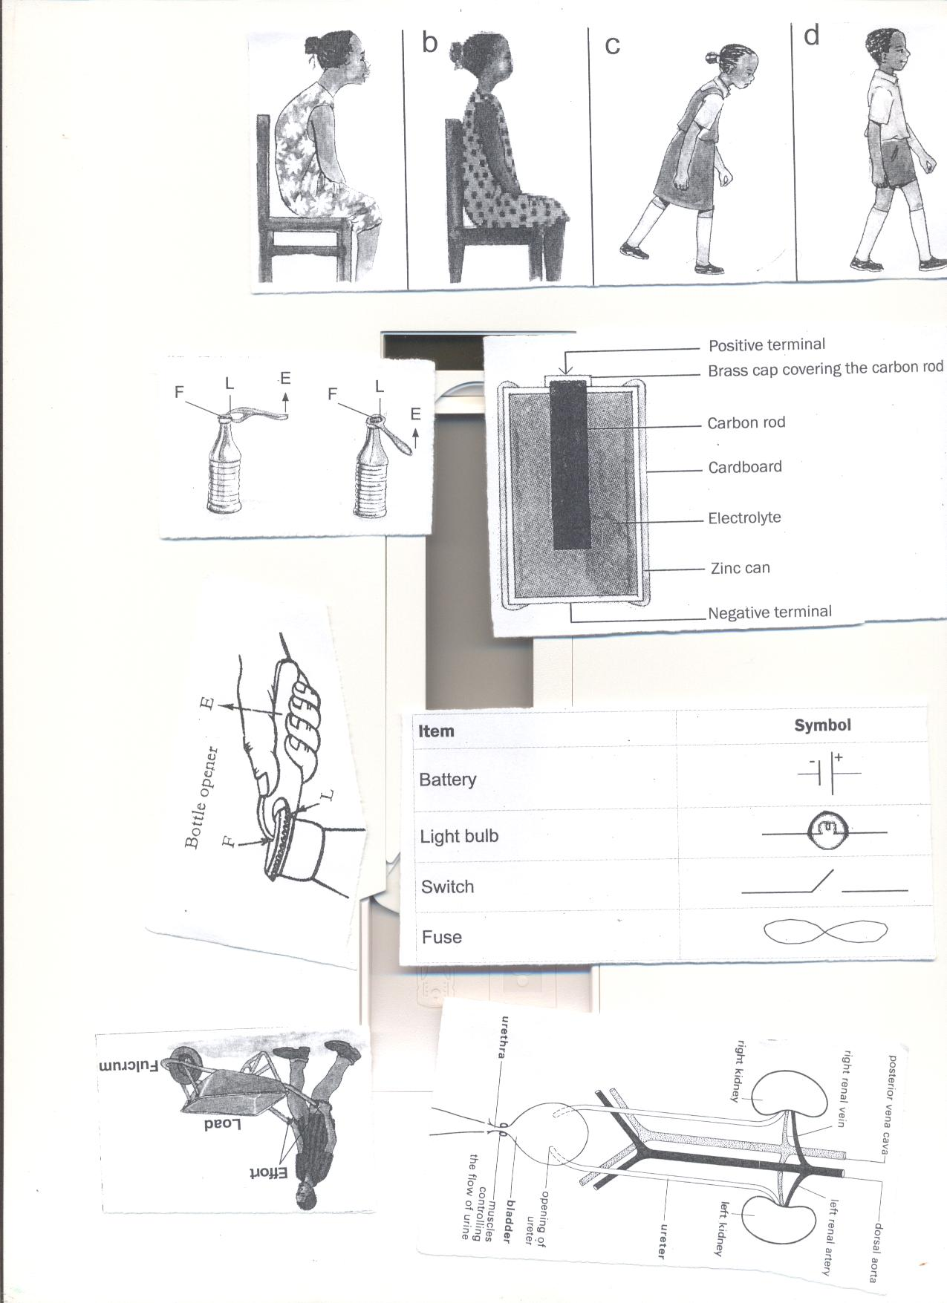

**Importance of correct posture**

1. Prevents body aches.
2. It prevents one from growing bent bones.

**Topical questions.**

1.Which class of food is necessary for proper growth of bones?

2. Write down one example of each of the following

a) Skeletal muscles b) Smooth muscles

3. What is the functional difference between ligaments and tendons?

4State one disorder to each of the following

1. Ligaments b) tendons.

5. Which part of the skeleton protects the following?

a) Brain b) tendons

6. State one health habit that can keep one’s skeleton in a healthy working condition.

**Topic 2: ELECTRICITY AND MAGNETISM (lesson one) week two**

**VOCABULARY**

* **Electricity Fuse**
* **Circuit Switch**
* **Insulator Magnet**
* **Dynamo Electro – magnet**
* **Device**

**Electricity**

Electricity is a form of energy produced by the flow of electrons.

**Sources of electricity.**

-Cells i.e. Dry cell, Simple cell, chemical batteries, solar cell accumulators.  
- Running water  
-The sun.  
-Fossil fuels.  
-Wind.

**ELECTRIC CELLS**

Types of cells

1. **Primary cells** e.g.), Dry cells, a simple cell(wet cell)
2. **Secondary cells/accumulators/storage cells.** E.g. lead batteries, solar cells.

**The dry cell.**

**Dry cell**  
A dry cell is an electric cell.  
It stores chemical energy.  
**Structure of a dry cell**



**Functions of each parts of a dry cell**  
**1.Bras cap:** it acts as the positive terminal and contact.  
**2. Carbon rod**: It is a non metallic conductor of electricity that acts as a positive pole.  
**3. Electrolyte**: A liquid that conducts electricity.   
**4. Zinc can**: a container in which the dry cell content is put and It acts as a negative terminal.

**5.** **Insulating top seal**: It prevents the jelly from drying up.   
 **N.B**: I. A dry cell has voltage of 1.5 volts  
The energy needed to push an electric current through a electric circuit is called voltage. Voltage is measured in volts.

A dry cell stores chemical energy which is later changed to electric energy.

**Calculating voltage.  
Exercise:**

1. Juliet’s radio uses **seven** dry cells.

How many volts are needed if he is to use it to listen to news.

Solution:

**1 dry cell= 1.5 volts**

**7 dry cells= ?**

**7dry cells X 1.5 Volts.**

**=10.5 volts**

1. **How is the carbon rod useful in a dry cell?**
2. **Suggest any one cause of dry cells losing their energy.**
3. **What is the difference between electricity and electric energy/**
4. **Identify any one source of electricity.**

**Simple cell (Wet cell): lesson two, week two**  
It consists of a zinc plate and a copper plate dipping in dilute sulphuric acid.  
The zinc plate acts as the **negative** pole.  
The copper plate acts as the **positive** pole.  
Sulphuric acid acts as the **electrolyte**.  
The zinc and copper are called **electrodes**

**An electrodes** is a piece of metal that allows electric current to pass through it when placed in an electrolyte.

HOME MADE

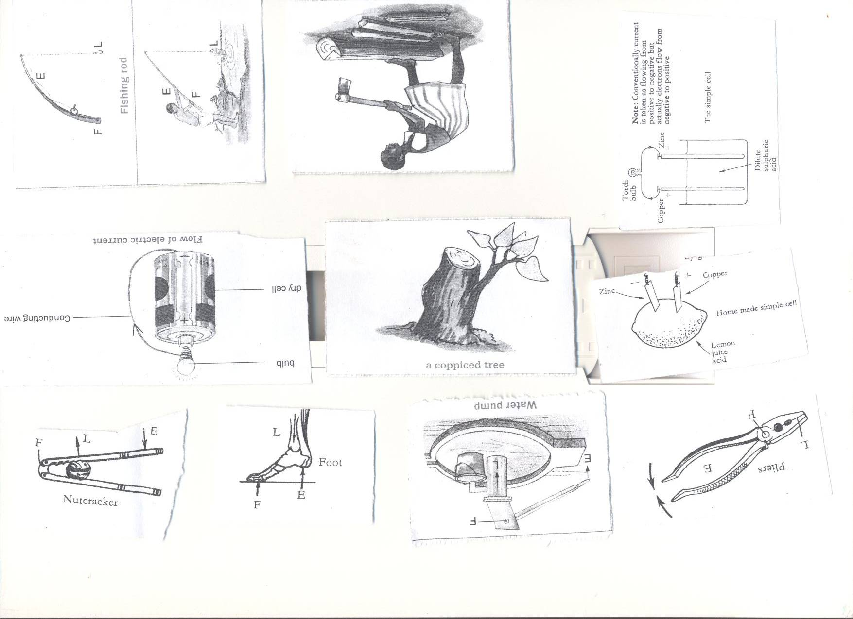 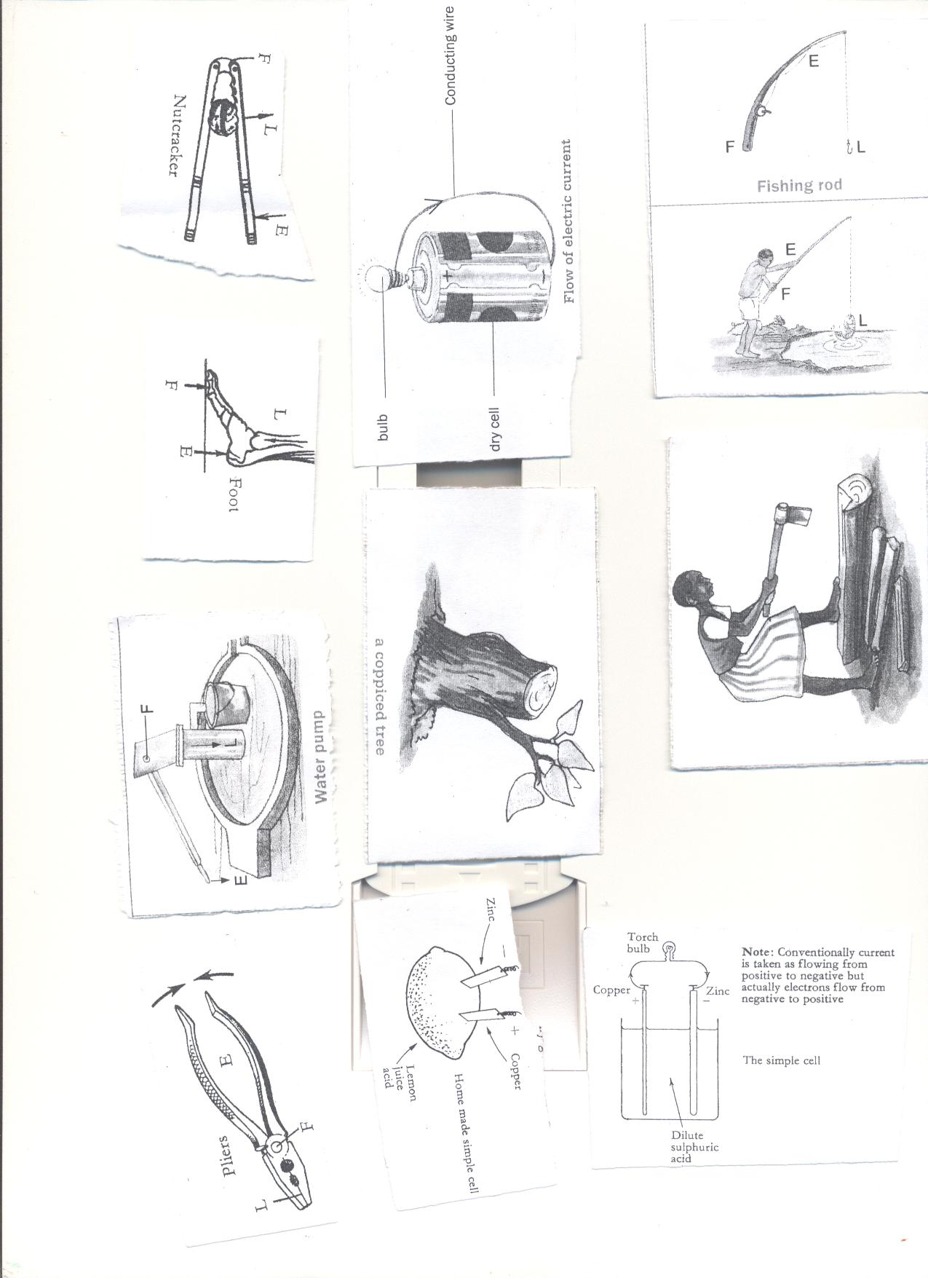 The bulb connected across the cell, begins to glow but after only a few minutes it becomes dimmer until it finally lights off.  
**Disadvantages of using a wet cell.**

1. It is not very efficient.

ii.It can only be used in an upright position.

1. It works for a short time

Questions.

1. What is the importance of the dilute sulphuric acid in a wet cell?
2. Why do wet cells lose their magnetism easily?
3. State one disadvantage of using wet cells?
4. What acts as the electrolyte in a locally made wet cell?
5. Why does a wet cell light for a shorter time?

**Chemical Battery( lesson three), week two.**  
A Car battery is an example of chemical batteries.

It has the positive **(+) {anode}** and negative **(-)** terminals {cathode} called **electrodes**

Chemical batteries convert **chemical energy** into **electric energy.**

**Advantage of using a chemical battery.**  
i.It can be recharged and used again when it has run down.  
**Running water**   
It produces hydro electricity {H.E.P}.  
For example electricity produced at Nalubale AND Bujagali Dams in Jinja.

**The sun**  
The sun produces light which is converted into solar electricity using solar cells.  
A number of solar cells put together form a solar battery.  
Solar electricity is used for lighting and cooking.  
**Fossil Fuels.**  
Fossil fuels used in production of electricity are coal, petrol and diesel.  
**Coal / oil** can be burnt to produce Thermal electricity.

Coal stores chemical energy.  
**Petrol and diesel** are used to run fuel generators.  
  
**Uranium**

It is burnt to produce to produce nuclear energy.  
Uranium stores chemical energy.  
**Wind**  
The wind turns windmills to produce electricity.

Questions

1. Cite any three sources of electricity.
2. How is the sun useful in the environment?
3. How is wind able to produce electricity?
4. Give one difference between wind and air
5. State any one example of a fossil fuel.

**Types of electricity.(lesson four)**

There are two main types of electricity;  
1. Current electricity

1. Static electricity.

**Current electricity**  
This is the electricity where there is flows of electrons.  
**The diagram showing the** **flow of current/ electricity/ electric current.**  
  
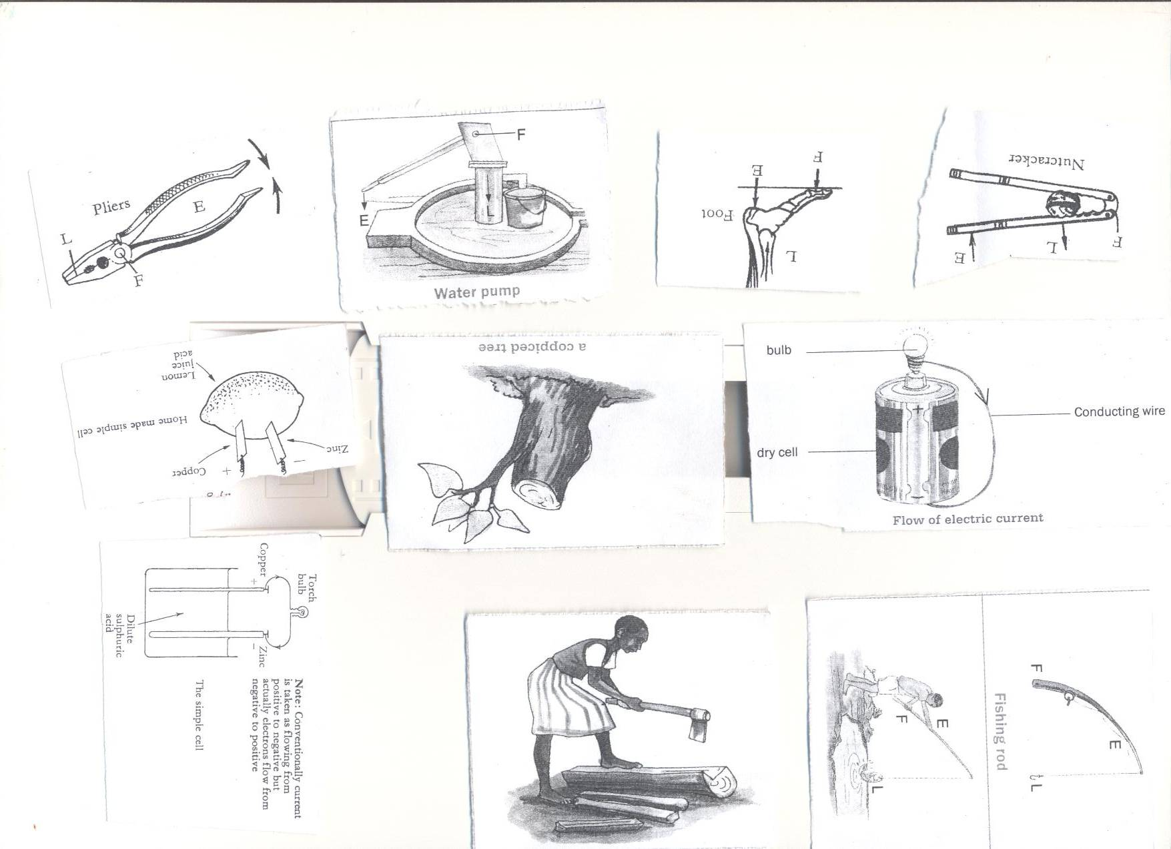

**The diagram showing the flow of electrons**  
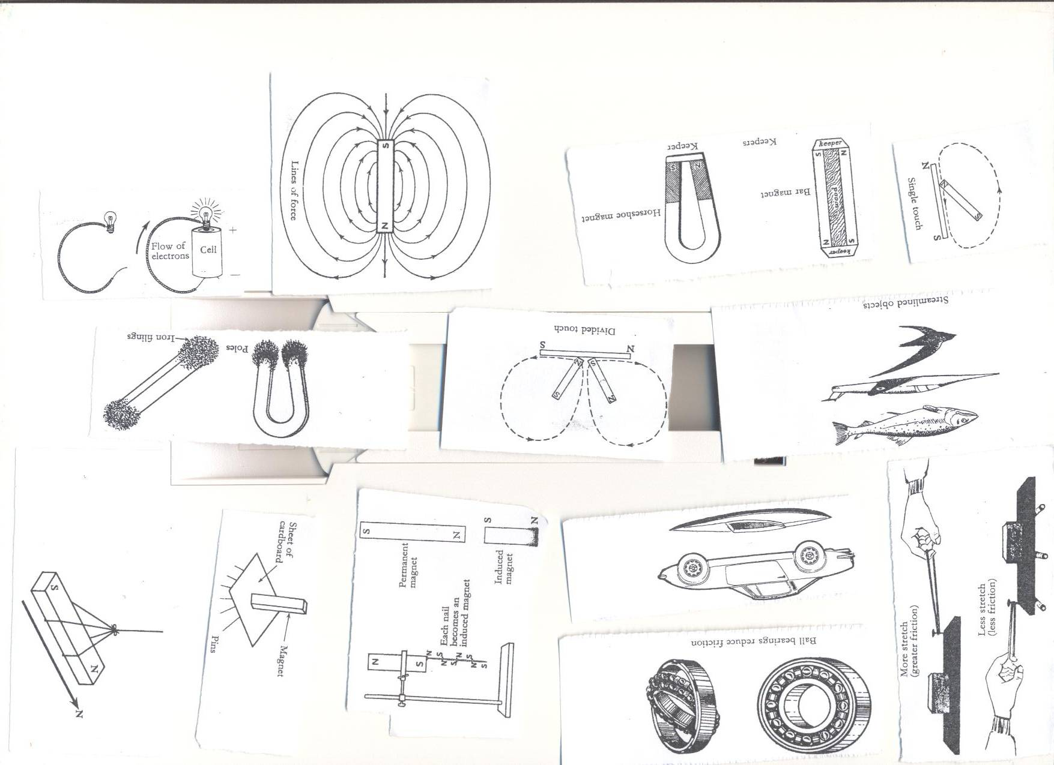

**Types of current electricity.**

1. **Direct current (DC) -** The current flows in one direction. I e from the source to the appliance. **Sources**: chemical batteries and dry cells.

**2.Alternating Current (AC) -** current flows in two directions. I e from the source to the appliance and the back.E.g. that one produced at **Nalubale dam in Jinja, generator**

**Forms of electricity.**

1. **Hydro electricity**; produced from water turning turbines at a dam.
2. **Thermal electricity;** Produced from fossil fuels.
3. **Solar electricity;** Produced from the sun.
4. **Nuclear electricity;** Produced from nuclear power stations**.**
5. **Geo thermal electricity;** Produced from hot rock in the earth.

**QUESTION**

1. **Write down the types of electricity**
2. **State any two forms of electricity**
3. **Draw a diagram to show flow of electricity**
4. **What type of electricity is commonly used by most urban areas in Uganda?**
5. **Briefly explain the term alternating current.**

**Conductors of electricity ( lesson four , week two)**

Conductors are materials that allow electricity to pass through them .

**Examples of conductors of electricity.**  
1. Metals like; Iron, copper, Tin, Silver, zinc, lead, brass.  
ii. Materials like; spoons, pair of compasses, razor blades e.t.c.  
iii. Water from rivers, lakes, springs and wells.  
iv. Carbon {non metallic conductor)  
v. Salt solution.  
vi. Wet wood.  
**N.B:**  
1. Wet wood is a good conductor of electricity because it contains minerals.  
2. Pure water does not conduct electricity because it doesn’t contain minerals.  
**3. Silver** is the best conductor of electricity.  
4. We use aluminum to make electric wires because silver is expensive and rare.  
**Insulators of electricity.**  
These are materials that do not allow electricity to pass through them easily.  
**Examples of insulators;**

1. Rubber, plastic, dry wood, dry paper, dry cloth, air and porcelain  
   **Importance of insulators**

1. Used to insulate flat irons to prevent electric shocks.

2. Prevent conductors from meeting to cause short circuits.

**Electric circuit (lesson five)**  
An electric circuit is a path through which an electric current flows.  
**Components of an electric circuit.**

* A switch.
* A torch bulb
* A conductor (wire)
* Dry cells
* The conducting wire.
* Fuse

Questions.

1. How are insulators different from conductors of heat?
2. Give any two examples of insulators.
3. How are insulators important in our daily life?
4. State any two components of an electric circuit.
5. Why is wood said to be bad conductor of electricity?

**A simple Electric circuit. (lesson five week two)**

**In symbol form In diagram form**

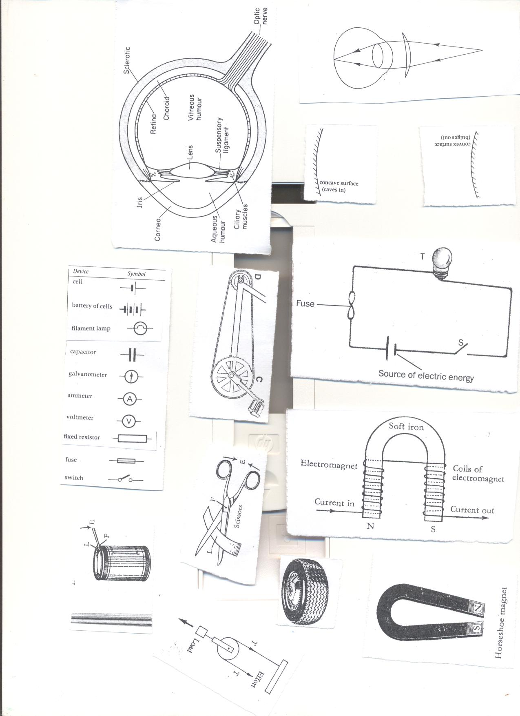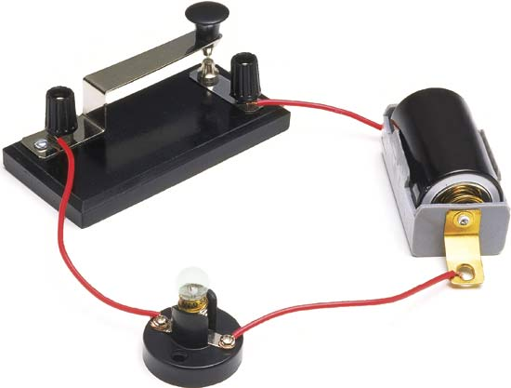

**Uses of parts of an electric circuit.**  
**1. Switch**: This breaks and completes the circuit at the users wish.  
**2. Battery/dry cells**: These provide electric energy in the circuit.  
**3. Conducting wire**: Transmits electric energy through the circuit.  
**4. Fuse**: It breaks the circuit when there is too much current flowing.

It is a thin wire(alloy) with a low melting point.  
**5. Bulb:** It gives out light.

**Symbols used in an electric circuit.**





**The conducting wire**

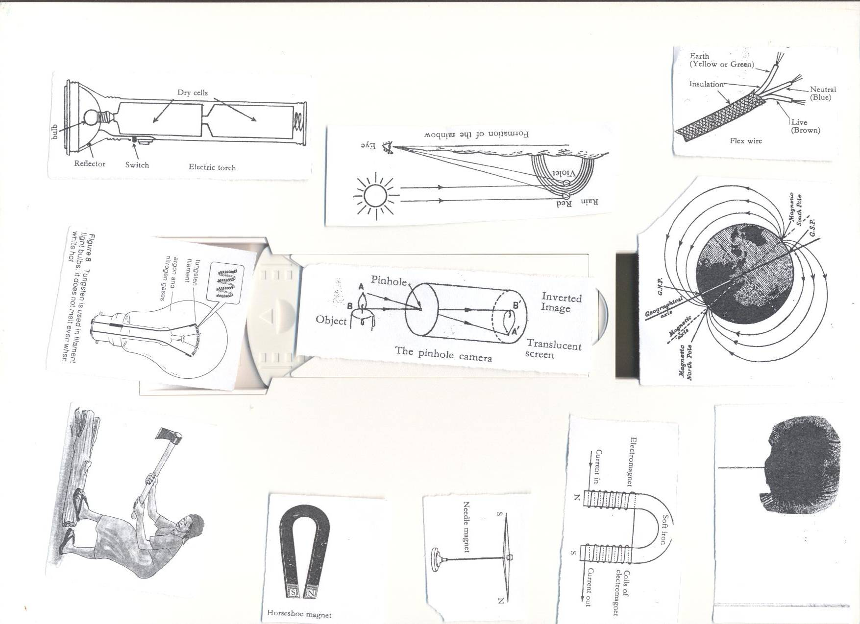

**Uses of each component of a conducting wire**  
i. **Earth (yellow or green):** Minimizes excess current to preventus from electric shocks.  
ii. **Neutral (Blue/black):** Takes back current to the source.  
iii. **Live (Red/brown):**  brings current from the source to the appliance.  
iv. **Insulation**: prevent electric shocks.

Questions

1. How are the following important in a circuit?
2. Switch
3. Fuse
4. How is a fuse similar to a switch?
5. How is a red wire useful in an electric circuit?
6. Draw a diagram of a bulb.

**The torch/flash light (lesson six), week two**



**Uses of parts of a torch**

**1. Reflector**: Directs lights into **a parallel** beam of light.

**2. Bulb**: It produces light.

It changes electric energy to heat then to light.  
**3. Dry cells**: It is the source of electric energy.   
**4. Glass**: It protects the bulb and reflector.  
**5. Switch**: Breaks and completes the circuit at the users wish.  
**6. Cover and springs**: Keep the dry cells tightly together.

**The Electric Bulb. (lesson seven) week two**

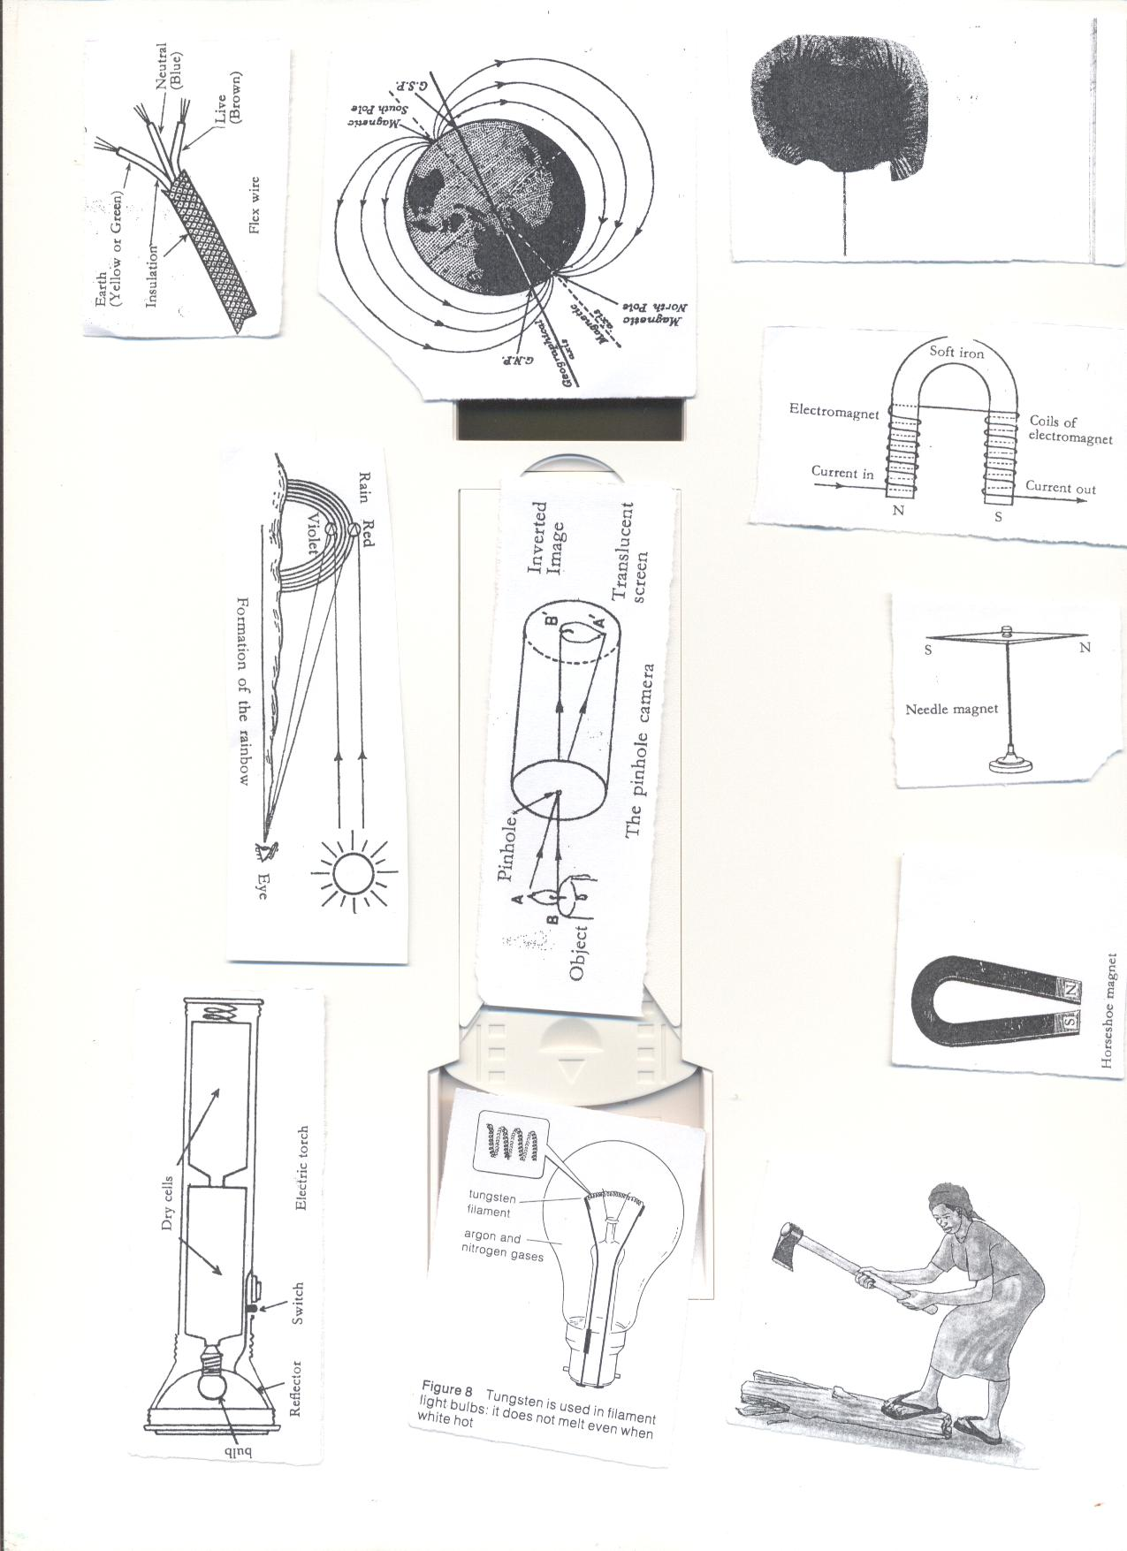

**Uses of parts of a bulb**  
**1. Filament:** It produces light.

It is made of **tungsten** from a mineral called **wolfram**

**Adaptation of the filament for its function.**

* It has a high melting point.
* It is coiled to increase electric resistance

**2. Conducting wire**: It conducts electricity to the filament.  
**3. Glass**: Protects the inside parts of the bulb.

It prevents nitrogen and argon gases from escaping.

It is transparent to allow light to pass through.  
**4. Filament support**: It supports the filament.  
**5. Contact**: It allows electricity into the bulb.  
**6. Insulating material**: It separates the conducting wires.

**Question**

1. Why is a filament of an electric bulb coiled?
2. State any component of a circuit that use an alloy.
3. How is the reflector important in an electric torch?
4. Which gas is commonly used in electric bulbs?
5. Give one reason why the glass of a bulb is transparent?

**Short circuits.(lesson eight) week two.**A short circuit is a path of low resistance towards flow of current through circuit.  
**Causes of short circuit**

* Poor wiring when installing electricity in buildings.
* Pushing metallic objects in electric sockets.
* When bare electric wires get into contact.
* Wrong connection of wires in electric equipment.
* Overloading sockets.

**Effects of short circuit.**

* Destruction of electrical equipment.
* Fire that may burn the building.
* Lead to death of people and animals.

**How to avoid short circuit**

* Electric wires should be covered with an insulating material.
* Installation should be done by experts only.
* Repair of electric appliances should be done by experts.

**STATIC ELECTRICITY (lesson 9) week two**

* It is the type of electricity where there is no flow of electrons.
* It is formed when two insulators are rubbed against each other.
* In nature static electricity can be seen when lightning occurs.

**Lightning.**

* This is static electricity in nature.
* When a positively charged cloud meets a negatively charged cloud, a huge spark is formed and may pass to the ground.
* During the passage of lightning, the surrounding air is heated strongly, expands suddenly and then contracts quickly as it cools.
* This air vibrates to produce the sound called **thunder.**  
  **Advantage of lightning**.
* Lightning fixes nitrogen into the soil.

**Preventing effects caused by lightning.**

* Avoid sitting under tall trees when it is raining.
* Install lightning conductors on buildings.

**How lightning conductors reduce risks to the building.**

* They provide route for electrons to pass into the ground without damaging the building.  
  **Differences between static electricity and current electricity**

|  |  |  |
| --- | --- | --- |
|  | **Static** | **Current** |
| 1 | Takes place in insulators. | Takes place in conductors. |
| **2** | The charge is on the surface. | Charge is inside the conductor. |
| 3 | The charge does not flow. | Charge flows through the conductor from one place to another. |
| 4 | Protons (+) and electrons (-) are both necessary for this type of electricity. | Only electrons flow. |

**Importance of electricity**.(lesson ten), week two.

* Cooking
* Lighting
* Run machines like radios,

**Advantages of electricity in solving everyday problems.**

* It is quick.
* It is clean.
* Easy to use.
* Conserves the environment.  
    
  **Disadvantages of electricity**.
* It is expensive to install.
* Electricity can shock.
* It can burn buildings.

**Safety precautions in handling electricity and electrical appliances.**

* Never touch a switch with wet hands
* Avoid over loading the socket.
* Avoid repairing the appliance when not trained.
* Avoid pushing metallic objects into sockets.
* Never open anything that uses electricity if not an expert.
* Never touch an electric wire that has fallen from an electric pole.
* Never take shelter under tall trees during thunderstorm.

**Topical questions**

1. Briefly explain the term electricity.
2. Why electricity is called a form of energy?
3. Give any one way in which electricity can prevent deforestation.
4. Why is it important to properly handle electric appliances?
5. Draw a symbol of an electric bulb.
6. Suggest any one way in which we can prevent our electric appliances from being destroyed by electricity.
7. State any one difference between conductors and insulators.
8. Why are electric wires carrying current from the source raised some meters high from the ground?
9. Cite any one disadvantage of using electricity in the environment
10. Draw a diagram to show the flow of current.
11. Cite any one danger of lightning to the environment.
12. State the static electricity in nature.
13. Briefly explain how to overcome the dangers of caused by short circuits in the environment.
14. Why is the filament of an electric bulb coiled?
15. How is a fuse important in an electric circuit?

**Magnetism (lesson one), week three**

Is the property of a magnet which enables it to attract or repel other metals.

**Magnet**

Is a piece of metal that attracts other magnetic substances.

**What are magnetic materials?**  
Are materials that can be attracted by a magnet.

They can easily be magnetized.

**Examples of magnetic materials**

* Iron (most common magnetic substances)
* Nickel
* Cobalt
* **What are non magnetic substances?**  
  Are substances that cannot be attracted by magnets.  
  **Examples of non magnetic substances**.
* Dry wood
* Plastic
* Lead
* Glass
* Cloth
* Copper
* Paper
* Aluminium
* Brass

**Types of magnets.**

There are two main types of magnets;  
i**. Artificial magnets.  
ii. Natural magnets.**

1. **Artificial magnets (lesson two) week three**  
   These are magnets made by people.  
     
   **Examples of artificial magnets and their shapes.**

* **Bar magnet**; This is a bar of uniform cross section. It may be rectangular or circular.

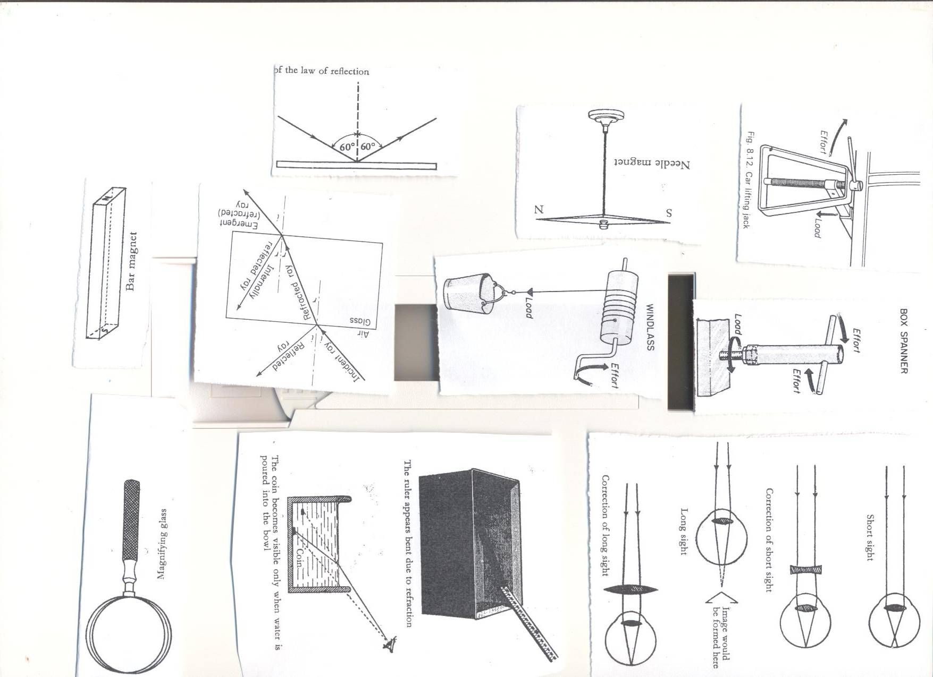

* **Horse shoe magnet**; It has u shape.

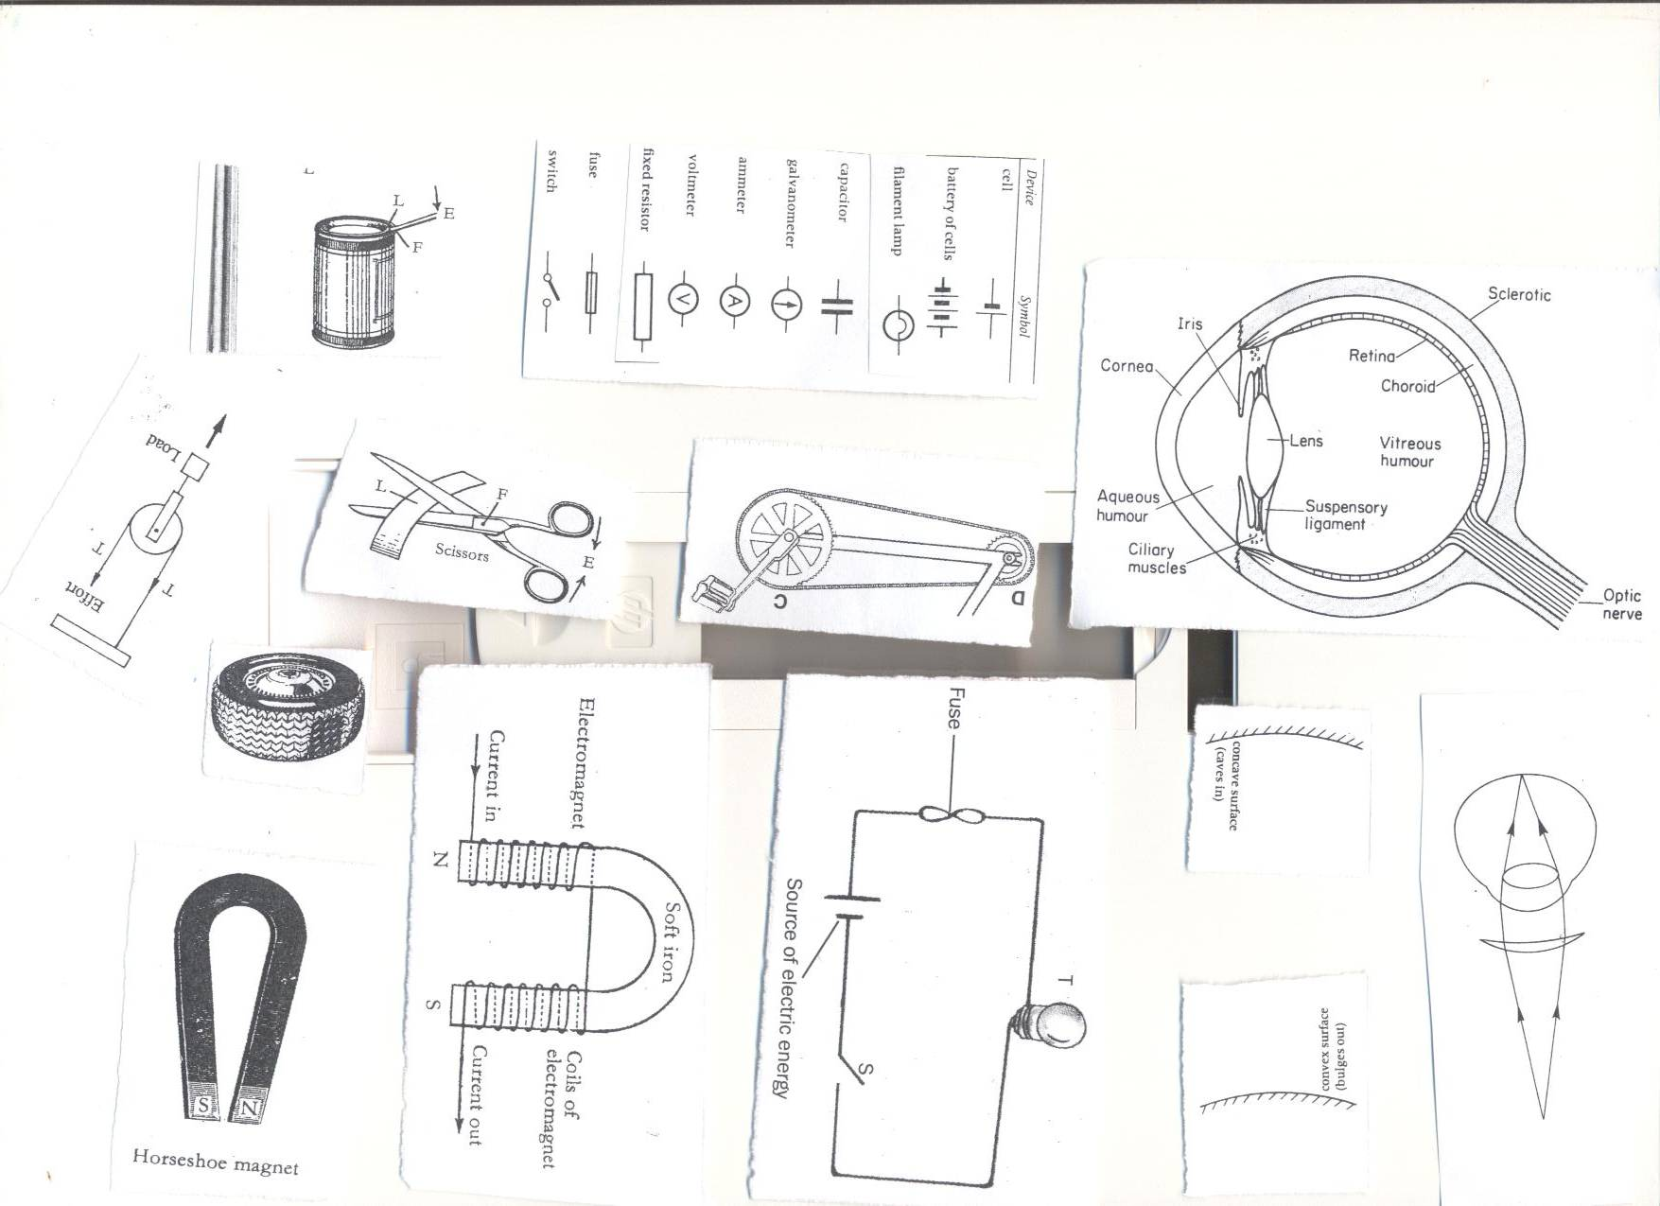

* **Needle magnet**; It has a thin pointed at both ends and balanced at the centre.

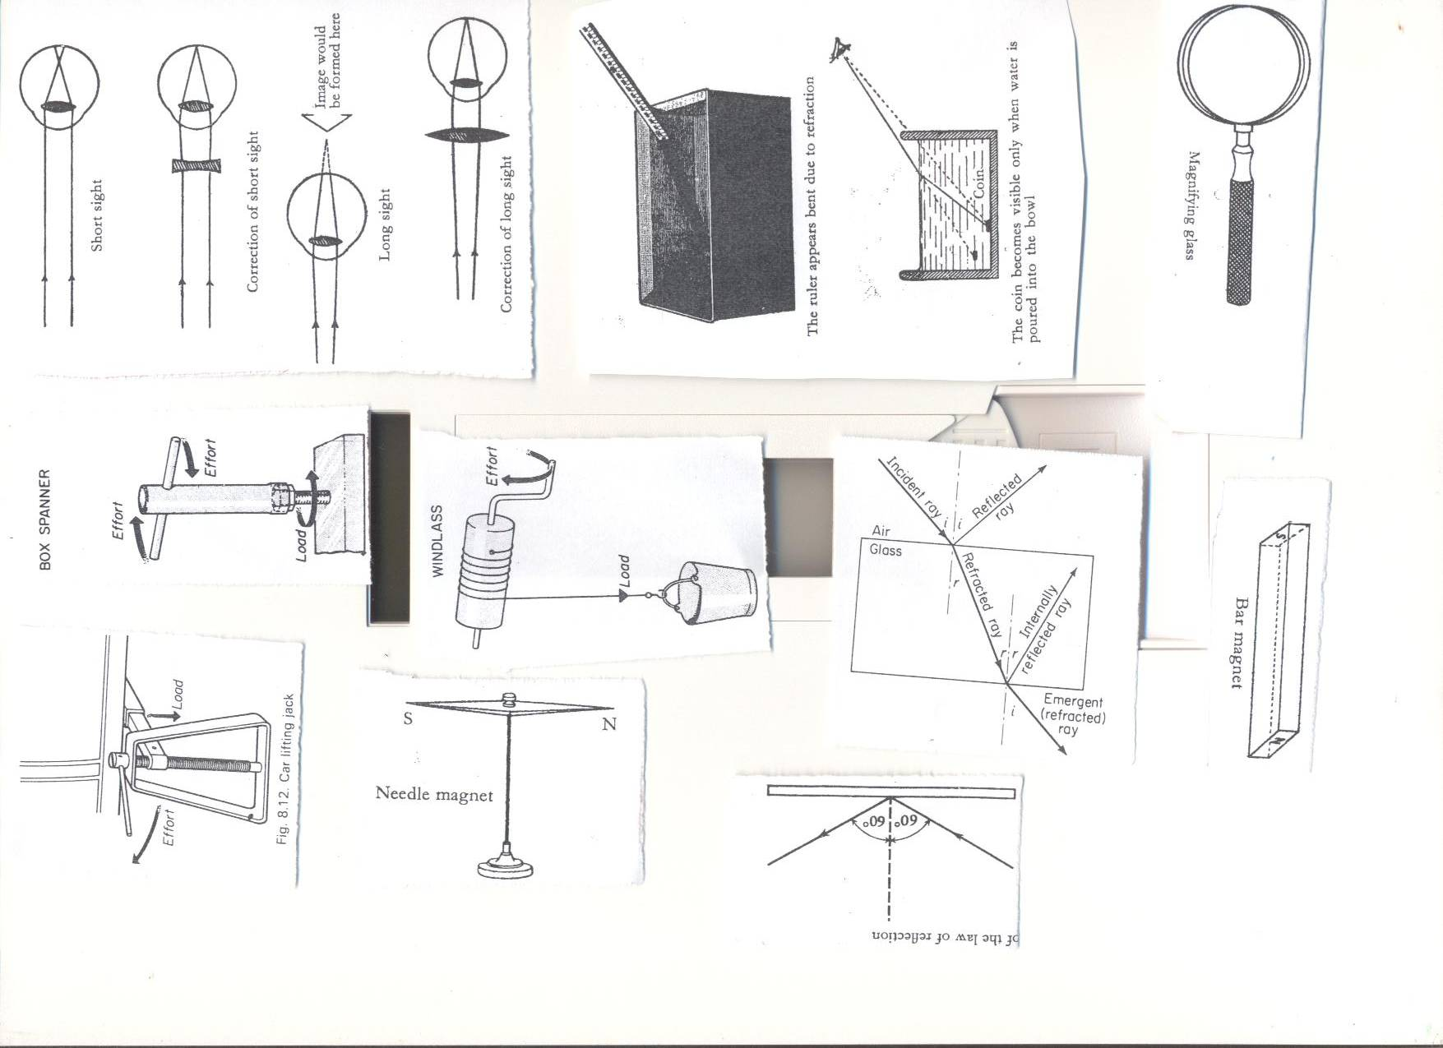

* **Electromagnet**



1. **Natural magnets**   
   They don’t lose magnetism.

**Examples of natural magnets.**

* **The Earth**; It is a huge natural magnet. Its magnetic field is weak, that is why you can’t feel it.



* **Lodestone/magnetite**; Lodestone is a magnetic ore which occurs naturally in the earth. It was discovered near the ancient city of magnesia in Asia Minor. It was the first magnet to be discovered by people.

**Properties of magnets(lesson four week three.**

* Like poles of a magnet repel.

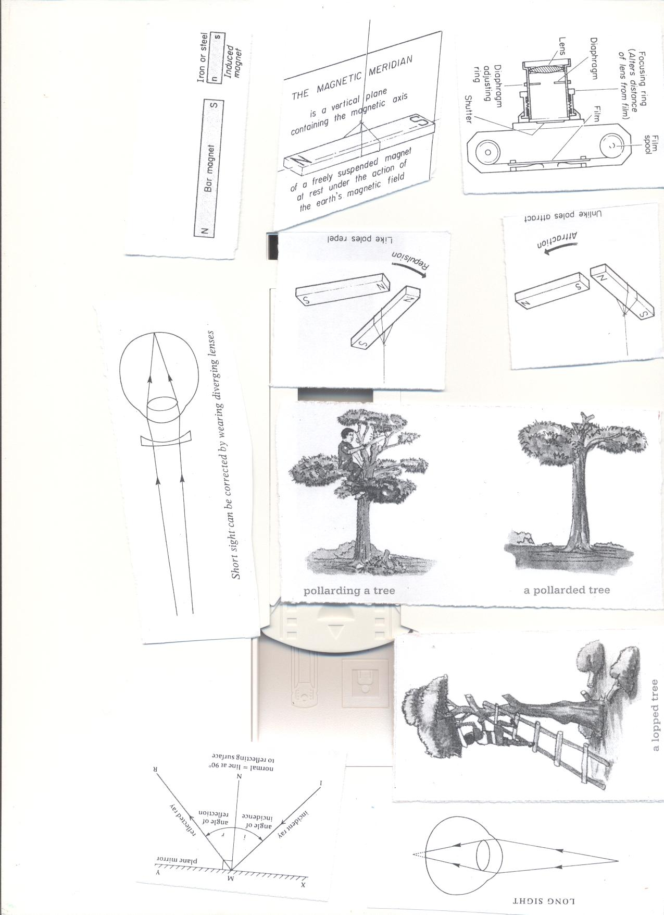

* Unlike poles attract each other.

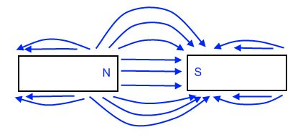

* When a magnet is freely suspended by a piece of thread it will always rest in the north –south direction.

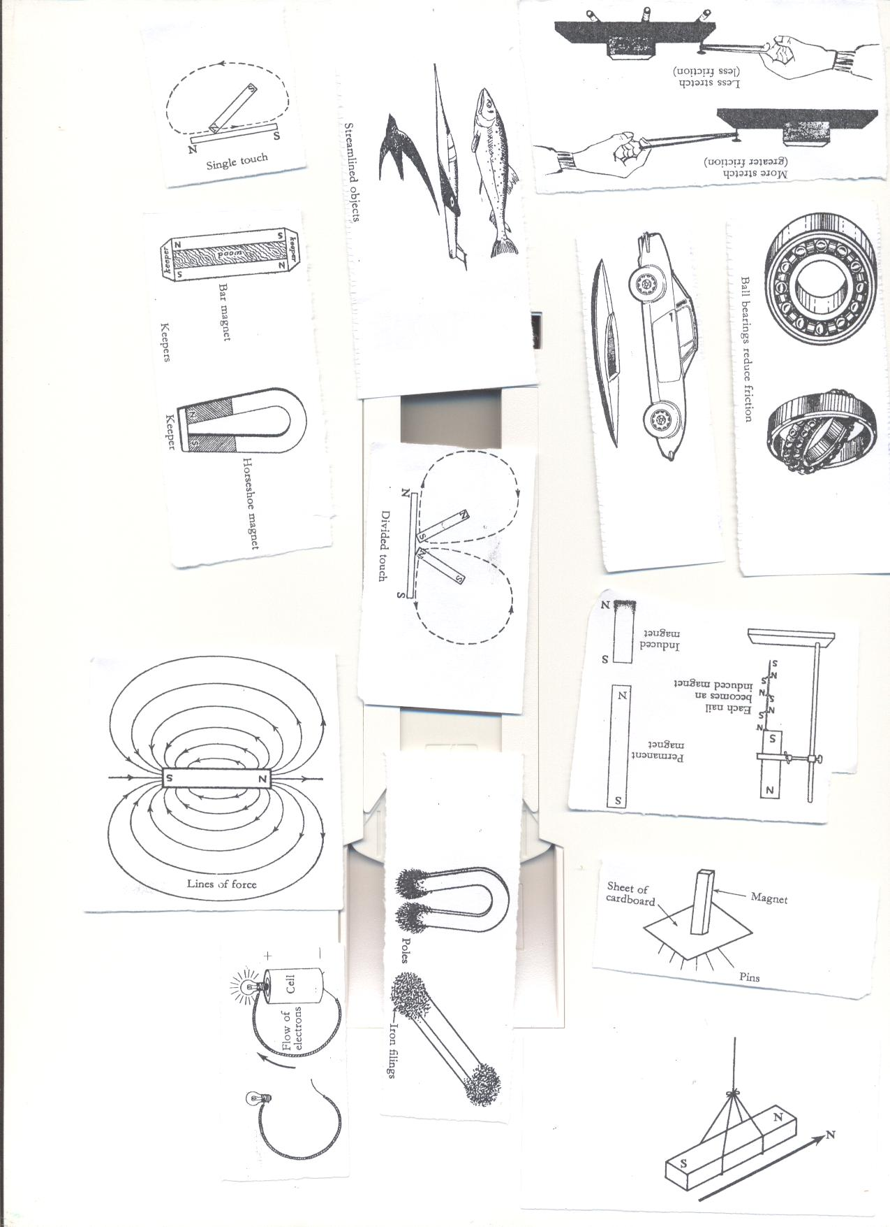

* The poles are the strongest part of the magnet.

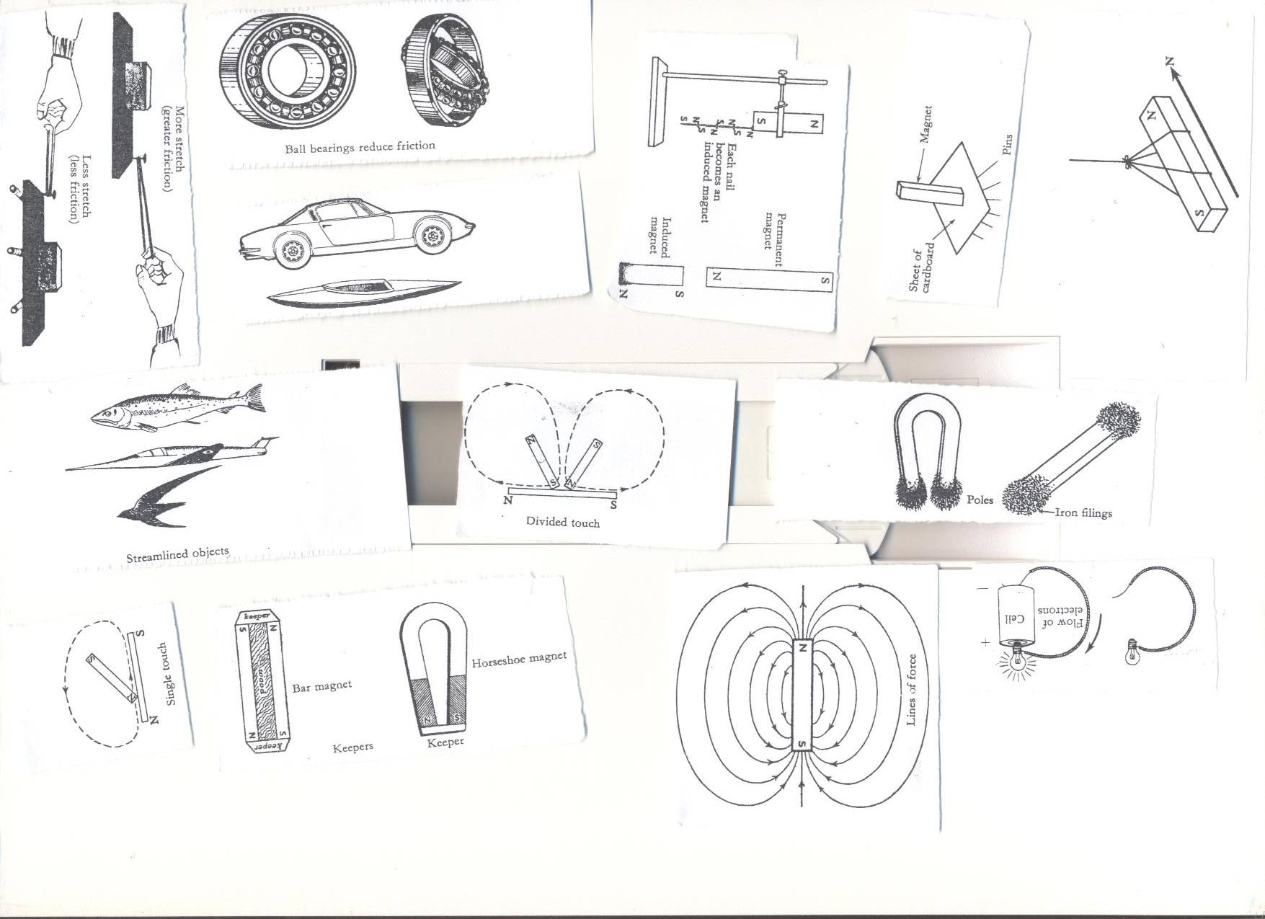

* Magnets have magnetic fields around them.



* Magnetism passes through **non magnetic materials** like wood and paper.



* Broken pieces of magnets regain their poles.

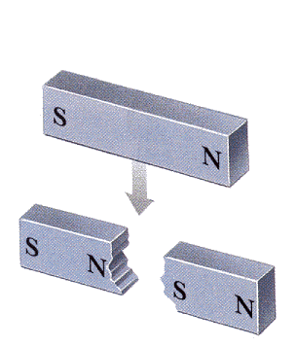

* Magnets become weaker with age.

**Preventing magnets from losing magnetism.**

* Keep them using iron keepers.



(Lesson four) week three

**Laws of magnets**

* Like poles of a magnet repel each other while unlike poles attract each other.

**What is magnetic field?**  
It is the area around the magnet in which it can attract other magnetic materials.

**Properties of magnetic fields.**

* They originate from **North Pole** and end at the **South Pole.**
* The lines forces do not intersect with each other.
* A line of force is continuous; it starts from the North Pole and ends at the south pole.
* There is no line of force within the magnet itself

**Methods of making magnets**.

* **Stroking by single touch:**

It is stroking by single touch method because one magnet is used.

Note. **The end after the stroke becomes the opposite pole of the magnet being used.**

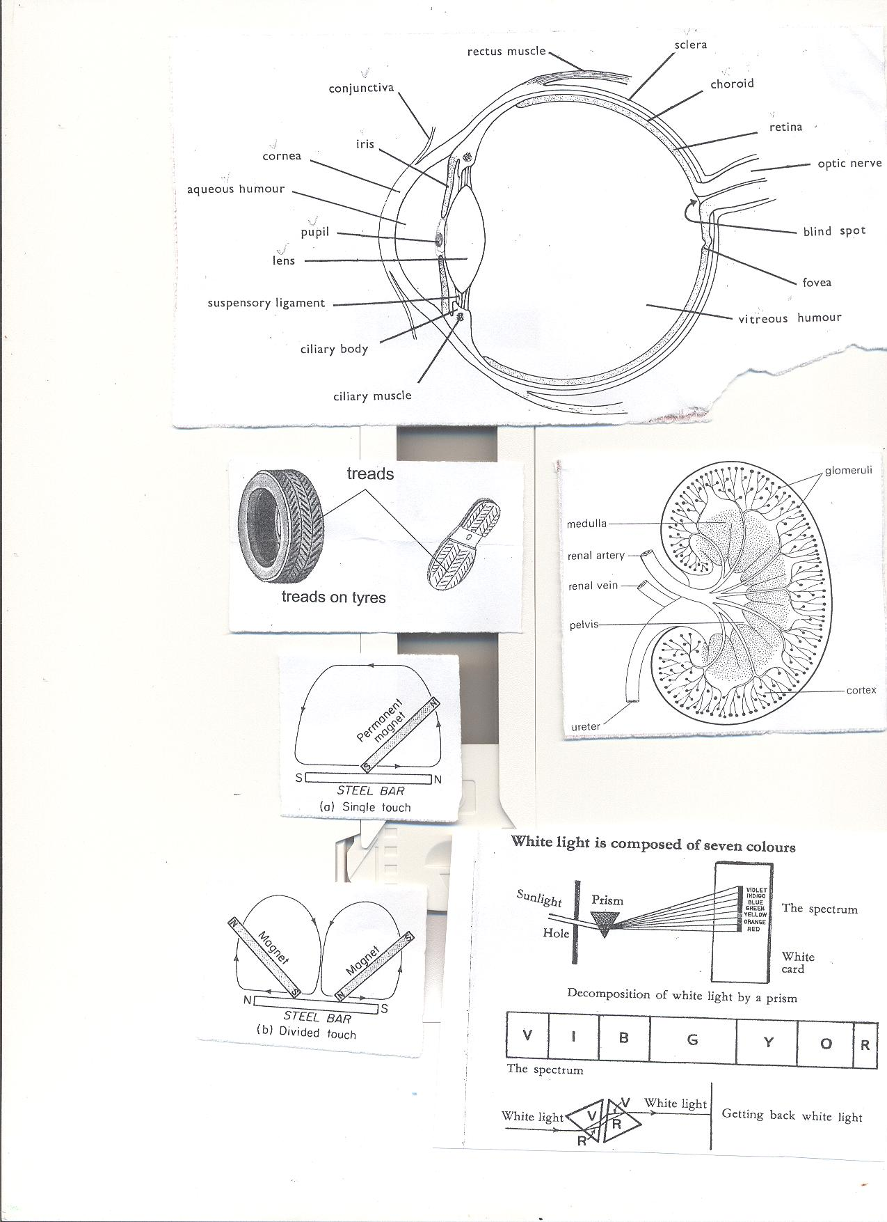

**Stroking by double/divided touch**

It is so because two magnets are used.



* **By induction** A magnetic object becomes magnetized by induction when it is nearer or contact with a magnet.

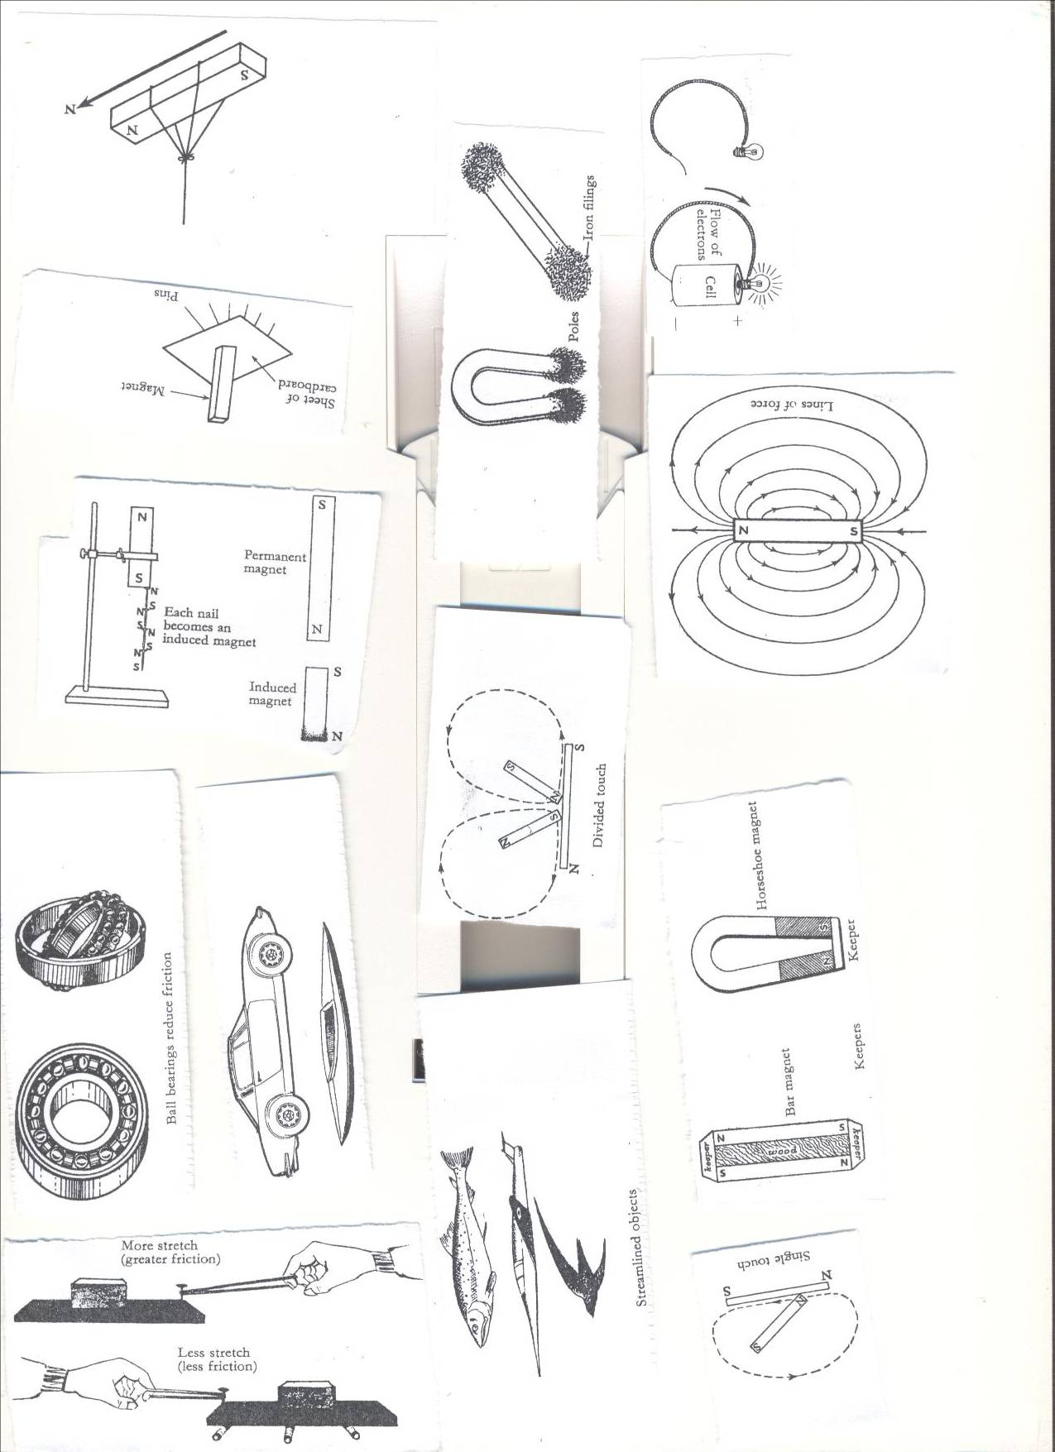

Lesson five and six ) week three

* **By electrical method**  
  This is a method of making magnets using electricity

A magnet made by using electricity is **electro- magnet.**

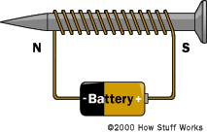 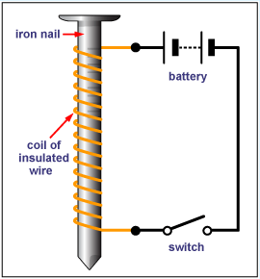

**Electro magnets are made stronger by;**

* By increasing the coils around the soft iron
* By increasing the voltage (electrical strength

**Determining the poles an electromagnet.**

1. **The direction of flow of current.**

* Looking at it from either end;
  + If current flows in an **anticlockwise** way through the solenoid, the pole is **North (N)**
  + If current flows in **a clockwise** way through the solenoid, the pole is **South(S).**

**ii. Using the right hand grip rule.**

* Grasp the solenoid in the **right hand** with **thumb pointing in the direction of current.**
* The thumb points to **the North Pole.**

**Demagnetizing a magnet(lesson seven) week three**

* It is making a magnet lose its magnetism.
* It is weakening or destroying a magnet.  
  **Ways of demagnetizing a magnet**
* Hammering/hitting strongly.
* Strong heating.
* Leaving a magnet in an east-west direction for a very long time.
* By keeping the magnets with like poles together.
* By passing an **alternating current** through a magnet.
* Leaving it to rust.
* **Uses of magnets in modern world of work.**
* Magnets are used in compasses by sailors, pilots and explorers.
* Electromagnets are used in industries to collect heavy scrap iron.
* An electric bell is also built on the principle of magnets.
* Magnets are used in telecommunication devices.
* Electric motors which produce electricity use magnets.
* They are used in loud speakers.
* They are used on doors of fridges.

**Appliances that use electricity**

* Flat irons
* Heaters
* Driers.
* Washing machines
* Electric fans
* Cooker

**Appliances that use magnetism**

* Magnetic compasses.
* Magnetic tapes.  
  **Appliances that use both electricity and magnetism.**.
* Fridges.
* Radios
* Televisions
* Mobile phones
* Electric bells

**An Electric bell(lesson eight and nine) week three**

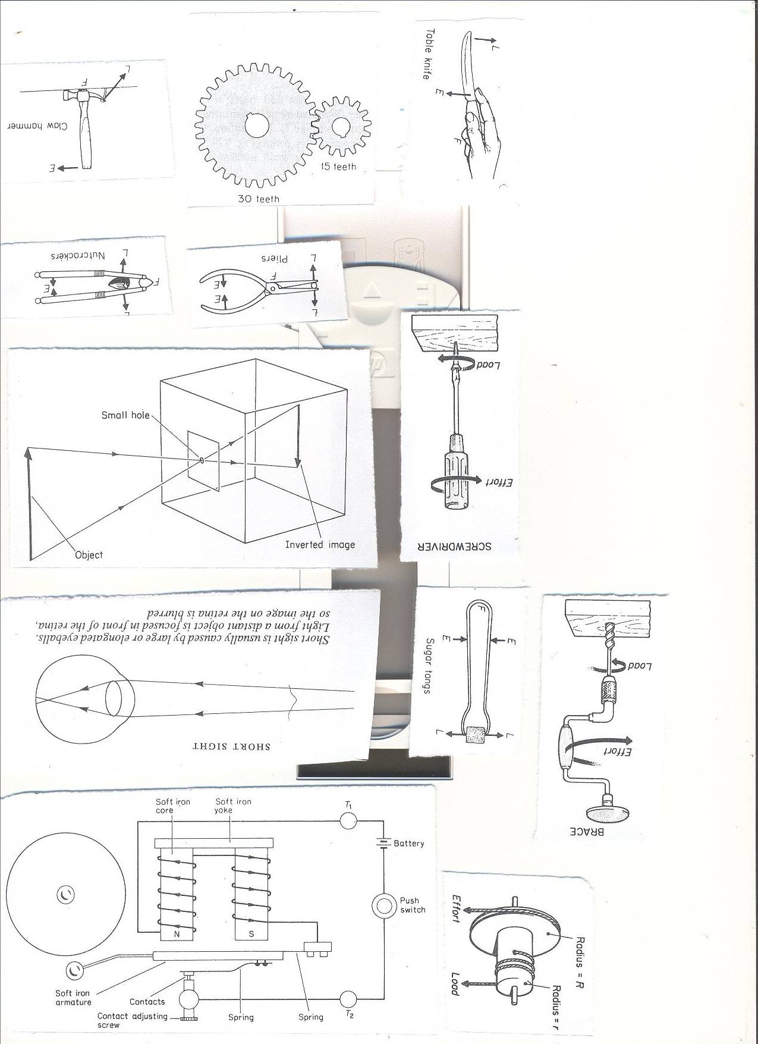

**How it works**

* When the contact is made the soft iron becomes magnetized.
* It pulls the soft iron strip with the hammer.
* The hammer hits the gong producing sound.
* When the strip is pulled the soft iron loses its magnetism and the contact is broken because current is not flowing.

**Generating electricity using a dynamo.**

**Dynamo.**

A dynamo is a device which converts mechanical energy into electrical energy.  
A dynamo uses **a permanent magnet** and a coil of wires on electro magnets

During the turning, the **mechanical energy** is turned into **electric energy.**

**Generator**

The type of current electricity produced is **A.C**

They change **Mechanical energy** to **electric energy.**

**Uses of dynamos and generators**

* Provide electricity for light.
* Provide energy to run machines.
* Provide energy for cooking
* Generators are used in hospital theatres incase power goes out.

**Topical questions**

1. How is magnetism different from magnets?
2. State the any one law of magnetism
3. How are magnets important to the following?
4. Doctors b) pilots c) teachers
5. Cite one item that uses both magnets and electricity.
6. How are magnets found in radios important?
7. In four sentences, briefly explain how an electric bell works.
8. Write the term AC in full.
9. What is the importance of the hammer found on an electro magnet?
10. State one way of making magnets.
11. In which one way can a p7 child make a magnet lose its magnetism?
12. Briefly explain how strong heating a magnet can make it lose its magnetism?

LESSON ONE WEEK FOUR

**TOPIC 3: ENERGY RESOURCES IN THE ENVIRONMENT.**

**VOCABULARY**

* **Resource Hydro**
* **Tidal Fossil**
* **Coal Petroleum**
* **Bio gas Bio fuel**
* **Wood fuel**

**A RESOURCE**  
This is anything that people uses to satisfy their needs.

**ENERGY RESOURCE**  
It is anything that provides people with useful energy.

**TYPES OF RESOURCES.**  
1. Renewable resources. – Things that can be replaced naturally when used up.

**Examples:** Plants, animals, land( soil), water, air,  
2. Non renewable resources.- Things that cannot be replaced when used up.

Examples: Minerals, rocks, fossil fuels.  
**Energy resources .**

-Sun, Water, Minerals, Air or wind, Plants and Animals.

**The sun as major source of energy in the environment (solar energy).**

**THE SUN**  
The sun is the main source of heat and light as forms of energy on earth.  
**Importance of the sun to people and environment**

* The sun helps in rain formation.
* Preserve our food by sun drying.
* Helps the human skin to make vitamin D
* Helps to disinfect beddings
* Light from the sun helps us to see.
* Light from the sun is used to make solar electricity.
* Light from the sun enables plants to make food.
* Dry our clothes.

**Water as an Energy resource:**

It helps people to get the following form of energy.

* **Hydro electricity:**

It is the form of electricityproduced by the power of running water at a fall.

When waterfalls at a greater height, **potential energy** is changed to **kinetic energy**.

**Kinetic energy** turns the turbines connected to a generator with powerful magnetic field and a coil of wire turning it. In this way HEP is produced.

* **Steam**

Steam with Kinetic energy helps to power **steam engines.**

LESSON TWO WEEK FOUR

* **Tidal energy**

This is the form of energy got from **water tides** on the sea shores.

Tides are periodic rises and falls of large bodies of water.

The tides are caused by gravitational interaction between the earth and the moon.

**Importance of water as an energy resource to people and environment**

* Fast running water at a fall turns turbines to produce HEP.
* Used to cool machines in industries.
* Used for bathing and drinking.
* Tidal energy is used to produce electricity.

**Fossil fuels (coal, petroleum, Uranium) as energy resources.**

**Importance**

**Examples of fossils.**

* Coal
* Petroleum

Petroleum//crude oil

It is an energy resource from the ground formed from animals that died many years ago.

The changes in the earth created a lot of heat and pressure on them hence turning into petroleum.

Examples of petroleum.

* Petrol, diesel, oil, jet fuel, paraffin

These fuels are got from crude oil by the process called fractional distillation.

**Importance of petroleum products**

* Used to generate power that can run machines and vehicles.
* They are burnt to produce light and heat.

**Importance of coal.**

* Used as fuel in steam engines.
* Coal is burnt to produce thermal electricity
* It is used to make tar for surfacing roads.

**Other products from petroleum.**

* Plastics, polythene paper, tar, dye, detergents, Vaseline, mattresses, grease, paint, fertilizers, etc

**Other products from coal**

* Paints, fertilizers, perfumes.

Uses of uranium

* It is used to make atomic bombs.
* It is used as fuel in nuclear powered sub marines.
* Uranium is burnt to produce atomic electricity.

Geothermal energy

* It is got from hot springs// thermal springs where steam is trapped to turn turbines to produce electricity.

LESSON THREE AND FOUR WEEK FOUR

**ANIMALS AS ENERGY RESOURCES.**

* Animals like oxen are used to plough land.
* Some animals like the donkeys are used for transport.
* Some animals are used as source of food.
* Some animals like oxen and ass are used to pull carts.

PLANTS AS ENERGY RESOURCES.

* They are source of food.
* They are source of wood fuel.
* They are source of building materials.
* They are used as shelter by some animals.

**How to conserve plant resources.**

* Through a forestation.
* Use fuel saving stoves.
* Use other //alternative sources of fuel like biogas.
* Educate people about the advantages of plants in the environment.  
  **Wind as energy resources.**

**AIR/WIND**

Importance.

* Used for winnowing
* Used to turn wind mills to produce electricity.
* Used to sail boats
* Helps to disperse seeds
* Used in pollination.
* Used to fly kites.
* Speed up evaporation and hence increases the speed to dry things.  
  **Plants (wood fuel, food) as energy resources.**

LESSON FIVE AND SIX WEEK FOUR

**Animals as energy resources.**

**Biogas production from plants**  
**What is biogas?**  
It is a methane that is produced from the rotting organic matter.

The waste plant materials.  
1. Cow dung.  
2. Plant materials.  
3. Animal urine.

**Steps of making biogas digester.**  
The above materials are put into an air-tight container called a biogas digester.  
where they are worked on by anaerobic bacteria to ferment and biogas is formed.  
When the gas formation stops, the remains can be used as manure.

**Structure of Biogas digester**

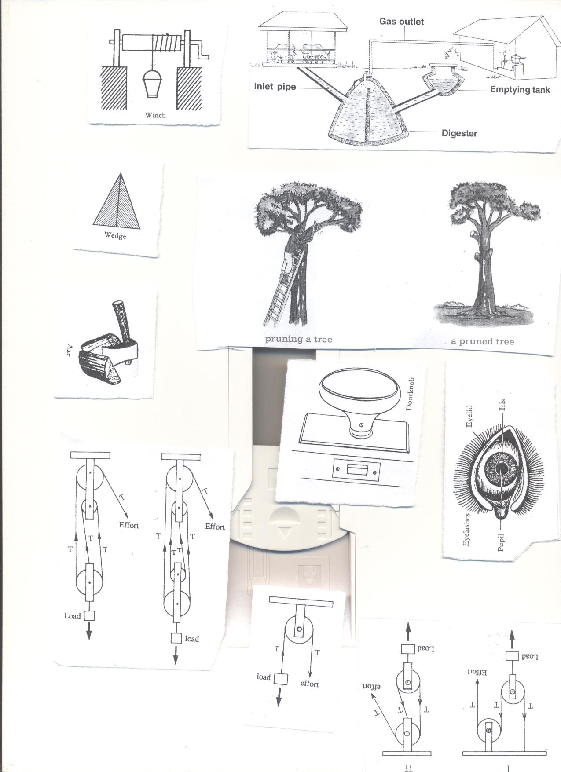

**Uses of the parts**.

* Inlet: For inserting in plant and animal matter.
* Inlet pipe: allows plant and animal matter into the digester.
* Outlet: For removing old used up matter to the garden.
* Emptying tank: Where used up matter is collected before it is taken to the garden.
* Biogas tube: It traps biogas and takes it to the heating or lighting equipment.  
  **Uses of biogas**  
  1. For cooking  
  2. For lighting  
  3. For heating.

**Advantages of using biogas**  
1. It is cheaper than using natural gas  
2. It does not pollute the environment.  
3. The materials are readily available in the environment.

**TOPICAL QUESTIONS**

1. In which one way do plants depend on?
2. Cattle b) human beings c) goats
3. Mention any one advantage of using biogas over using firewood.
4. How is a biogas digester important in the production of biogas?
5. Cite any one thing used in the making of biogas.
6. Write down any three ways how animals depend on non living things in the environment.
7. In what way can a farmer use the residue left after making bio gas.
8. State any two uses of biogas to human beings.
9. Why is wind said to be a form of energy?
10. How does use of biogas contribute towards the control of environmental degradation?
11. What danger caused when biogas containers are kept near the reach of young children?  
    **(WRITING, MARKING AND GOING THROUGH MID TERM EXAMINATIONS IN WEEK FOUR LESSONS 7,8,9,WEEK FIVE LESSONS: 1,2,3,4,5,6 and 7)**

**Topic 4: Simple Machines and Friction**

**VOCABULARY**

* **Friction Force**
* **Nuisance Moments**
* **Mechanical advantage Wedges**
* **Inclined Plane Axles**
* **Screws**

**LESSON 8 AND NINE WEEK FIVE**

**FRICTION**

* Is the force that opposes movement of objects.

**Types of friction  
1. Static friction**: It is found in objects which are fixed in one position.  
**2. Sliding or rolling friction**: It is found in moving objects.  
**3. Viscosity friction**: This occurs in liquids and gases.

**Properties of friction.**  
i.There is more friction with rough surfaces than with smooth or slippery ones.  
ii.The greater the load, the greater the friction force (weight increases friction)  
iii.Whenever friction occurs heat is produced.

**Friction as a useful force in our daily life.**1. It helps in moving and stopping vehicles.  
2. It helps when writing.  
3. It helps when sharpening objects.  
4. It helps when walking.

5. It helps in lighting match sticks.  
**Friction as a nuisance force/ disadvantages.**

1. It wears away things e.g. shoe soles, parts of engines.  
2. It hinders work as it makes us use a lot of force.  
3. It produces unnecessary heat and noise.

**How to increase friction.**  
i. Making smooth surfaces rough.  
ii. Putting treads on vehicle tyres / on shoe soles.

  
iii. Putting spikes on sports boots.  
iv. Putting grips on handles of bicycle.

**How friction can be reduced.**

i**. Using rollers**; they decrease areas of contact between moving parts.

  
ii. **Using ball bearings**; these are round metallic balls they reduce friction by keeping moving parts separated.



iii. **Lubricating**; This involves using oil or grease.  
Oil and grease are referred to as **lubricants**.  
iv. Stream lining objects like planes, cars

   
v. Making rough surfaces smooth.

Questions.

1. State a brief meaning to the term friction.
2. In one way explain how friction can be increased on a slippery surface.
3. Write down any two advantages of friction in our lives.
4. Why is friction said to be a nuisance force?
5. Why are some objects stream lined?
6. State any two items that are stream lined?

**WEEK SIX LESSON 1 AND 2  
MACHINES**  
It is a device that simplifies work.

**How do machines simplify work**  
1. By changing the direction of force.  
2. By reducing the effort required to do work  
3. By increasing the speed of work.  
**Types of machines**1. Simple machines.  
2. Complex machines.

**A complex machine**  
It is a machine that is made up of many parts and simplifies work.  
When two or more simple machines (tools) are put together a complex machine is made  
**Examples of complex machines**Tractor, Bicycle, Sewing machine, Car, Aero plane etc.

**Simple Machine.**

It is a device that is made up of few parts and simplifies work.  
**Examples of simple machines.**

|  |  |  |  |  |  |
| --- | --- | --- | --- | --- | --- |
| A hoe | See saw | Claw hammer | Nut cracker. | Human arm. | Nut cracker. |
| A wheel barrow | Pincers. | Water pump | Sugar tongs. | Spade. | Sugar tongs. |
| A pair of scissors | Crow bar. | Bottle opener | Fishing rod | Ladder. | Stairs. |

**Classes of simple machines.**1. Levers  
2. Inclined planes/slope  
3. Pulleys.  
4. Screws.  
5. Wheel and axle  
6. Wedges  
**Levers**  
Is a stiff rod that turns on a fixed point called a pivot or fulcrum.

**Parts of a lever**

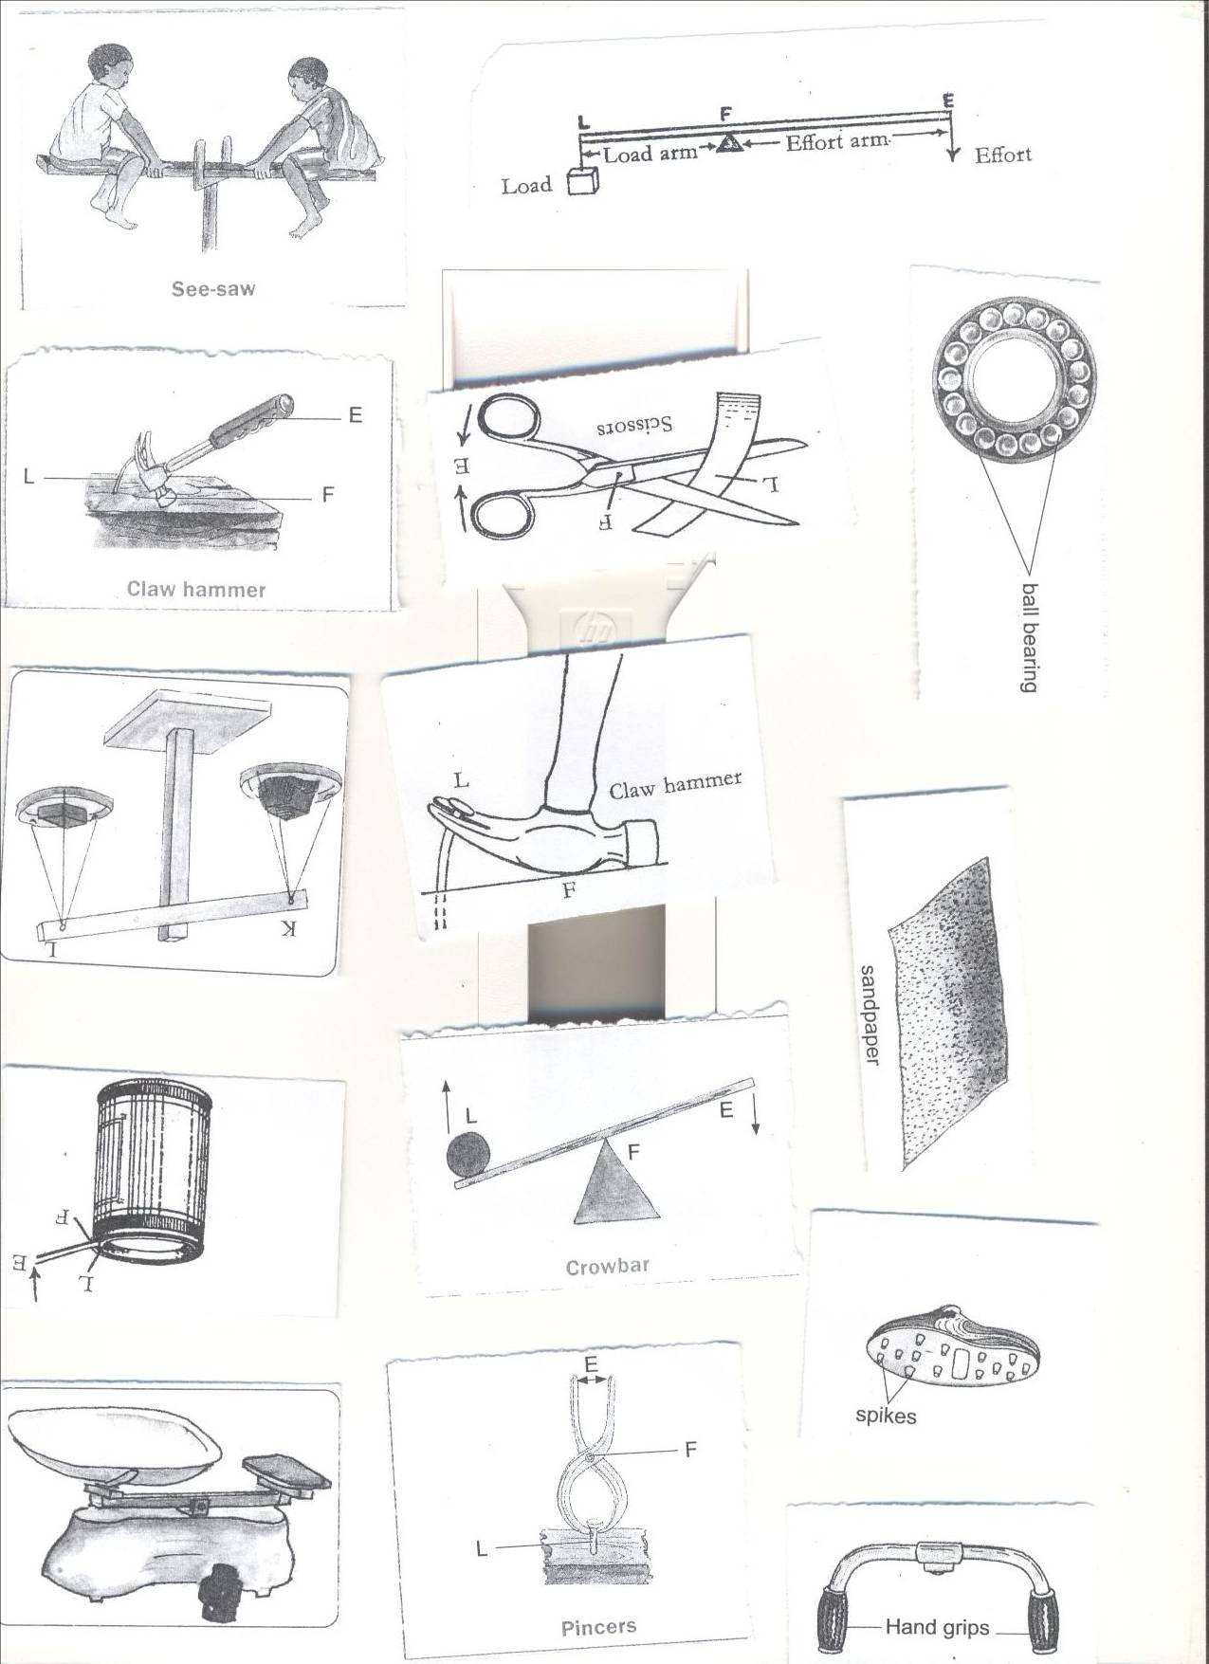  
**1. Effort:** is the force exerted on a machine to overcome the load.  
**2. Load / resistance:** it is the weight of the body to be lifted.  
**3. Fulcrum** **or Pivot:** is the turning point of a machine.  
**4. Load arm** is the distance between the fulcrum and the load.  
**5. Effort arm** is the distance between the fulcrum and the effort.

**WEEK SIX LESSON THREE AND FOUR**  
**Classes of levers.**  
There are three classes of levers depending on the position of the fulcrum(f), Load(l) and effort(E)  
**First class levers**  
Fulcrum/pivot is between the load and effort

In this class, the effort arm is longer than the load arm.  
The longer the effort arm, the smaller the effort applied.  
The advantage of the first class lever is that less effort is used.  
**Examples of first class levers.**

|  |  |  |  |
| --- | --- | --- | --- |
| 1 | See saw | 5 | Crow bar |
|  | C:\Documents and Settings\Kirinya\Desktop\stepu\order form 3 016.jpg |  | C:\Documents and Settings\Kirinya\Desktop\stepu\order form 3 016.jpg |
| 2 | pincers | 6 | pliers |
|  | C:\Documents and Settings\Kirinya\Desktop\stepu\order form 3 016.jpg |  | C:\Documents and Settings\Kirinya\Desktop\stepu\order form 3 015.jpg |
| 3 | Claw hammer | 7 | Water pump |
|  | C:\Documents and Settings\Kirinya\Desktop\stepu\order form 3 012.jpg |  | C:\Documents and Settings\Kirinya\Desktop\stepu\order form 3 015.jpg |
| 4 | scissors | 8 | Lid opener |
|  | C:\Documents and Settings\Kirinya\Desktop\stepu\order form 3 007.jpg |  | C:\Documents and Settings\Kirinya\Desktop\stepu\order form 3 007.jpg |
| 9 | scales | | |
|  | C:\Documents and Settings\Kirinya\Desktop\stepu\order form 3 016.jpg | | |

**Second class lever**  
**Load** is between the **fulcrum** and **effort.**  
The fulcrum and the effort are on either side. (FLE OR ELF)

The load is closer to the fulcrum than the effort  
The effort applied is smaller compared to the load.  
First and second class levers are referred to as force multipliers

**Examples of second class levers**.

|  |  |  |  |
| --- | --- | --- | --- |
| 1 | Wheel barrow | 3 | Human Foot |
|  | C:\Documents and Settings\Kirinya\Desktop\stepu\order form 3 014.jpg |  | C:\Documents and Settings\Kirinya\Desktop\stepu\order form 3 015.jpg |
| 2 | Nut cracker | 4 | Bottle opener |
|  | C:\Documents and Settings\Kirinya\Desktop\stepu\order form 3 015.jpg |  | C:\Documents and Settings\Kirinya\Desktop\stepu\order form 3 014.jpg |

**Questions.**

1. Write down any two examples of each of the following.
2. 1st class lever b) second class lever
3. State any one advantage of using first class lever?
4. Draw one any two items in 1st class lever.
5. How are machines important in life?
6. State any two ways in which machines are able to improve on the efficiency of a machine

**WEEK SIX LESSON FIVE AND SIX**

**Third class levers**  
Effort is between fulcrum and load  
The fulcrum and the load are on the either side. (FEL)

The effort is closer to the pivot than the load  
The effort used is greater than the load.  
Third class levers are referred to distance multipliers.

The advantage of using this class is that the effort moves through a shorter distance  
**Examples of third class levers**

|  |  |  |  |
| --- | --- | --- | --- |
| 1 | Sugar tongs | 3 | Fishing rod. |
|  | C:\Documents and Settings\Kirinya\Desktop\stepu\order form 3 012.jpg |  | C:\Documents and Settings\Kirinya\Desktop\stepu\order form 3 015.jpg |
| 2 | Human arm.  C:\Documents and Settings\Kirinya\Desktop\stepu\order form 3 012.jpg | 4 | Spade.  C:\Documents and Settings\Kirinya\Desktop\stepu\order form 3 013.jpg |
| 5 | Table knife 6. Tweezers | | |
|  | C:\Documents and Settings\Kirinya\Desktop\stepu\order form 3 004.jpg http://shop.nouveaubeautygroup.com/media/catalog/product/cache/1/thumbnail/650x650/9df78eab33525d08d6e5fb8d27136e95/h/d/hdbrows_tweezers_1.jpg | | |

**N.B**  
The formula PLE or FLE can help to determine the class of lever

**The principle of moments. (The law of the lever)**  
The load force multiplied by the load arm is equal to the effort force multiplied by the effort arm.// it states that clock wise moments are always equal to anti-clock wise moments  
**Examples**

1. A man weighs 60 kgf. He sits 1.5 metres from the fulcrum of the see saw. How far from the fulcrum will the boy whose weight is 30 kgf sit in order to balance the man.  
   Let the man be the effort and the boy be the load.  
   Let the load be x metres.

X 1.5m

MAN

BOY

Load x Load arm = Effort x effort arm.  
30Kgf x X =60kgf x 1.5m  
 30x = 90  
 30 30  
 x =3 metres  
2. A boy weighing 60kgf sits 2 metres away from the fulcrum of the see saw.  
A girl sits on the other side at a distance of 3 metres from the fulcrum in order to balance the see saw. Find the weight of the girl.

2m 3m

60Kgf

X kgf

Let the boy be the effort and the girl the load.  
Let the girl’s weight be y  
Then, Load x Load arm=Effort x Effort arm  
 y x 3m =60Kgf x 2 metres.  
 3y =120  
 3 3  
 y = 40kgf  
3. A weight of 120 grams at a distance 3cm from the fulcrum is balanced by a weight of 30g on the other side. Find the distance from the 30kg weight to the fulcrum.

Take 120kgf as the effort and 30kg as the load.  
Let y be the distance of the load from the fulcrum.  
Then Load x load arm=Effort x Effort arm.  
 30 x y =120gf x 3cm  
 30y = 360  
 30 30  
 y =12cm

**4.**Using a see-saw shown below, find the length of the wooden plank AB.

A 2m B

3kgf

5kgf

**WEEK SIX LESSON SEVEN AND EIGHT**

**1.Find the value of X**

4m 2m X m

5kgf

15kgf

10kgf

1. **Find the weight at X**

4cm 2cm 3c m

5kgf

15kgf

**X**

1. Find the weight at X

3m 2m 2m 4m

30g

40g

**X**

25g

**WEEK SIX LESSON NINE AND TEN**  
**The inclined plane (slope)**  
An inclined plane is a slanting surface.

**Importance of an inclined plane.**

* It enables heavy loads to be raised using a lesser effort.  
  **Examples of inclined plane**

|  |  |  |  |
| --- | --- | --- | --- |
| 1 | Winding road |  |  |
|  | C:\Documents and Settings\Kirinya\Desktop\stepu\order form 3 010.jpg |  |  |
| 2 | Stairs/ steps. | 4 | Ladders |
|  | C:\Documents and Settings\Kirinya\Desktop\stepu\order form 3 010.jpg |  | C:\Documents and Settings\Kirinya\Desktop\stepu\order form 3 006.jpgC:\Documents and Settings\Kirinya\Desktop\stepu\order form 3 012.jpg |

**Mechanical Advantage of machines.**

Mechanical Advantage is the ratio of the load to effort. i.e. M.A = Load/effort.  
M.A is the number of times a machine simplifies work.  
M.A has no units since it is a ratio.  
Friction lowers M.A.

Example;  
John used a slope to raise a load of 60kgf from the ground to the higher level as shown below.

c 60kgf  
   
 4m 5m

A B   
Work out the following  
The effort distance  
 =5m  
The load distance  
 =4m  
Work done  
 W=FXD

M.A= Load

Effort

= Distance effort moves

Distance load moves

**= 5**  
 **4**

**Work**  
Work is a product of force and the distance moved.  
Work=Force x Distance moved.

Work done by the effort=effort x effort arm.  
Work done by the load= load x load arm.  
The unit of work is a joule.  
The unit of force is the Newton.  
The standard unit of distance is the metre.  
1 kgf = 10N  
1 joule(of work) is done when one newton (of force) moves through one metre( of distance)  
1 joule=1 N x 1 m  
1 joule=1 Nm

Questions

From comprehensive science book seven.

**WEEK SEVEN LESSON ONE**

**WEDGES**

A wedge is a cutting tool. It is double inclined plane/slope.

**Examples of wedges**

|  |  |  |  |
| --- | --- | --- | --- |
| **1** | Knife edge. | **5** | Axe blader |
|  | C:\Documents and Settings\Kirinya\Desktop\stepu\order form 3 004.jpg |  | C:\Documents and Settings\Kirinya\Desktop\stepu\order form 3 011.jpg |
| **2** | Hoe | **6** | Razor blade |
|  | http://www.easydigging.com/images-new/home-grape-hoe.jpg |  | [http://t2.gstatic.com/images?q=tbn:ANd9GcTIE6EoqmU1uhn6oT3YYz7krE0IbWL1xY3_rCxkvI_eKjLOa1ctsHbPGZbI](http://www.google.com/imgres?imgurl=http://lunyole.webonary.org/wp-content/uploads/bantu/images/original/razor.png&imgrefurl=http://lunyole.webonary.org/?s=razor%20blade&partialsearch=1&usg=__BNcddsRX0bAoxj2PKoF09yyTX98=&h=1131&w=1351&sz=15&hl=en&start=20&zoom=1&tbnid=ZP5O7exX4QMmRM:&tbnh=126&tbnw=150&ei=fwYNUbGVNseKhQet3YHgDQ&prev=/search?q=razor+blade&um=1&hl=en&gbv=2&tbm=isch&um=1&itbs=1) |
| **3** | Nail. | **7** | Needle. |
|  | http://image.made-in-china.com/4f0j00VCLEmPsfsYgG/Iron-Nail.jpg |  | **[http://adaptstudio.ca/blog/uploaded_images/needle-769303.png](http://adaptstudio.ca/blog/uploaded_images/needle-769308.png)** |
| **4** | A wedge  C:\Documents and Settings\Kirinya\Desktop\stepu\order form 3 011.jpg | | |

**LESSON TWO**

**SCREWS**

**DIAGRAM SHOWING A SCREW.**

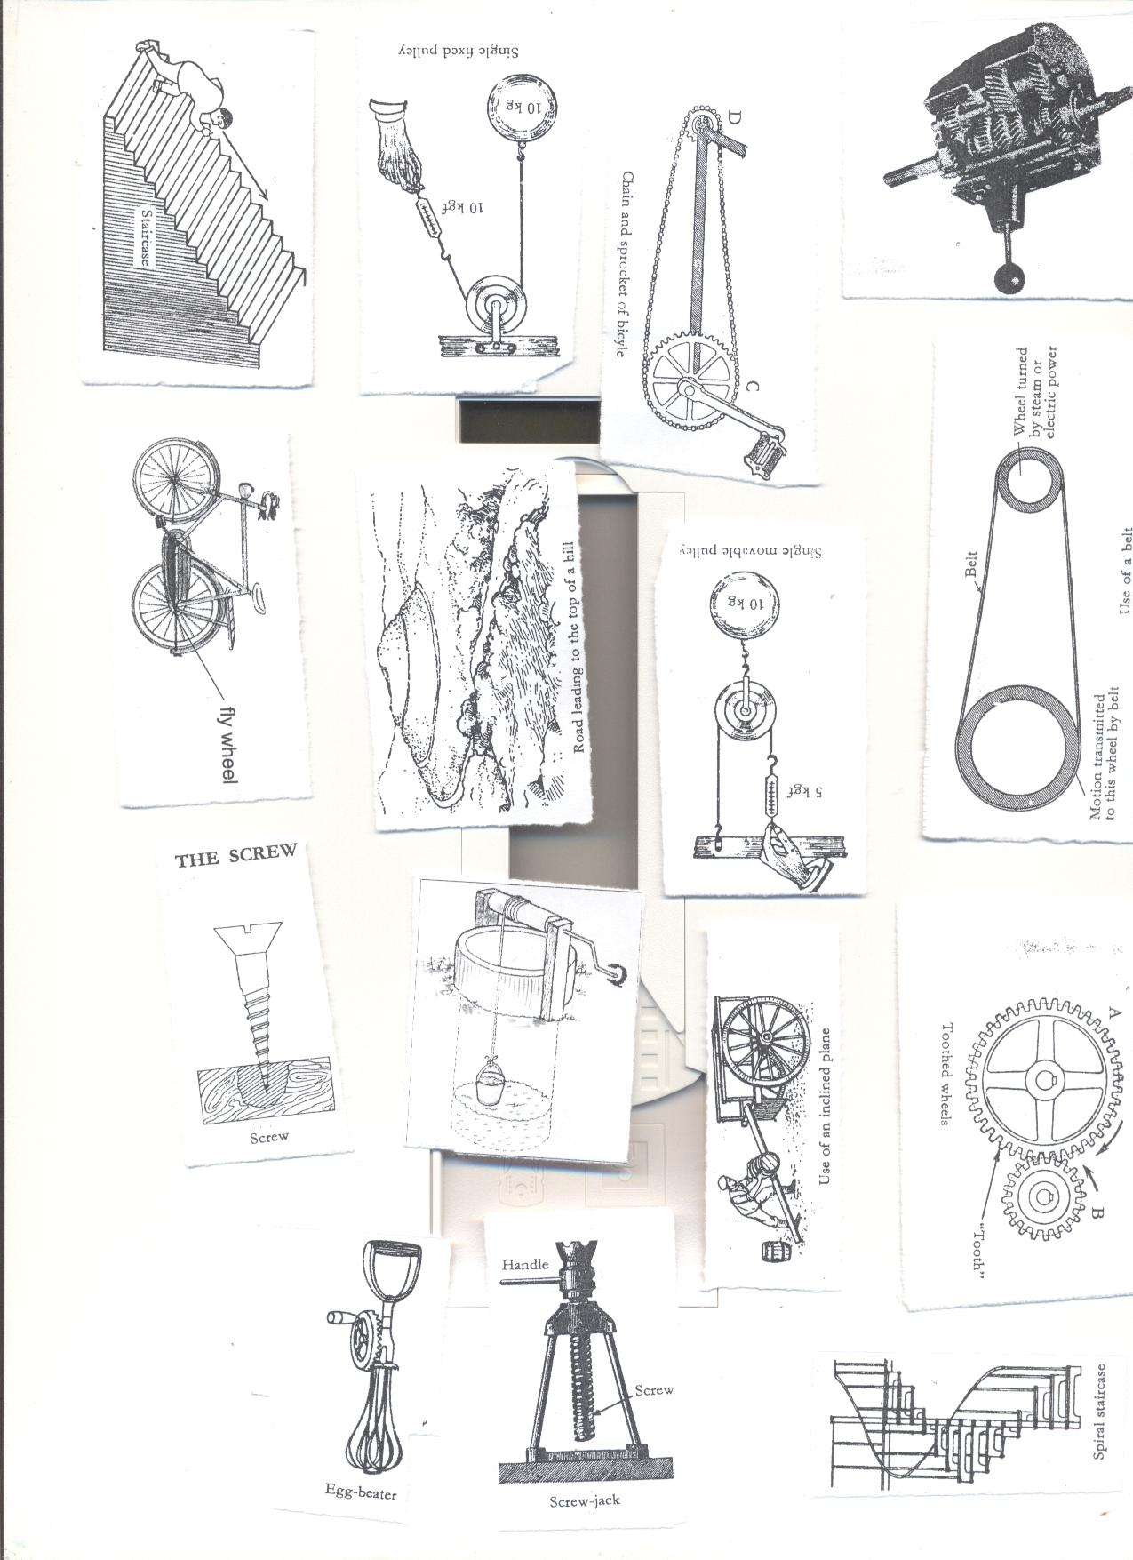

A screw is an inclined plane wound round  
We use it to make our work easier.  
**USES OF SCREWS**  
1.Lifting very heavy things e.g. screw jack.  
2. It makes movement upstairs easier e.g. using a spiral staircase

3. Used to fasten things together.  
EXAMPLES OF SCREWS

|  |  |  |  |
| --- | --- | --- | --- |
| **1** | Spiral staircase | **3** | Screw jack |
|  | **C:\Documents and Settings\Kirinya\Desktop\stepu\order form 3 010.jpg** |  | C:\Documents and Settings\Kirinya\Desktop\stepu\order form 3 012.jpg |
| **2** | Screw nails |  |  |
|  | C:\Documents and Settings\Kirinya\Desktop\stepu\order form 3 012.jpg |  |

**WEEK SEVEN LESSON THREE**

**Wheel and axle**  
An axle is a rod passed through a wheel.  
The wheel rotates on an axle.  
**Examples of devices that use wheels and axles.**

|  |  |  |  |
| --- | --- | --- | --- |
| **1** | Door Knobs | **5** | Pedal wheels |
|  | C:\Documents and Settings\Kirinya\Desktop\stepu\order form 3 011.jpg |  | C:\Documents and Settings\Kirinya\Desktop\stepu\order form 3 007.jpg |
| **2** | steering wheel | **6** | Egg beaters |
|  | C:\Documents and Settings\Kirinya\Desktop\stepu\order form 3 012.jpg |  | C:\Documents and Settings\Kirinya\Desktop\stepu\order form 3 010.jpg |
| **3** | Screw drivers | **7** | Brace |
|  | C:\Documents and Settings\Kirinya\Desktop\stepu\order form 3 012.jpg |  | C:\Documents and Settings\Kirinya\Desktop\stepu\order form 3 004.jpg |
| **4** | Windlass  C:\Documents and Settings\Kirinya\Desktop\stepu\order form 3 005.jpg |  | Handles of a bicycle.  http://www.benluiindia.com/cycle_imgs/handles-a,b2.jpg |

**USES OF WHEEL AND AXLE**  
1. Drawing water from underground tanks using windlass/winch.  
2. Drilling holes in wooden materials using the brace  
3. Turning screws to fix things together using a screw jack.  
4. It helps in loosening the screws.  
5. Preparing eggs for frying using egg beaters.

Questions

1. **Give any two examples of each of the following:**
2. **Wheels and axles**
3. **screws**
4. **How are screws important to people?**
5. **Give any two uses of screws.**
6. **Give any two examples of screws.**
7. **How are inclined planes important to human beings?**

**WEEK SEVEN LESSON FOUR AND FIVE**

**PULLEYS**  
A pulley is a wheel with grooved rim that rotates freely about an axle through a centre.  
A rope or chain passes over the pulley and is prevented from slipping by the grooved

The frame which holds the pulley is called block.  
**IMPORTANCE OF PULLEYS.**  
1. They help in lifting objects from the lower level to higher level.  
2. They help in lifting heavy loads during building.  
3. They help in off loading heavy vehicles.  
4. They help in towing vehicles.  
5. They are used to raise flags on the poles.  
6. Help to move window curtains.

**TYPES OF PULLEYS.**  
1. Single fixed pulley  
2. Single movable pulley.  
3. Block and Tackle system.  
**SINGLE FIXED PULLEY.**  
The effort applied is equal to the load.  
It changes the direction of force  
Boy applying the down ward force, work becomes easier.  
The M.A of a single fixed pulley is one (1).

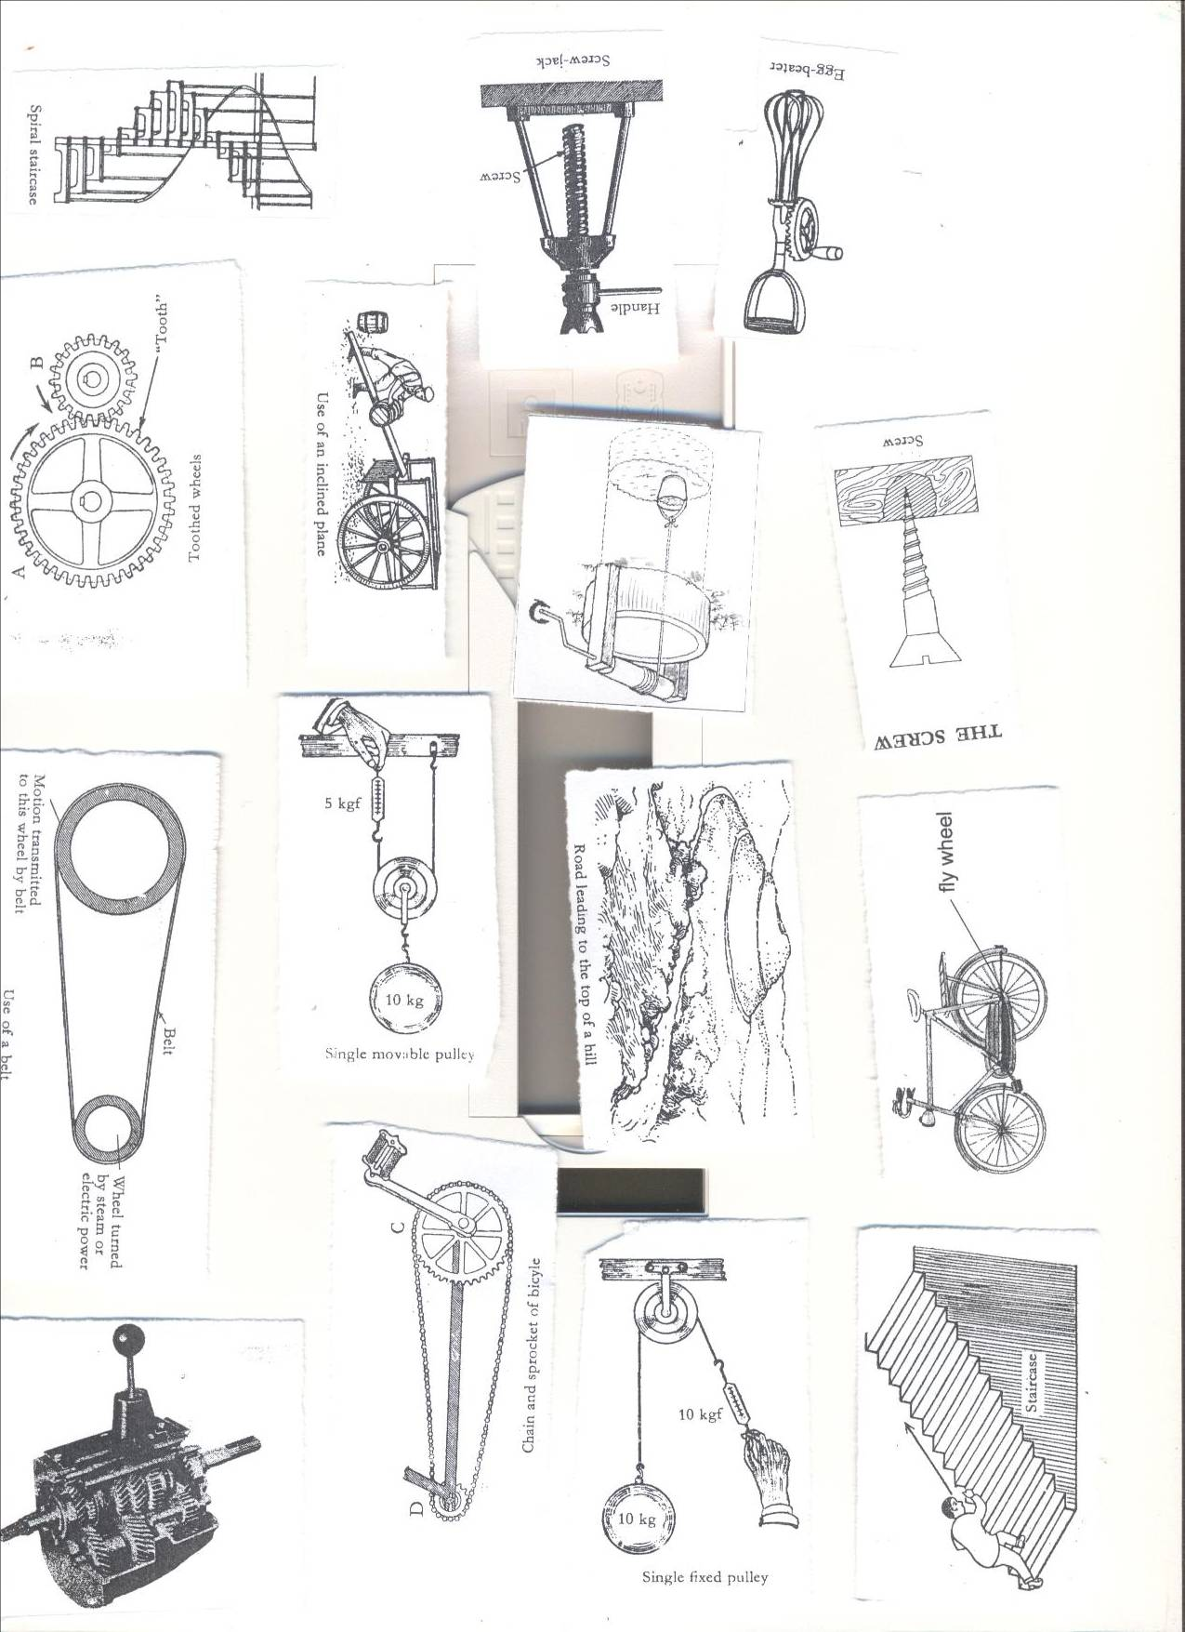

**Example;**  
If a load of 30kgf is to be raised using a single fixed pulley, find the effort needed  
M.A =1  
L=30kgf  
E=??  
M.A = load/Effort  
 1 = 30/E  
E x 1 = 30  
 E = 30kgf.  
**LESSON SIX**

**SINGLE MOVABLE PULLEY**  
It is supported on two ropes.  
The rope is pulled up wards.  
The pulley moves with the load.  
Each of the ropes share a half of the effort needed.  
The rope moves twice as far as the load.  
The M.A advantage of single movable pulley is 2 (two)

Effort applied is half the load force. (It reduces the effort needed)

  
**Example**. If a load of 30kgf is to be raised using a single movable pulley, Find the effort needed.  
M.A = 2  
L = 30kgf  
E =??  
M.A = L/E  
 2 = 30/E  
2 x E = 30  
 2E = 30  
 2 2  
 E =15kgf.

**DIFFERENCES BETWEEN FIXED AND MOVABLE PULLEY**

|  |  |
| --- | --- |
| **Fixed pulley** | **Movable pulley** |
| Work is done faster | Work is slower |
| Change direction of force | No change of in direction of force |
| Force used is equal to the load. | Effort applied is half the load force. |

**WEEK SEVEN LESSON SEVEN**

**BLOCK AND TACKLE SYSTEM.**   
It does work more easily because it is a combination of both fixed and movable pulleys.  
It changes direction of force.  
It reduces effort needed.  
The ratio of load to Effort is determined by the number of pulleys.

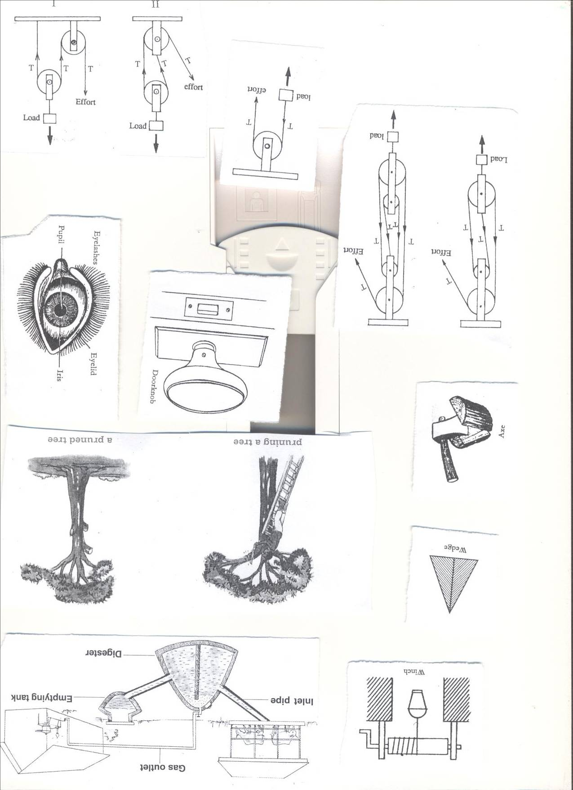 

**GEARWHEELS/COG WHEELS OR TOOTHED WHEELS**  
A gearwheel is a special form of the wheel  
It has teeth around its edge.  
These teeth interlock with the teeth of another gear wheel.  
When one turns it causes the other one to turn.

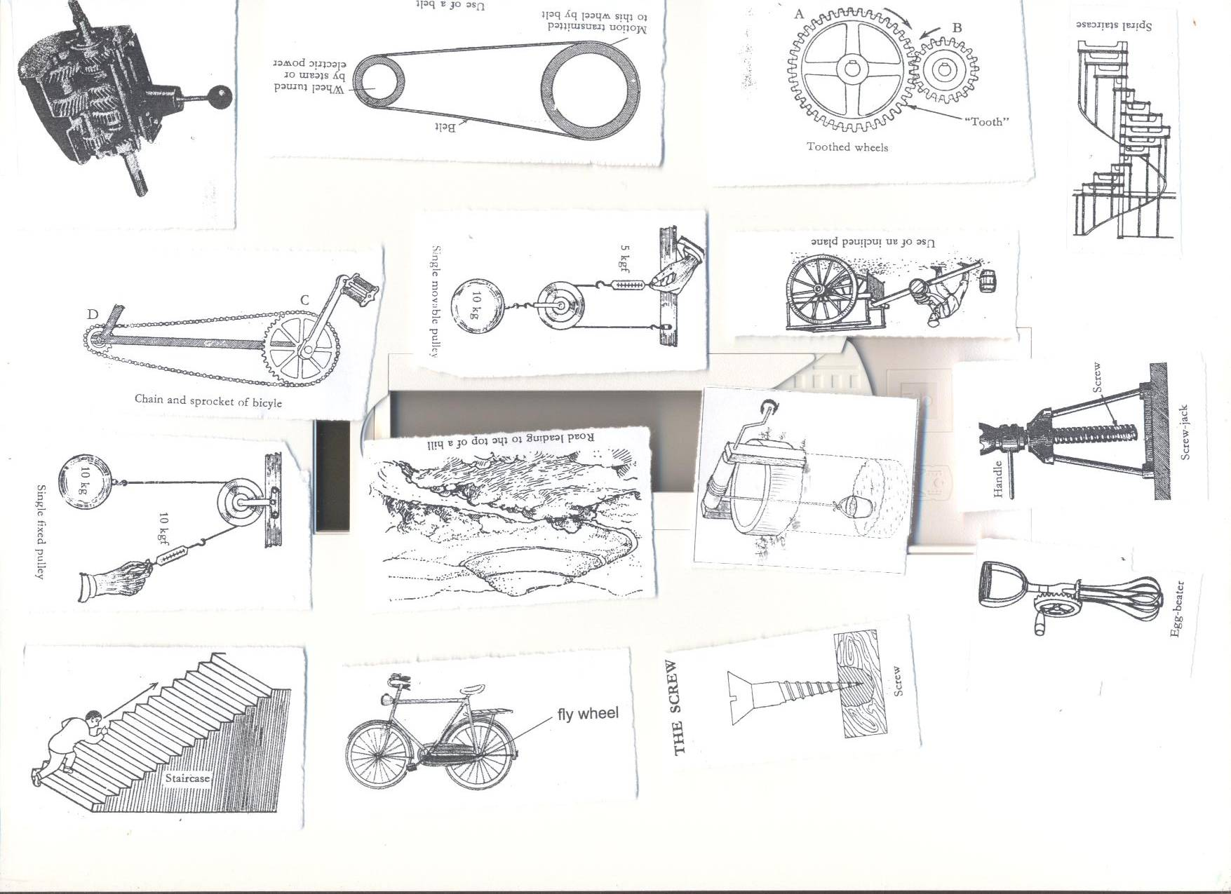  
If A has 30teeth and B has 15 teeth, how many rotations does B make in one revolution?  
30divided by 15  
=2 turns.

Questions.

1. Give any two types of pulleys.
2. How are pulleys important at school?
3. Calculate the Mechanical Advantage of a machine that needs an effort of 20kg to over come a load of 60 kg.
4. State one difference between a single fixed pulley and a single movable pulley.
5. Cite any two importance of the rope on a pulley.

**WEEK SEVEN LESSON 8 AND 9**

**Topic 5: EXCRETORY SYSTEM**

**VOCABULARY**

* **Excretion Ureter**
* **Urinary system Wastes**

**Excretory system that collects waste products in the body cells and removes them from the body.**

**Importance of the excretion.**

* Maintains homeostasis by keeping the body’s internal environment stable and free from dangerous substances.

**EXCRETION:**

It is the process by which harmful materials are removed from the body.

The removal of harmful substances from the body.

**EXCRETORY PRODUCTS FROM THE BODY.**

|  |  |
| --- | --- |
| **Excretory organ** | **Excretory products** |
| Lungs | Carbon dioxide ,water |
| Kidneys | Uric acid, excess water ,salts, urea |
| Skin | Water, salt |
| Liver | Bile pigments |

Note: **Urea, inactive hormones, excess salts and water** are waste products in **Urine.**

**Water** and **salts** are waste products in **sweat**

**WEEK EIGHT: LESSON ONE AND TWO.**

**THE HUMAN SKIN**

It is the largest organ of the body.  
It covers most part of the body.  
It is a sense for feeling  
The skin removes sweat from the body.  
Through sweating, the body cools down.

**STRUCTURE OF THE SKIN.**

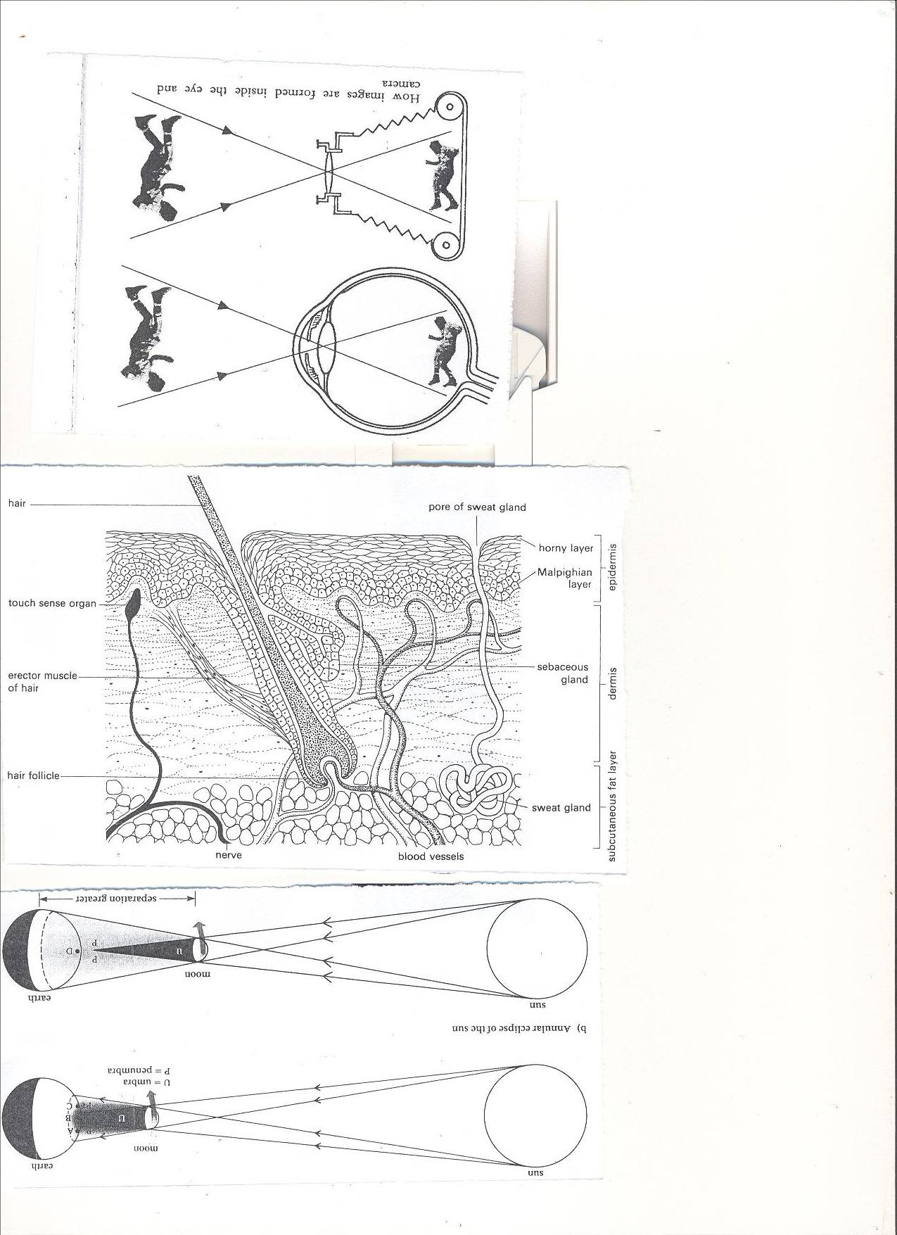

**The skin consists of two main layers.**

* Epidermis.
* Dermis layer.  
  **Epidermis.**  
  - It is the outer layer.  
  **The layers that make up the epidermis**.  
  a) Cornified layer.  
  b) Granular layer  
  c) Malpighian layer.  
  **Cornified layer**  
  It is the tough outer most layer with dead cells.
* It prevents bacteria/germ invasion to the skin.
* It provides resistance to damage.
* It reduces excessive loss of water by evaporation.  
  **Granular layer**  
  It contains living cells and produces new cells which die continuously to form the cornified layer.  
  **Malpighian layer.**  
  It is made up of young cells.  
  It contains melanin that determines skin colour and hair colour.  
  Melanin also protects the skin against strong radiation from the sun.
* NB: When you lack melanin, you become an albino
* On the finger nails are cells called keratin that helps to produce toes and finger nails.

**Dermis.**  
It is the inner layer of the skin.  
**Parts of the dermis.**

Capillaries, Sweat glands, Hair follicle, Sebaceous glands, Sweat duct, Pore,

* Erector muscles, Nerves, Subcutaneous fat .  
  **Uses of some parts of the skin.**
* **Hair**: For keeping the body warm.
* **Sweat glands**: They produce and store sweat  
   Absorbs sweat from blood.
* **Pore**: It lets sweat out of the body.
* **Capillaries**: Transport food and oxygen to all parts of the skin.
* **Sebaceous glands**: Produce an oily substance called sebum.  
   Sebum protects, lubricates and water proofs the skin, helps repel water, damaging chemicals and microorganisms.
* **Erector muscle**: It keeps the hair standing.
* **Nerves:** Conduct sensations of pain and touch.
* **Subcutaneous fat:** It contains fat cells where fat is stored.

**Function of human skin.**

* Excretes salts, water and urea (sweat).
* Stores fat for keeping the body warm.
* Prevents the entry of germs in the body.
* It regulates the temperature of the body.
* It is a sense organ for feeling.
* It water proofs the body.
* It helps in making vitamin D
* Protects the body from mechanical injury.

**How does the body regulate body temperature?**

**When it is hot, the skin regulates the body temperature through:**

* Sweating.
* Vasodilation- widening of arterioles to allow blood flow to the skin surface.

**When it is too cold, it regulates the temperature by:**

* Shivering
* Vasoconstriction- arterioles become narrow to reduce the flow of blood to the skin surface.
* Furry mammals and birds fluff out fur of feathers to improve insulation and reduce heat loss from the body.
* Production of goose pimples in man.

**LESSON THREE AND FOUR**

**Diseases of the human skin.**

* Scabies- caused by itch mites.
* Athlete’s foot- caused by fungus.
* Dhobi itch- caused by fungus
* Leprosy- Caused by bacteria.
* Impetigo- Caused by bacteria
* Boils- Caused by bacteria.
* Skin cancer- using strong chemicals on the skin.
* Chicken pox- caused by a virus.
* German measles- Caused by a virus.
* Scurvy- Lack of vitamin c

**Disorders of the human skin.**

* Albinism: Lack of colour in the skin.
* Burns.
* Scalds
* Cuts  
  **Care of the human skin.**
* Wash the body with clean warm water and soap.
* Smear the body with Vaseline to make it soft.
* Avoid sharing clothes towels, basins and sponges.
* Wash and iron clothes before wearing them.
* Eating foods rich in a balanced diet.
* Avoid playing with sharp cutting materials.
* Do regular physical exercises.

**KIDNEYS**

* They remove nitrogenous compounds from the body.
* Regulate the amount of water and salt in the body.
* They belong to the excretory and urinary systems.

**LESSON FIVE AND SIX**

**Structure of the kidney**





**FUNCTIONS OF THE PARTS OF THE KIDNEY.**

* **Kidney wall**: It protects the internal parts of the kidney.
* **Cortex**: For filtration of blood.
* **Medulla**: Re absorption of water, salt and other substances.

The process of re absorption of water from urine is known **as osmoregulation.**

* **Pyramid:** A hole through which urine from the cortex pours into pelvis.
* **Pelvis**: receives urine from the cortex before it goes down to the urinary bladder.
* **Ureter**: It is a passage of urine from pelvis to the urinary bladder.
* **Renal artery**: It carries oxygenated blood from the aorta to the kidney.
* **Renal Vein:** It carries deoxygenated blood from the kidney to the vena cava.
* **Kidney**- It filters blood to remove urine// regulate amount of salt and water.
* **Urethra**-It is a tube through which urine is passed out of the body.
* **Sphincter muscle**-They control the flow of urine out of the urinary bladder.
* **Urinary bladder**-It stores urine before it is passed out of the body.

**Functions of the kidney.**

* Filters blood
* Regulates the level of water, sugars and salts in the body.

**Good habits for the kidney**

* Doing daily physical exercises.
* Avoid holding back urine for a long time.
* Go for medical examination in case of long time back pains
* Drink boiled water.  
  **Why do we urinate frequently on a cold day than a hot day**?  
  On a hot day, you sweat a lot, therefore there is less work of kidneys  
  On a cold day, there is less or no sweating as the pores are half or fully closed.  
  So, the kidneys take over the work of removing excess water from the body.  
  **Why do you pass out of urine when you drink a lot fluids?**  
  Kidneys keep a constant amount of water in the blood.

**Why is the left kidney located slightly higher than the right kidney?**

* The right kidney is found under the liver which is the largest internal organ than the left kidney which is under the spleen.

**DISEASES OF THE KIDNEY AND THE URINARY SYSTEM.**

* Kidney stones.
* Kidney failure
* Bilharzia.
* Nephritis: this is an inflammation of the kidne**y**

**THE LUNGS AS EXCRETORY ORGANS.**

* The Lungs remove carbon dioxide and water from the body.
* Lungs are both **excretory and respiratory organs.**
* As air goes through the nose it is warmed, moistened and cleaned. (filtered)
* When we breathe through the mouth we take in cold air which may affect our lungs.
* Gaseous exchange takes place in the alveoli.

**DISEASES OF LUNGS.**

* Diphtheria, Lung cancer, Asthma, Pneumonia, Bronchitis, Tuberculosis Whooping cough
* Haemophilius influenza, Laryngitis, Emphysema, Pleurisy

**DISORDERS OF THE LUNGS.**

* Choking
* Hiccups
* Yawning

**LESSON 8 AND 9**

**LIVER**  
It is the largest internal body organ.  
**Function of the liver.**

* Regulation of blood sugars.
* Produces bile salts which aid absorption of fats.
* Stores iron.
* It reduces on excess amino acids in the body (deamination)
* Manufacture of plasma proteins.
* It burns fats to forms glucose and release energy.
* It converts poisonous compound into harmful substances (Detoxication)
* It stores vitamin A, D and B12
* It produces heat.

**Circulation to and from the liver.**

* **Hepatic artery**: It supplies oxygenated blood to the liver.
* **Hepatic portal vein**: It supplies blood with digested food from the stomach and intestines to the liver.
* **Hepatic vein**: Caries deoxygenated blood from the liver to the venacava.

**Diseases of the liver.**

* **Hepatitis:** Caused by a virus spread by contaminated water.
* **Cirrhosis:** Hardening of liver tissue as a result of alcoholism.

**Abscesses** There are pus filled sacs on the liver.

Questions.

1. How are the following important in our bodies:
2. Kidneys c) liver
3. Lungs
4. **State any two excretory organs.**
5. **Write down any one waste material from the body.**
6. **Why is it important to keep our bodies clean?**
7. **State any one disorder of the following:**
8. **Skin b) kidneys.**
9. **State any two ways of keeping the following in good working conditions**
10. **Skin b) lungs c) liver**
11. **Why is the skin called an excretory organ?**
12. **Write down any two diseases of the following:**
13. **Skin b) lungs**

**TERM TWO 2013**

**WEEK TWO: Lesson one and two**

**Topic 6: Light Energy**

**VOCABULARY**

* **Beams Translucent**
* **Opaque Shadows**
* **Eclipse Solar**
* **Lunar Periscope**
* **Optical**
* **Spectrum Prism**

**LIGHT**

Light is a form of energy that enables us to see.  
**NB:** We see things around us because light **from them** is reflected into **our eyes.**

**Light as a form of energy.**

Light is a form of energy because it is capable of doing work.  
**Importance of light in the environment.**

* Sunlight enables plants to make their own food.
* It enables us and other animals to see
* Our skins are able to make vitamin D.
* It is used for photography.
* We use artificial light on the streets to control traffic

**SOURCES OF LIGHT.**

1. **Natural sources of light.**
2. **Artificial sources of light.**

**Natural sources of light**  
These are sources of light provided by nature.  
**Examples of natural sources of light include**

* Sun, Star, Erupting volcanoes, Lightning, Glow worms, Fireflies  
  **Nb**:- Of the above, some are very hot e.g. sun and stars, erupting volcanoes.   
   - Others are not hot at all e.g. fireflies, glow worms  
  **ii. Artificial sources of light**  
  These are sources which are made by people.  
  **Examples of artificial sources of light.**
* Solar lamps, Electric lamps, Fluorescent tubes, Electric tubes, Hurricane lamps, Fire  
  Objects that produce light are divided into two;  
  i**) Luminous objects**  
  ii) **Non luminous objects.**  
  **Luminous objects/ Direct sources.**  
  These are objects that produce their own light  
  Examples are sun, stars, erupting volcanoes, lamps, torches, hot charcoal etc  
  **Non luminous objects/ indirect sources.**  
  These are objects that reflect light from other sources of light.  
  Examples of non luminous are the moon, the planets, and mirrors.

**The speed of light**  
The speed of light in normal air is 300000km/sec.

Light travels faster in materials less dense than air e.g. warm and slowly in materials that are denser than air e.g. glass, water.

* **TOPICAL QUESTIONS**

1. State any two sources of light.
2. How is the sun useful to human beings?
3. Cite any two examples of non luminous objects.

LESSON THREE  
**Propagation/properties of light**.  
1.Light travels in a straight line

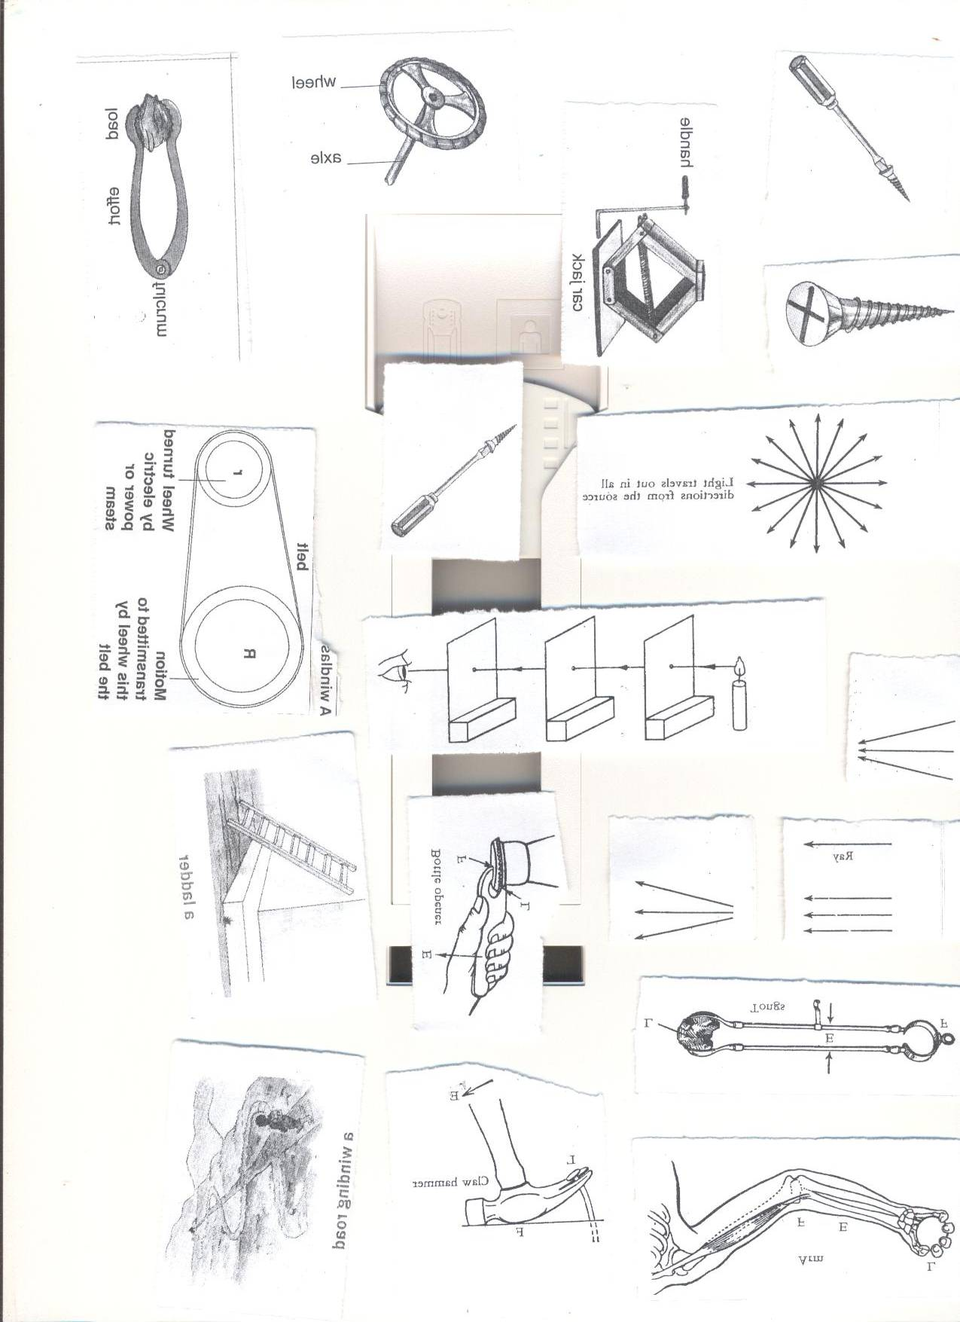

2.Light travels from a source in all directions.

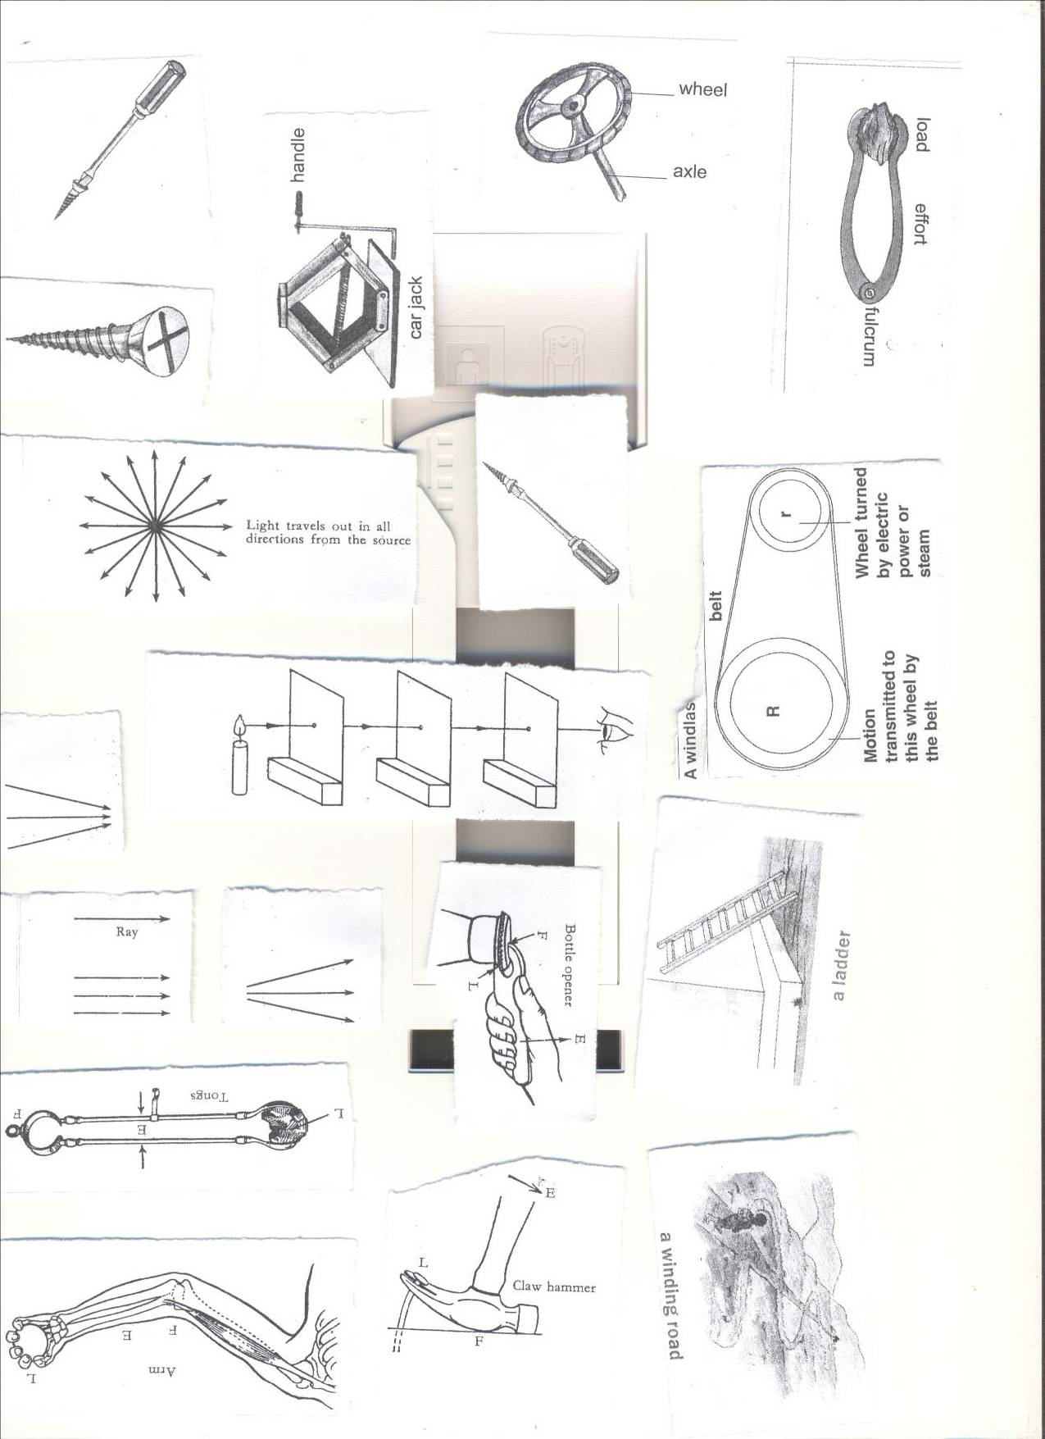

**RAYS**  
A ray is a path taken by light.



**BEAMS OF LIGHT**

A beam is a group of light rays traveling in the same direction.  
**Types of beams**  
i. Parallel beam

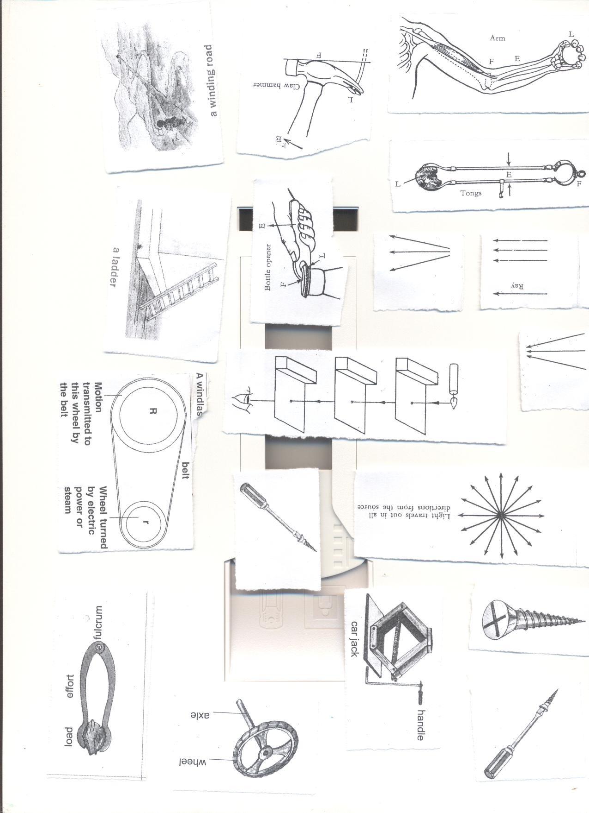

ii. Divergent beam

  
iii. Convergent beam



**EFFECTS OF DIFFERENT MATERIALS ON LIGHT.**

* **Transparent objects**  
  These are materials that allow all light to pass through them  
  **Examples of transparent materials**  
  1. Clear glass  
  ii. Clear still water.  
  iii. Air.
* **Translucent materials**  
  These are objects which allow little light to pass through them.  
  We can’t see through translucent objects because they scatter light passing through them.  
  **Examples of translucent materials.**

1.Frosted glass  
ii. Ground glass.  
iii. Coloured glass.  
iv. Oiled paper.  
v. Smoky air.  
vi. Thin cloth.  
vii. Tracing paper.  
**Effects of translucent objects on light**.  
They allow little light to pass through them.  
They diffuses the light

* **Opaque objects**  
  An opaque object is that which does not allow any light ray to go through it.  
  **Examples of opaque objects**  
  1. A wall.  
  2. A hard paper.  
  3. Wood.  
  4. Stones.  
  5. Human Body  
  6. Metals.  
  **Effects of opaque objects in light**  
  They obstruct light and form shadows.
* **TOPICAL QUESTIONS**

1. State any two sources of light.
2. How is the sun useful to human beings?
3. Suggest any two types of lenses.
4. Why is it important to keep our body organs used for seeing clean?

**LESSON FOUR AND FIVE**

**SHADOWS**

A shadow is a region of darkness caused by obstruction of light.  
**Formation of a shadow**  
a) **Shadow formed from a point of source of light.**  
A total shadow is formed.

b) **A shadow formed from a source of light bigger than a point.**  
Each point on the source produces its own shadow  
All these shadows overlap to give a single shadow.  
This single shadow has a darker inner portion and less dark outer portion  
**Parts of a shadow**  
i. **Umbra**- It is the darker part of a shadow.  
 It is formed by total obstruction of light  
ii. **Penumbra**- It is the lighter part of a shadow.  
 Penumbra is formed by partial obstruction of light.

**ECLIPSE**

Is a total/ partial blocking of sunlight when the earth/moon is between the other bodies. The sun, the moon and the earth are the bodies commonly involved in the eclipse.  
**Types of eclipse**  
**i. Solar eclipse**  
This is the eclipse of the sun.  
It occurs when the moon comes between the sun and the earth (SME)

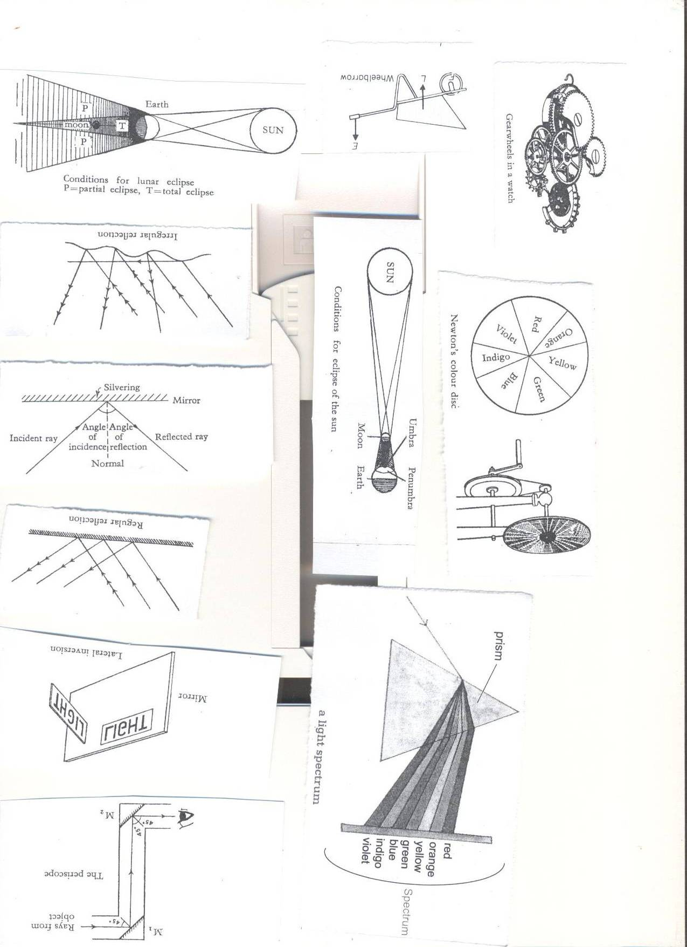

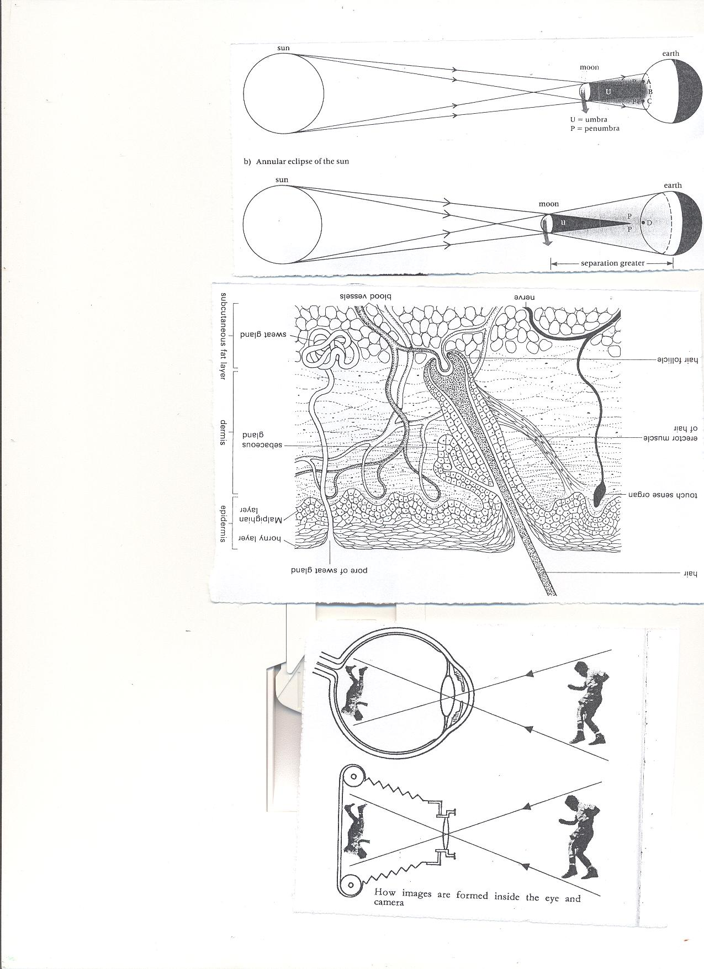**ii. Lunar eclipse**  
This is the eclipse of the moon  
It occurs when the earth comes between the moon and the sun (MES/SEM).

1. Write down the two types of eclipse
2. How is a lunar eclipse formed?
3. How are shadows important in our daily life?

**LESSON SIX AND SEVEN**

**REFLECTION**   
Is the bouncing back of light.

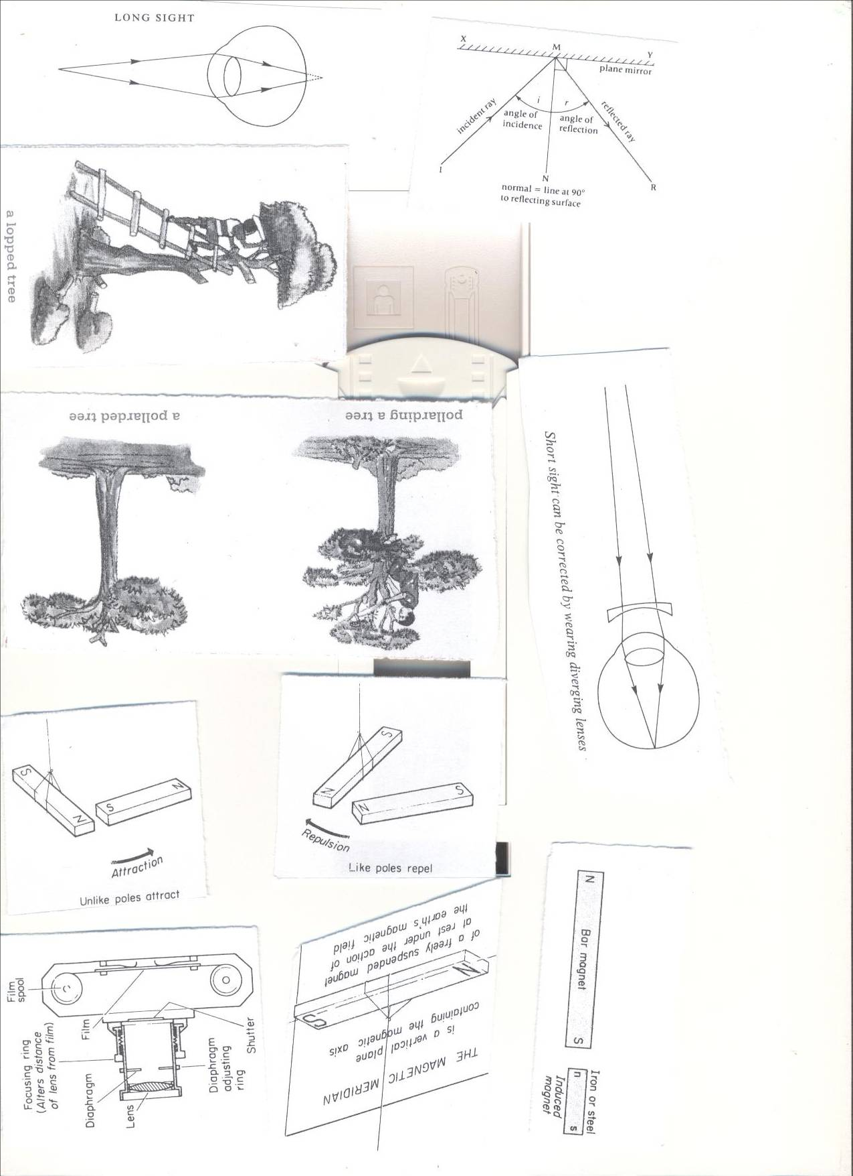

* The ray that hits the surface is **incident ray.**
* The ray that bounces off the surface is **reflected ray.**
* **The normal** is perpendicular between the incident ray and reflected ray.
* The angle between the normal and the incident ray is **angle of incidence.**
* The angle between the normal and the reflected ray is **angle of reflection.**  
  **Types of reflection.**
* Regular reflection.
* Irregular reflection/Diffuse reflection.  
  **REGULAR REFLECTION**.  
  It occurs on shiny smooth surfaces.  
  The reflections are regular.  
  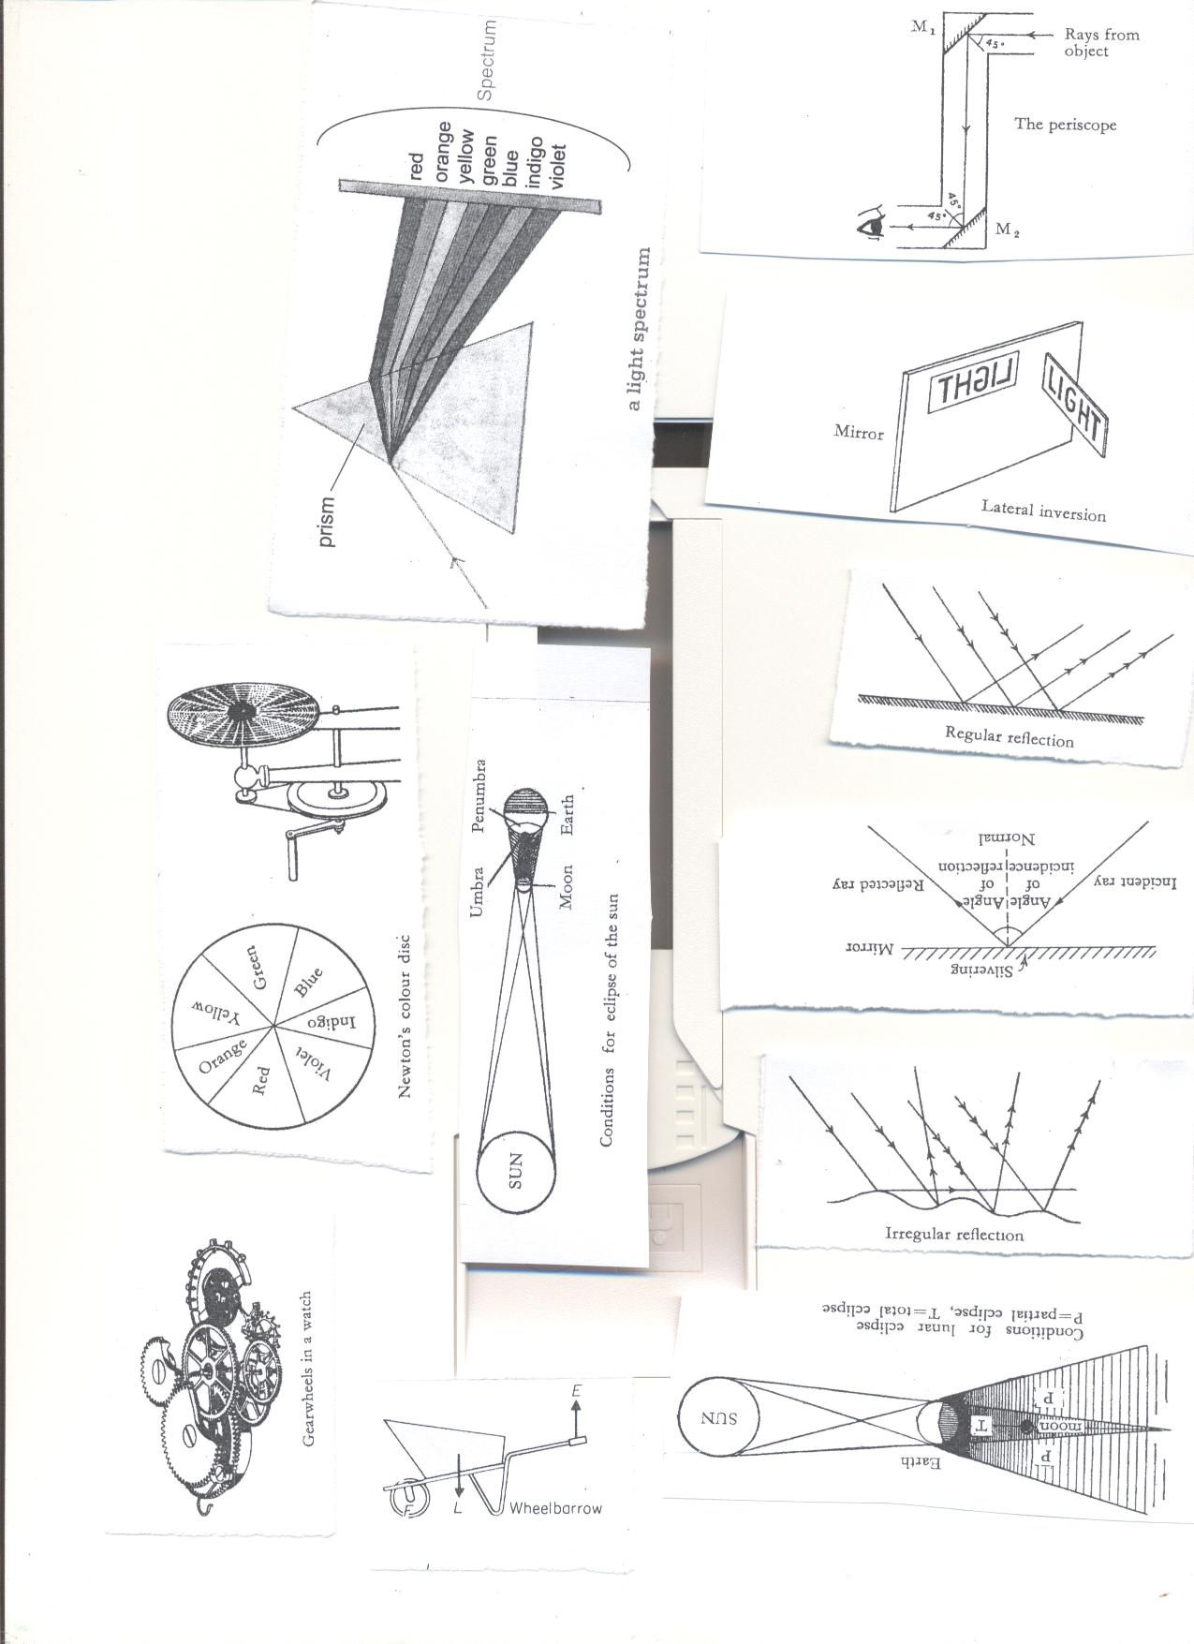

**IRREGULAR/DIFFUSE REFLECTION**  
It occurs in shiny rough surfaces   
The reflections are irregular



NORMAL REFLECTION

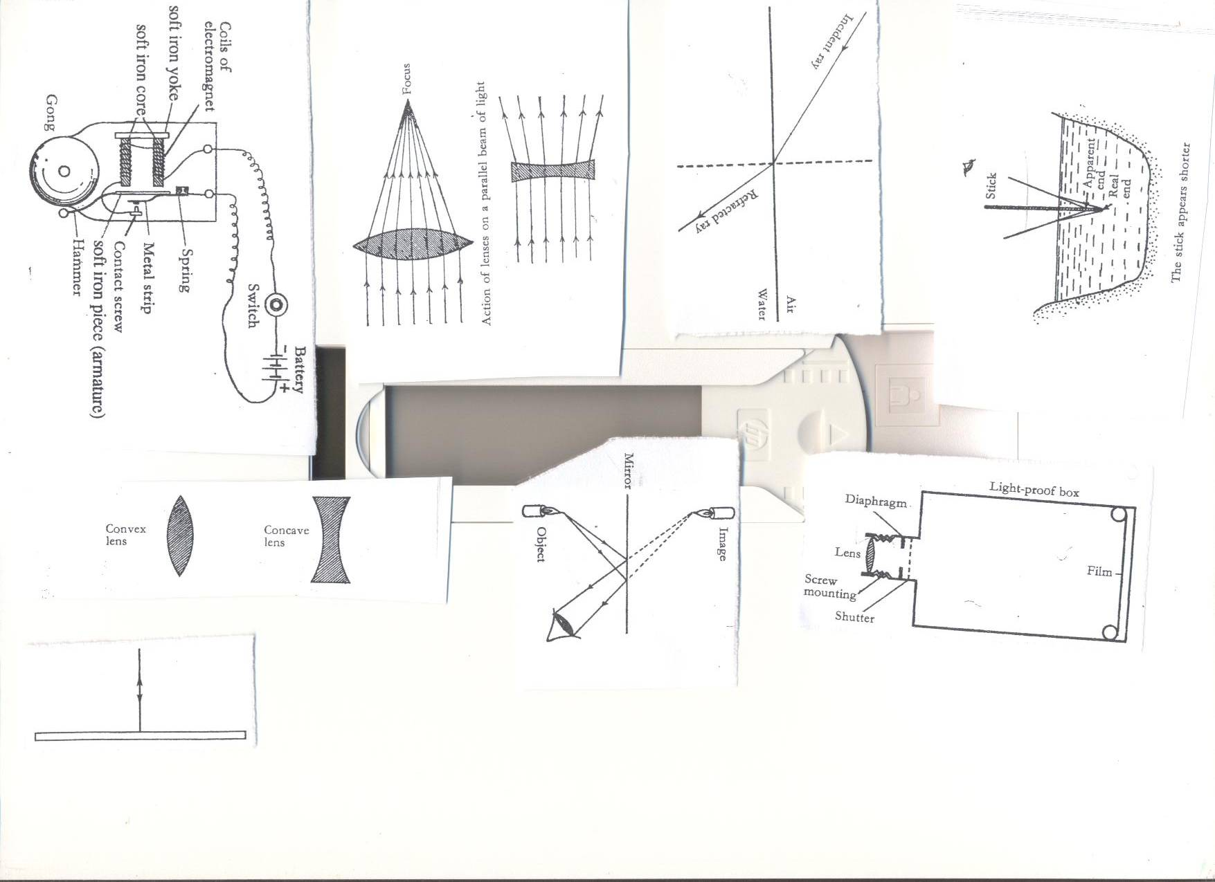

**The laws of reflection.**

* The incident ray, the reflected ray and the normal all lie in the same plane.
* The angle of incidence is equal to the angle of reflection.
* The ray travelling along the normal is reflected back along itself.
* An object appears a certain color because it reflects that color and absorbs the other colors.

**questions**

1. How can we keep our eyes clean?
2. Why is it important to use clean water when cleaning our eyes?
3. **Draw a diagram showing the effect on translucent objects on light.**

**LESSON 8 AND 9**

* **REFLECTION AND LIGHT**
* Light coloured objects reflect more light than the dull ones.
* White light contains all the three primary colours of light.
* A white object absorbs no colour but reflects all.
* A black object absorbs all the primary colors and reflects none.
* An object which absorbs all the primary colors appears black.
* Black light means absence of any color.

**When light falls on an object, the following can happen to it.**

* It is reflected either regularly or irregularly.
* It can pass through a body totally or partially.
* It is either refracted or diffused.
* It can be absorbed either partially or completely.  
  **The table shows why certain colours appear the way they appear**

|  |  |  |  |
| --- | --- | --- | --- |
| **colour** | **Absorbs** | **Reflects** | **Appears as** |
| Red object | Green, Blue | Red | Red |
| Blue object | Red, green | Blue | Blue |
| Green object | Red, blue | Green | Green |
| Black object | Red, Blue, Green(all) | None | Black. |
| White object | None | Red, Blue, Green(all) | White |

**Uses of reflection in our daily life.**

* People can watch football match over the heads of the crowd using a periscope.
* Soldiers can see enemies without exposing themselves to them using periscopes.
* Submariners can see ships on the surface of the sea using periscopes.
* Mirrors are used on vehicles to see traffic behind and avoid causing accidents.
* Torches, car headlamps have concave reflectors.
* Solar cookers use a concave mirror to focus sunlight on spot and use it for cooking.
* Some shaving mirrors are concave as they magnify the image.

Questions

1. **How does light move from one place to another?**
2. **Draw the following:**
3. **Diverging beam of light b) converging beam of light**
4. **State types of reflection**

**WEEK THREE**

**Lesson one**

**Simple optical instruments.**  
Optical instruments are instruments which use light for their functioning.  
Examples of simple optical instruments are **plane mirrors** and **lenses.**

**Plane mirrors**.

**Characteristics of images formed in a plane mirror.**

* They are erect/upright.
* They have the same size as the object.
* The image is laterally inverted. (the right appears to be left in the mirror).
* Image distance is equal to the object distance from the mirror
* The image is virtual. (not formed on the screen)



**Uses of plane mirrors**

* They are used in periscopes
* They are used as dressing mirrors.
* They are used by dentists.
* They are also used in saloons

**Lesson two**

**Curved Mirrors**  
These have their reflecting surfaces form a hollow sphere.  
**Types of curved mirrors**  
**Concave mirrors**: It is coated on the outside of the spherical surface.

* They are used as reflectors in head light of cars and torches.
* Used by dentists.
* They are used in solar cookers to focus light on one spot.
* Used as shaving mirror



**CHARACTERISTICS OF IMAGES IN CONCAVE MIRRORS.**

* They are real.
* They are upright.

**Convex mirror**: It is coated on the inside of the spherical surface.

* They are used as driving mirrors because they a clear view of the traffic behind.

Characretistics of images formed in convex mirrors.

* The images are upright
* The images are virtual.
* The images are smaller than the objects.

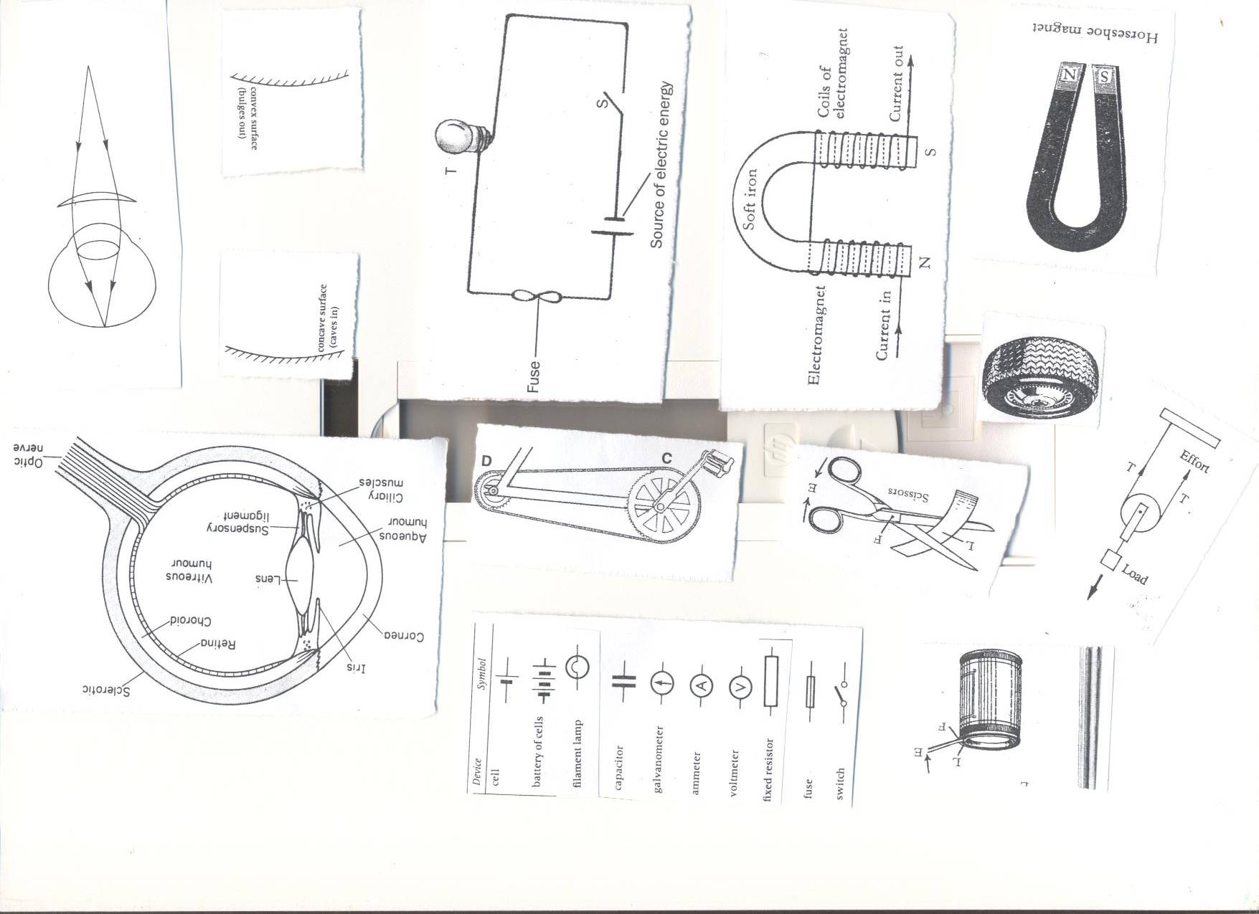

**Real and virtual images**  
Virtual images are not formed on screen.  
Virtual images are cast by plane mirrors, concave lens, and convex lens.

1. **How is reflection important to us?**
2. **How are periscopes useful to sub mariners?**
3. **State the way one can correct the following eye defects:**
4. **Myopia b) Hypermetropia.**

**Lesson three**

**Periscope**  
They are instruments used to see objects overhead.  
It is used by soldiers, sub mariners etc.  
A ray of light from the object strikes mirror one at 45 degrees and then turned through 90 degrees to strike mirror two until the object is seen by the observer.  
**Illustration of a periscope.**



**Pinhole camera**  
It works on the principle that light travels in a straight line.  


**Characteristics of images formed with a pin hole camera**

* The image is smaller than the object/diminished.
* The image is upside down./inverted
* The image formed is real.

**NB**:- If the distance between the object and camera is increased, the image becomes smaller and blurred.

* If the distance between the object and the camera is decreased, the image becomes larger and blighter.
* When the hole is too big, the image is blurred.

**Lesson 4 and 5**

**Refraction of light**  
Refraction means the bending of a light ray as it moves from one transparent medium to another.

**Principle/law of refraction.**

i.The incident ray, the refracted ray and the normal all lie on the same plane.  
ii.A ray of light travelling along the normal will not get refracted and will pass unchanged.

**Effects of refraction**   
i. Fish in water appears shallower than they are.

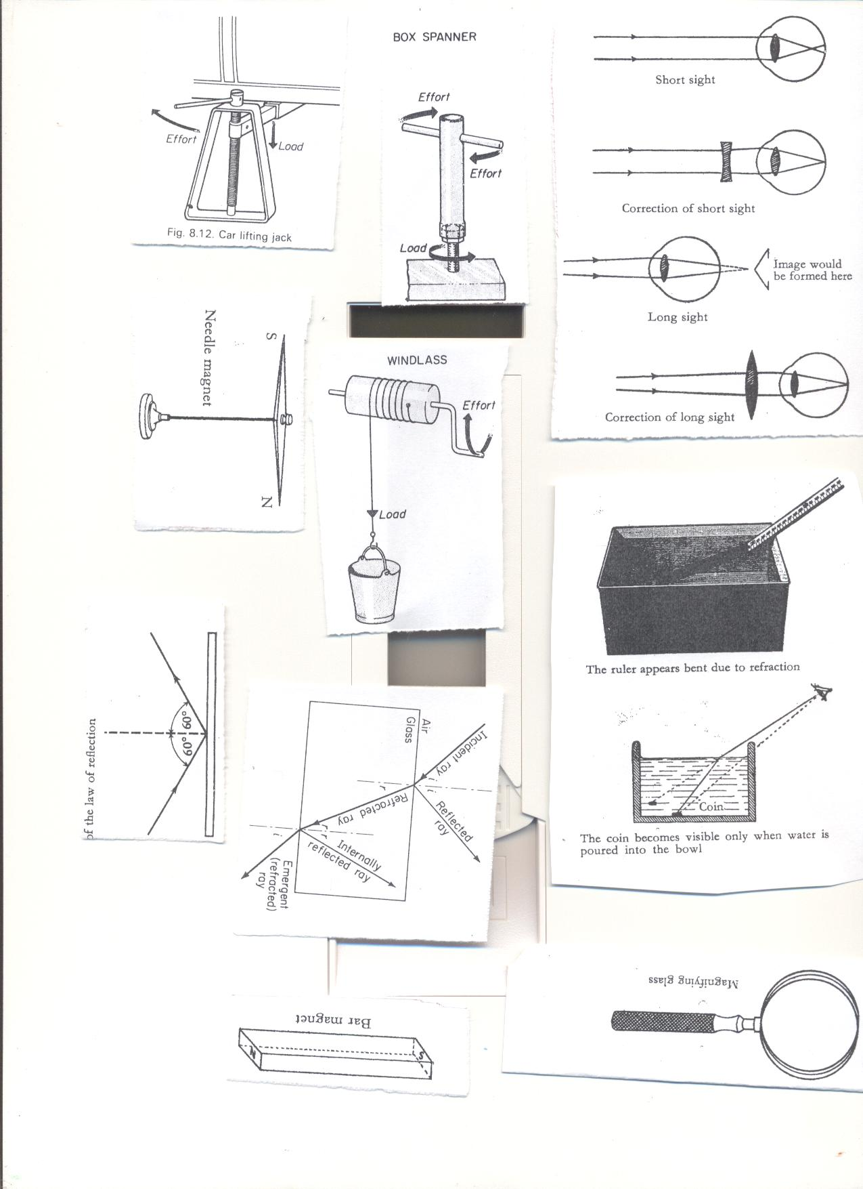  
ii. A pool appears shallower than it really is.  
iii. Refraction produces colors e.g. spectrum

IV. An object put in water appears bent.



**Prisms and Light spectrum.**  
**Spectrum**

Is a band of seven colours.  
**Dispersion of light.**

* Is the splitting of light into different colours.
* Dispersion is caused by refraction of light rays at different angles in glass prism.  
  **Dispersion/ Refraction of white light by glass prism**. (ROYGIBIV)
* Light rays in a glass prism bend at different angles because they move at a different speed.
* The fastest ray bends most (violet) and it has a short wave length.



* The slowest ray bends least.(red) and it has a long wave length.
* The order of the colours of the spectrum from top to bottom is Red, Orange, yellow, Green, Blue, Indigo, Violet.
* It can be memorized in the sentence Richard Okello Your Girl Benita Is Vomiting.

**Lesson 6 and 7**

**THE RAINBOW**

* It is a natural spectrum in the sky.
* It is formed when light rays from the sun pass through rain drops.
* The inner colour of the rainbow is violet.
* The outer colour of the rainbow is red.

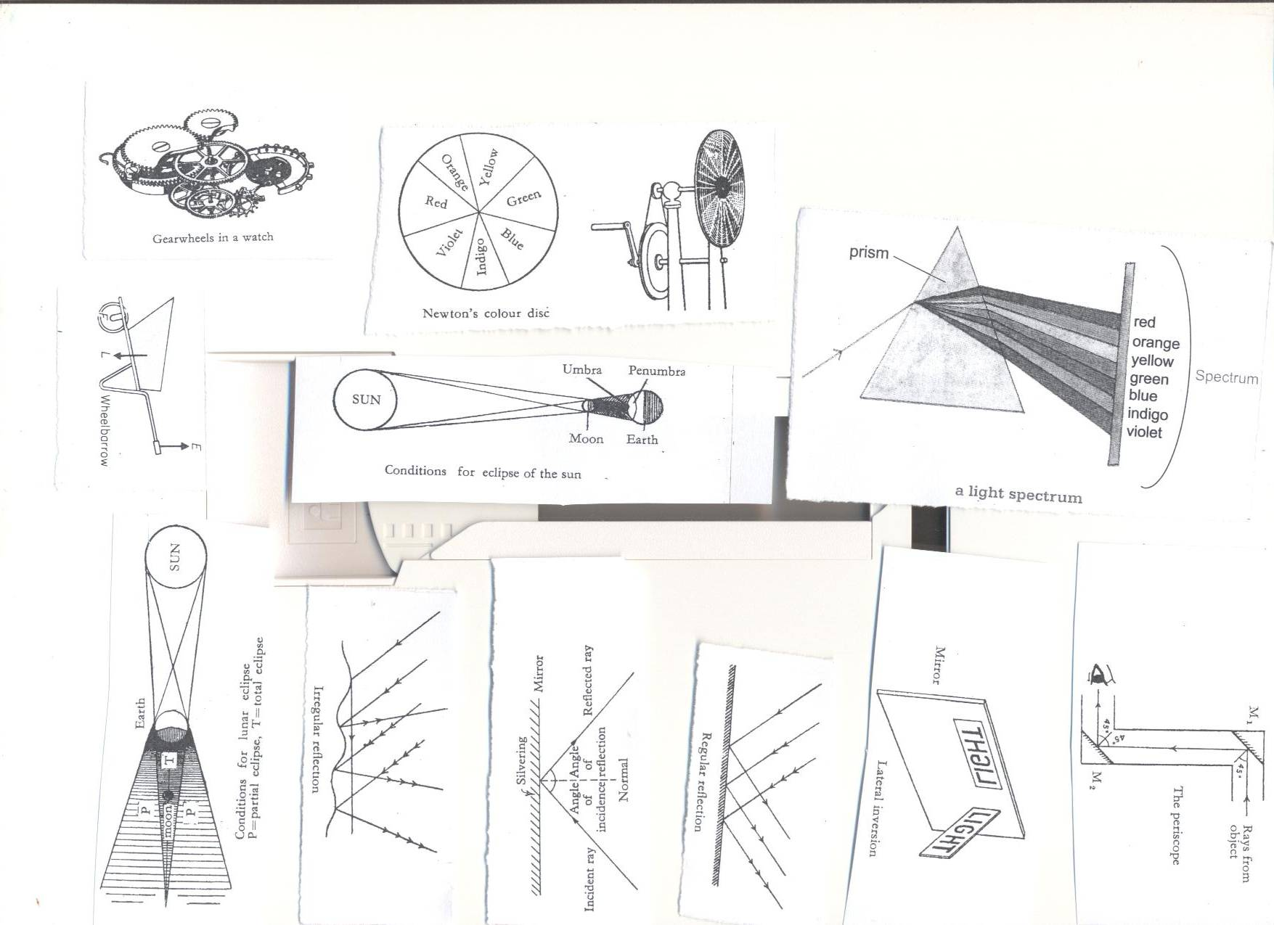

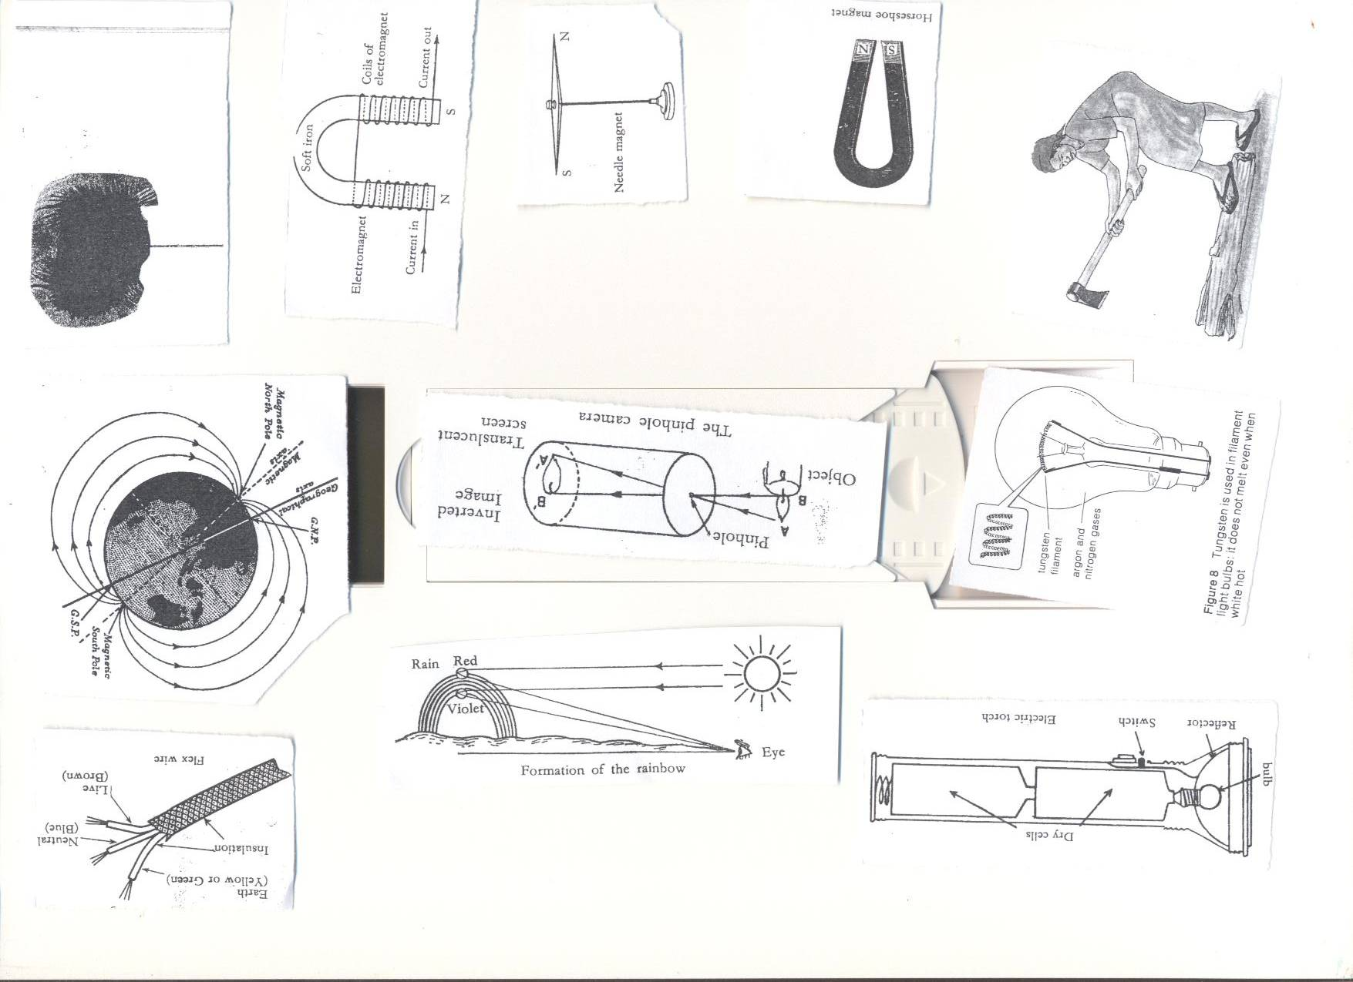

**Refraction through a rectangular glass prism.**

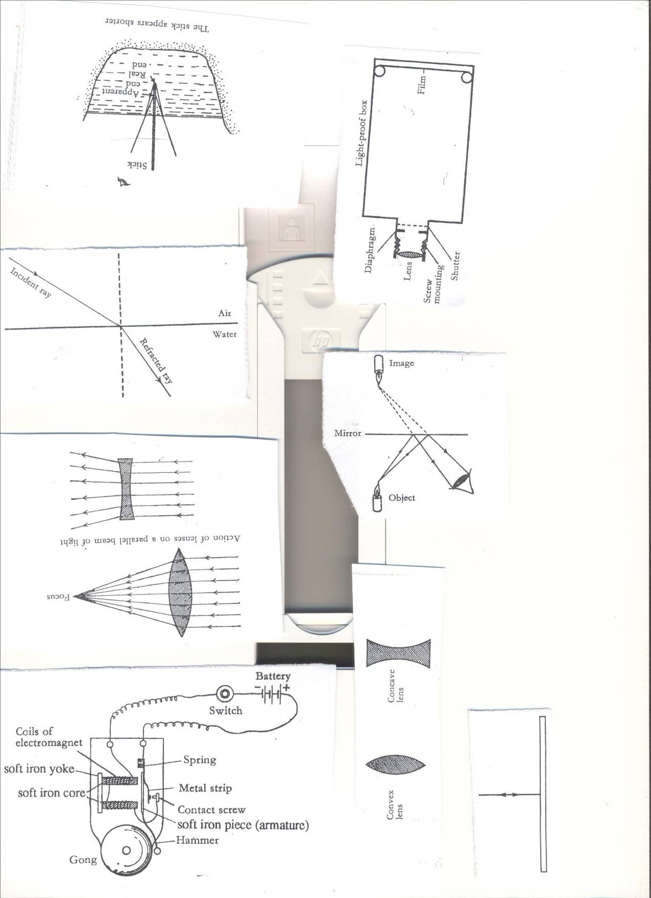

* **I** - Angle of incidence
* **R** - Angle of refraction
* Angle **i** is greater than angle **r.**

**Qn. What happens to the ray of light when it moves from one medium with fewer molecules to another one with more molecules?**-Its speed slows down.  
-It bends towards the normal

**Qn. What happens to the ray of light when it moves from one medium with molecules to another with fewer molecules?**-Its speed increases.  
-The light ray bends away from the normal.

**COLOURS OF LIGHT**  
TYPES OF COLOURS.

* Primary colours
* Secondary colours.
* Complementary colours.

**Primary colors** of light are the colours got without mixing any other colour.

**Examples of primary colours**.Red, Blue and Green

**Secondary colours** are the colours formed by mixing two primary colours.  
 Examples of secondary colours are Yellow, Magenta and cyan.  
 i.e. Red + Green = White  
 - Red + Blue = Magenta  
 - Blue + Green =Cyan

**Complementary colours**. Are the two colours of light which when mixed give white light  
Examples of complementary colours are  
Blue + Yellow = White  
Red + Cyan = White  
Green + Magenta = White  
Red + Green + Black = White light.

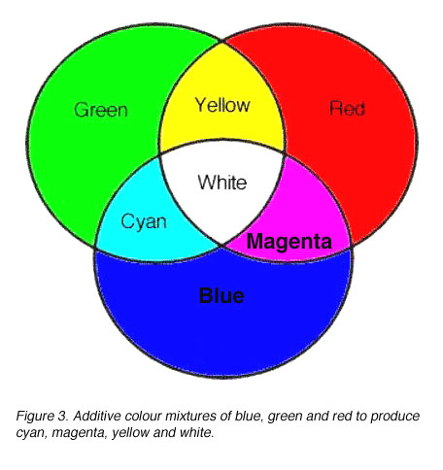

**Lesson 8 and 9**

**LENSES**

* Lenses are optical instruments used to focus or defocus.
* The surface of the lens may be convex, concave, plane or a combination of these.
* Lenses are used in materials like; cameras, microscopes, binoculars.  
  **Types of lenses**  
   **Convex (converging) lens**

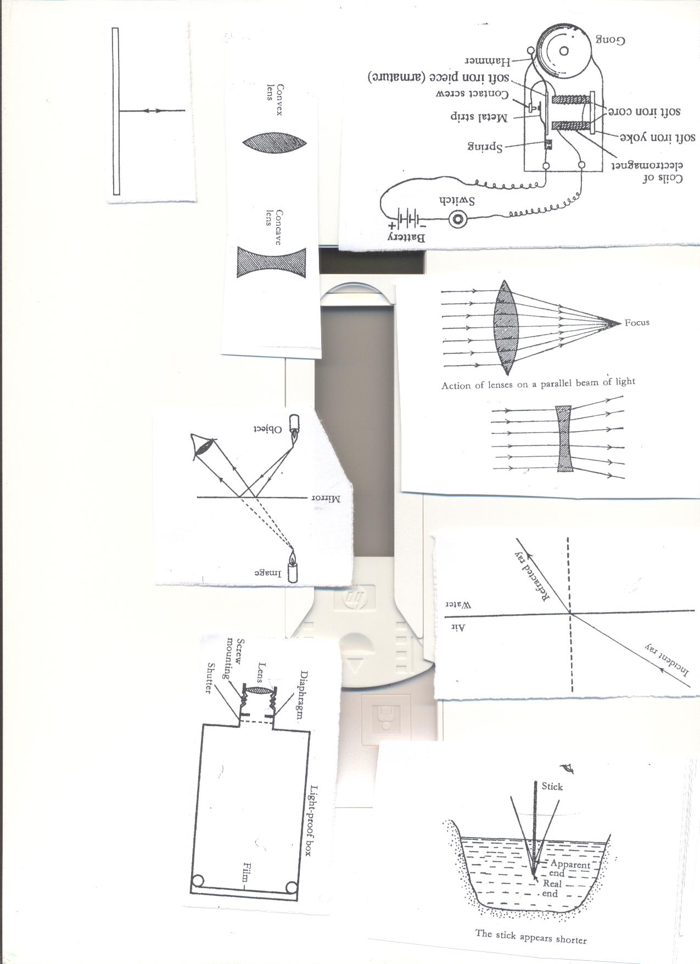

**Concave (diverging) lens.**



* **The effect of lenses on beams of light.**  
  **Convex (converging) lens.**It refracts light to meet at one point (focal point)

  
**Characteristics of images by convex lenses**

* It is inverted.
* It is magnified.
* It is real
* It is formed in infinity.

**Concave (diverging) Lens**  
It refracts light and spread it out in different directions.



* **Characteristics of images formed by concave lens.**
* Are erect/upright
* Are virtual.
* Image is diminished/reduced in size.  
  **Uses of lenses**
* Lenses are used in optical instruments like telescopes, camera, and microscopes etc
* Lenses are used in spectacles.
* Lenses are used in magnifying glasses.

**The magnifying glass**



**WEEK 4**

**Lesson one and two**

**The lens camera**

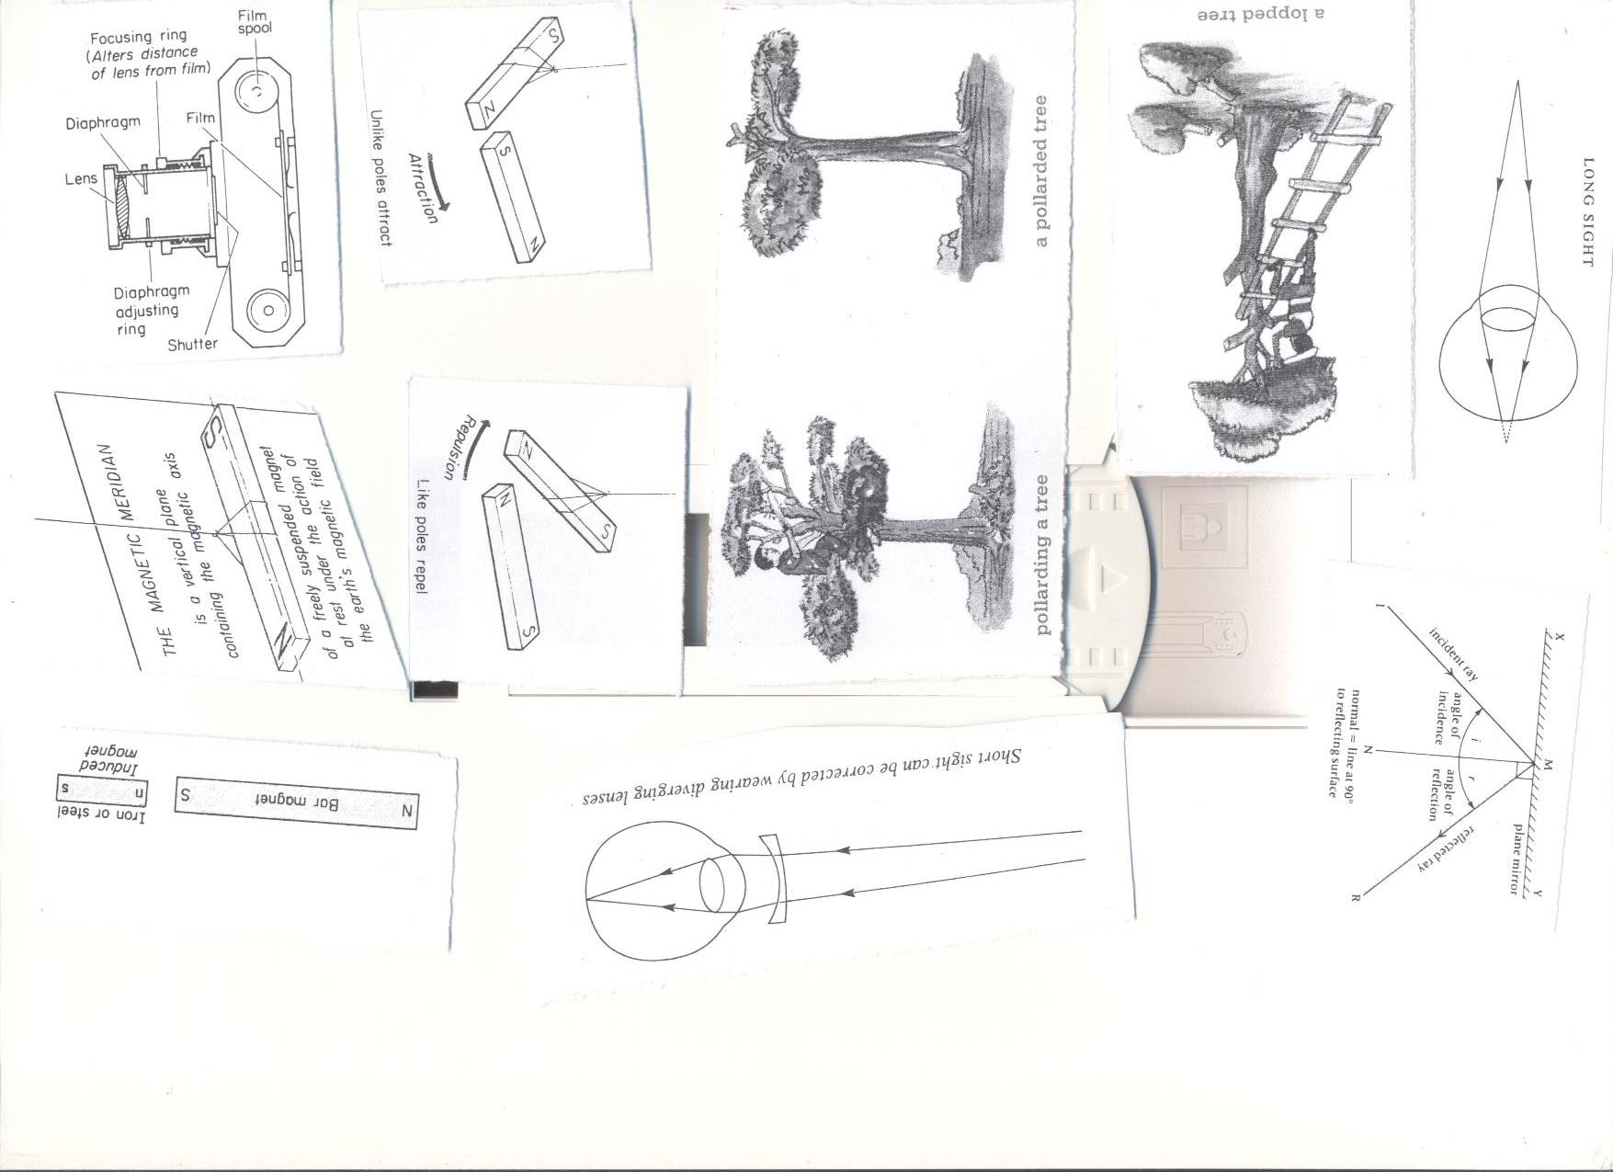

**Parts of the camera and their functions.**

* **Lens**: It focuses light to the film.
* **Film:** The image is formed there.
* **Diaphragm**: Controls the amount of light entering the camera.
* **Shutter**: It uncovers the diaphragm to allow light into the camera.  
   It blocks light entering the camera.
* **Bellows (screw mounting):** Adjusts the distance of the lens from te film to obtain the sharp image.

When the film is developed in a chemical a **negative** is got.  
On the negative the **bright** part appears **dark** and vice versa.  
That is the reason why it is called **negative**.

* **Aperture:** It allows light into the camera.

**Characteristics of images formed by the lens camera**

* They are real (they are formed on the film.)
* They are smaller than the object.
* They are inverted

**Telescope:**  
It is used to look at distant objects.

**Microscope:**  
It is used to look at very small objects e.g. bacteria, amoeba, cells etc.  
**Spectacles**  
**Projectors.**  
It casts images from films and slides to the screen.  
It consists of a source of light, a concave reflector and a condenser.  
The condenser focuses the rays through the film or side.

**Epivisors.**

**Lesson three and four**

**The human eye**

The eye is the sense organ for sight.  
The complete eye is called the **eyeball**.  
The eye ball is protected by the socket of the skull.

**A structure of a mammalian eye**

**Front view**

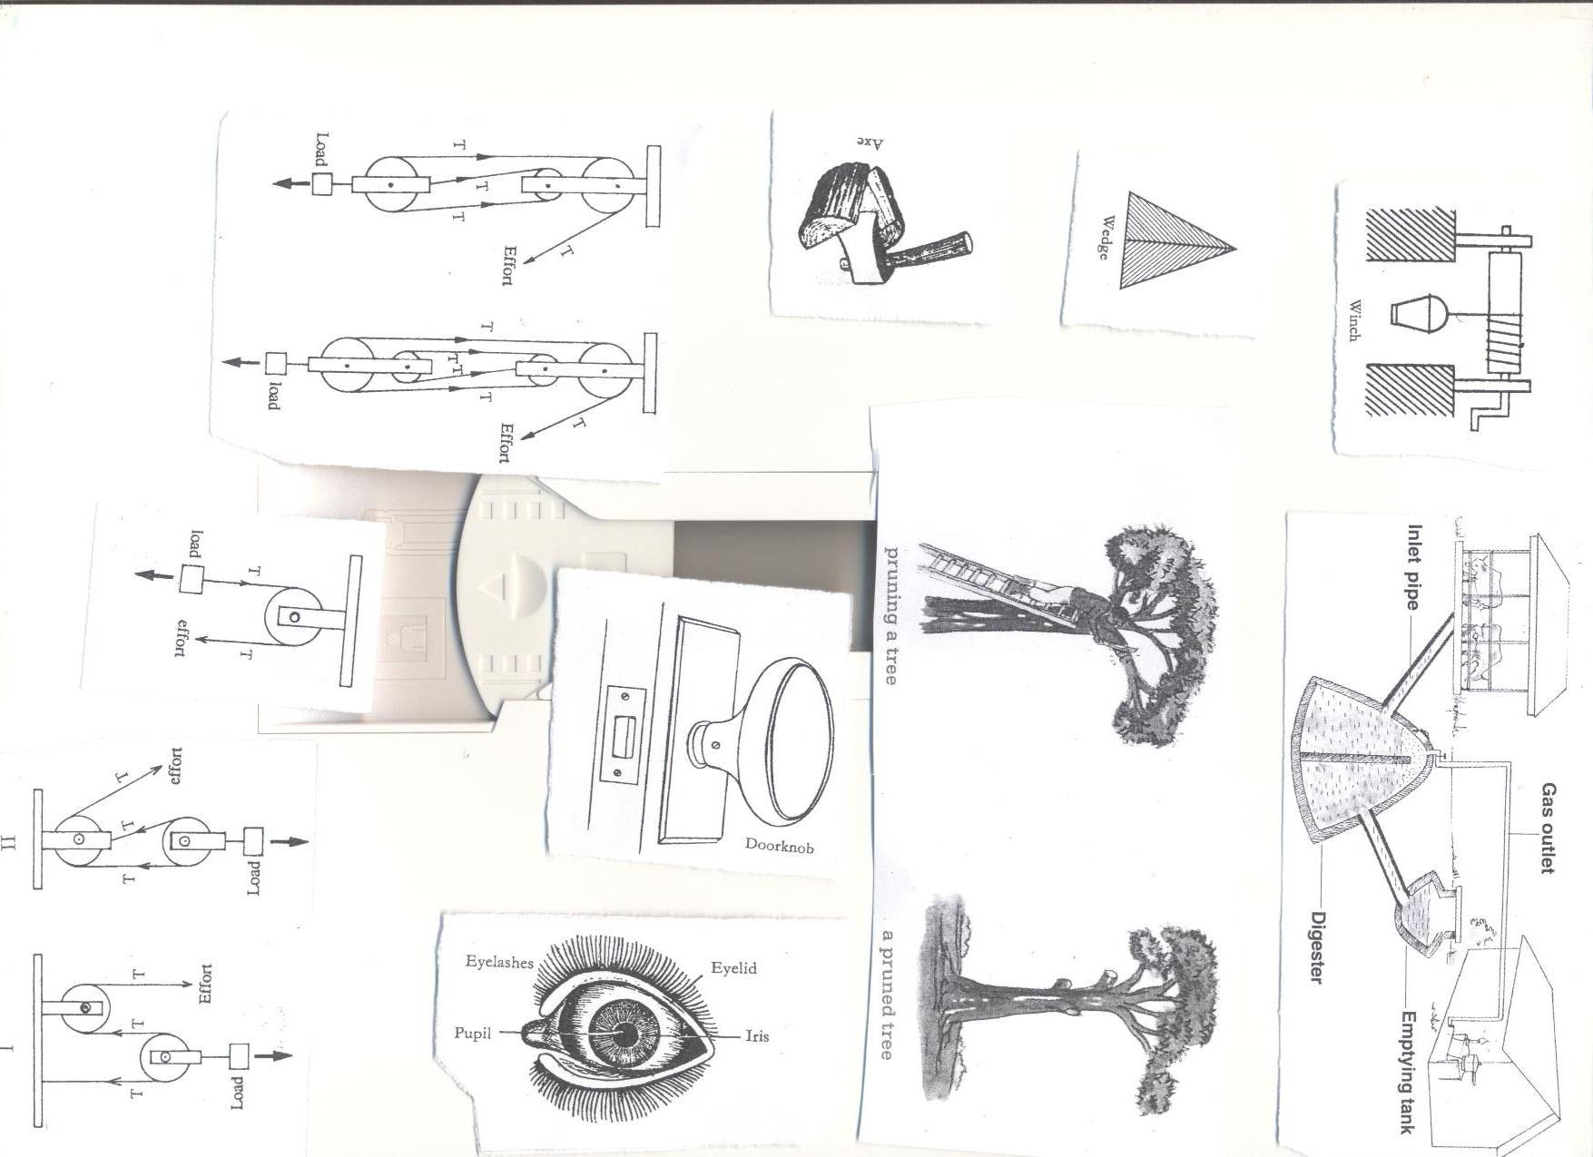

**Cross section view**



**Uses of the parts of the eye**  
**i. Cornea**: It aids refraction of light rays to begin converging as it passes through it.

**ii. Conjunctiva**: It covers the front part of the eye.  
**iii. Aqueous humors**: It maintains the shape of the eye.

It helps to refract light and form an image on the retina.

**iv. Iris:** It controls/regulates the amount of light entering the eye.  
 It expands and contracts to reduce the size of the pupil.  
**v. Pupil:** It lets enough light into the eye.  
**vi. Convex Lens:** It focuses light on to the retina (accommodation)  
**vii. Ciliary muscles:** These change the shape of the lens for accommodation.  
**viii. Vitreous humor:** It maintains the shape of the eye.

It helps to refract light and form an image on the retina.

**ix. Retina:** It is where the image is formed.

It has the rods (light sensitive cells that are responsible for dim light) and the

Cones (light sensitive cells that are responsible for bright light)  
**x. Optic nerve:**  It transmits light messages to the brain.  
**xi. The eye lids:** Prevent foreign bodies from entering the eye

**xii. Eye rashes:** Prevents water and other particles from entering the eye.  
**xiii. Fovea**: It gives the most accurate interpretation of an image.  
**xiv. Blind spot:** Has no light sensitive cells. If part of an image falls on it no impression is recorded in brain.

**xv**. **Biliary body**: It contains blood vessels which supply blood to the eye.

**xviii**. **Choroid:** a black pigment under the sclera that prevents **internal reflection** in the eye.

**xv**. **Tear glands:** produces a solution that keeps the eye moist and washes dust fro m them.

**xvi. Sclera:** It is a tough, non-elastic and fibrous coat round the eyeball

**How is regular blinking important to the eye?**

It distributes the fluid over the surface of the eye and prevents it from drying up.

**Characteristics of images formed by the eye.**

i. It is upside down/inverted.  
Ii.Smaller than the object/dismissed.  
Iii.The image is real.

**Normal vision.**  
In normal vision, the image of the object seen is formed on the retina.







  
The Lens in the person’s eye is **convex.**

**Compare a mammalian eye and a lens camera.**

**DIFFERENCES**

|  |  |
| --- | --- |
| **Eye** | **Camera** |
| Lens focuses light on the retina | Lens focuses light on the film |
| Iris controls light intensity. | Diaphragm controls light intensity |
| Eyelids block light from entering the eye | The shutter blocks light into the camera |
| The images are formed on the retina | The images are formed on the film |
| The pupil allows light into the eye | The aperture allows light into the eye. |
| The choroid prevents internal reflection | The black inside parts prevents internal reflection |

**Lesson five and six**

**SIMILARITIES BETWEEN IMAGES FORMED IN A CAMERA AND EYE.**

|  |
| --- |
| The images are real, diminished and upside down |

**Compare a mammalian eye and a pinhole camera.**

|  |  |
| --- | --- |
| **Eye** | **Pin hole camera** |
| Focusing is done by changing the shape of the lens. | Focusing is done by moving the camera forwards or backwards |
| Image is formed on the retina. | Image is formed on the screen |
| Iris controls light entering the eye | No control of light. |
| The eye can be covered by eyelids. | The pinhole is always exposed to light. |

**Similarities.**

|  |
| --- |
| The image formed is upside down  The image is diminished  The images formed are real |

**The parts of the eye and Camera with similar functions.**   
**Eye**   **Camera**  
1. Convex Lens convex Lens  
2. Iris Diaphragm  
3. Eye lid Shutter  
4. Retina Film  
5. Pupil Aperture  
6. Choroid The black inside part of the camera.

**Diseases and disorders of the human eye.**

**Eye diseases**  
**1. Conjunctivitis (Red eyes/pink eyes)**   
**Cause**   
It is caused by **bacteria or viruses**.  
**Spread**  
It is spread by finger and face towels.  
**Signs and symptoms**

* Red eye/pink eye.
* Mild burning in the eyes.
* Eyelids stick together during sleep.
* Watery fluid discharge.  
  **Control**
* Isolation of the sick.
* Avoid sharing towels, handkerchiefs and bathing containers.
* Always wash hands with clean water.
* Treat pregnant mothers with gonorrhea.

**2. Trachoma**  
**Cause**; It is caused by a bacterium called **Chlamydia.**  
Spread; It is spread by houseflies, hands and face towels.

**Signs and symptoms**

* The eye turns red.
* The eyes produce watery fluids.
* Irritation in the eyes.
* Small lamps under the upper eyelids.
* The white part swells.  
  **Control**
* Wash hands and eyes regularly.
* Do not shake hands during the outbreak.
* Do not share hankies and face towels.
* Treat the infected ones.  
  3. **River Blindness**  
  It is caused by **onchocerca**  
  It is spread by black flies/simulids /Jinja fly.

**Signs and symptoms**.

* The eyes turn red
* Tears flow.
* Inflammation of the iris.
* The skin gets rough.
* Enlargement of lymph nodes.
* Itching on the trunk.
* Lumps from under the skin.  
  **Control**
* Clear vegetation on banks of rivers.
* Spray the larva of Jinja fly.  
  **Other eye diseases.**
* Blepharitis.
* Cataracts-clouded lenses
* Glaucoma- damage to the optic nerve from too much pressure in the eye Sty.  
  **Eye defects/disorders, cause and correction.**
* **i.Short sight (myopia)**  
  It is where a person is able to see nearby objects clearly but not far off objects.



**Causes of short sight.**  
-Large/elongated eyeballs.  
-Eye diseases  
**Correction.**  
Wear spectacles with concave lens



**ii.Long sightedness.** (Hypermetropia

Is where a person can see distant objects clearly but not nearby objects.



**Correction.**  
Wear spectacles with convex lens.

  
**iii.Astigmatism.** (distorted vision at all distances)  
It is a condition in which one is unable to see both vertical and horizontal objects clearly at the same time.  
Astigimation is common during old age.  
**Causes of astigmation.**  
Having irregular cornea.  
**Correction**  
Wearing glasses with cylindrical lenses.  
  
**Care of the human eye**

1. Wash eyes with soap every day.
2. Don’t look directly at very bright light e.g. sun.
3. Don’t share face towels.
4. See the optician in case of a problem.
5. Avoid reading on dim light.
6. While reading, let the light come from over the shoulders**.**
7. Avoid rubbing your eyes.
8. While reading don’t be too close to the source of light.

**Questions**

1. **State any one reason why it important to keep our eyes clean always.**
2. **How are translucent objects important in our daily life**

**Topic 7: INTERDEPENDENCE OF THINGS IN THE ENVIRONMENT.**

**VOCABULARY**

* **Dependence**
* **Agro forestry**
* **Pollarding**
* **Lopping**
* **Coppicing**
* **Welfare**

**Interdependence:**

It the way things benefit from each in the environment.

**Environment:**

It refers to things surrounding people.

**Components of the environment**

They are divided into two groups:

1. Living things e.g. plants, animals
2. Non-living things e.g. water bodies, air, soils

**How plants depend on animals.**

1. Plants get carbon dioxide.
2. They get manure.
3. They are pollinated
4. They get care.
5. Plants are dispersed.

**How animals depend on plants.**

1. They get Oxygen.
2. They get food.
3. They get habitat.
4. People get fire wood from them.
5. They get building materials.
6. They get herbal medicine.

**Animals depend on other animals in the following ways;**

1. Some feed on others(predators)
2. Some animals live in/on others.eg internal parasites and external parasites.
3. Some provide transport to others.eg Donkey, Ass, Camels
4. Some provide security e.g. Dog

**Plants depend on other plants in the following ways.**

1. The weak get support from other plants.eg Morning glory
2. Some parasitic plants obtain food from the host plants.
3. Some tall plants provide shade to small trees.
4. Some plants protect small trees against strong wind.

**Interdependence of living things and non-living things**

1. **Animals depend on non-living things (air, water, soil)**
2. Termites / earthworms live in the soil.
3. People use soil to build houses, pottery etc
4. People get rocks for construction of roads, houses etc
5. Animals drink water.
6. Animals breathe in air.
7. Animals get heat and light from the sun.
8. **Plants depend on non-living things (air, water, soil)**
9. Plants breathe in air.
10. Plants get heat and light from the sun.
11. Plants grow on soil.
12. Plants use water to make food.

**Non-living things benefit from living things.**

1. Plants purify air by absorbing carbon dioxide from it.
2. Plants control silting of water bodies.
3. People add manure to the soil.

**AGRO FORESTRY**

**Agro forestry.**

* The growing of trees alongside crops.

**Importance of growing crops and trees together.**

* Trees provide shelter to other crops.
* Trees control soil erosion.
* Crops get protection from wind and strong sunshine.
* Some trees have nitrogen fixing bacteria that make the soil fertile.
* Double income e.g. food and timber.
* Reduce global warming as trees use carbon dioxide.
* Trees contribute to rainfall formation.

**Growing trees and keeping animals on the same farm**

* Trees provide shade to animals.
* Trees provide oxygen to animals.
* Trees purify the environment by using the carbon monoxide gas.
* Some leguminous trees are used as animal feeds.
* The farmer can get double income.

**Rearing animals and growing crops on the same farm.**

* Animals get food.
* Crops get manure.
* The farmer can get double income.
* Animals give carbon dioxide to crops.
* Crops provide oxygen to animals

**Rearing and caring for animals, growing crops and trees on the same farm.**

* Some trees are used to make live fences(hedge)
* Some leguminous trees may be used as sources of animal feeds.
* Trees provide oxygen to animals.
* Animals give carbon dioxide to plants.

**Tree growing**

* Trees grow from seeds.
* The seeds selected should be healthy.

**Indigenous trees**  
These are trees that have been growing in Uganda for many years.  
Examples include.

* Musizi
* Acacia
* Mvule
* Mahogany

**Characteriastics of indigenous trees;**

* Produce hard wood.
* Take long to mature.
* Can withstand rough soil and weather.
* Grow in the wild.

**Exotic trees:**

These are the recently introduced species of trees.

They include;

* Cypress, Pine, Cedar, Mango, Black wattle, Eucalyptus, Jack fruit tree and Ficus tree.

**Characteristics of exotic trees**

* They produce soft wood.
* They mature faster than the indigenous trees.
* Need proper care.
* Some cannot withstand harsh weather.

**Starting a tree nursery bed.**

**What is a nursery bed?**  
A nursery bed is a small piece of land prepared for raising seedlings.  
**Reasons for growing crops in a nursery bed.**

* It protects seedlings from bad weather conditions.
* It makes it easy to care for seedlings e.g. weeding, thinning, spraying etc.
* It enables the seeds to germinate well as the soil is loose and moisture.  
  **TYPES OF NURSERIES**

1. Nursery bed-raised on the ground.
2. Seed boxes-Wooden boxes filled with soil.
3. Soil blocks-Soil put in polythene bags and sacks.

**Care for seedlings in the nursery bed.**

* Watering.
* Thinning.
* Spraying.
* Hardening off seedlings.

**A seed bed**  
It is a large piece of land where seedlings are planted for further growth.

**Steps taken when starting a nursery bed.**

1. Choose a good site, clear the land and dig deep to make the soil fine.
2. Add manure in the nursery bed and mix it well with soil.
3. Furrow the soil using a stick and plant the seeds you have selected.
4. Cover the prepared area with mulches, provide a shade and water.

NB: Remove the shade when the seedlings are about to be transplanted.

**What is hardening off?**  
It is the making of seedlings gets used to garden conditions.  
**At this time the following are done.**

* Shelter is removed.
* Watering is reduced.

The garden conditions are rain, sunshine and pests.  
**Transplanting.**  
It is the process of moving seedlings from the nursery bed to the main field.  
(Seed bed)  
It should be done in the evening when the weather is cool and wet to prevent the plants from losing a lot of water due to transpiration of water.

**Ways of caring for trees in agro forestry**  
1. **Watering**; this is the application of water to plants.  
2. **Fencing**; the construction of wooden fence around the gardens or individual plants.  
3. **Transplanting**: the removal of seedlings from the nursery bed to a seed bed.  
4**. Spraying**: the application chemicals to plants to kill pests   
5. **Mulching**: The covering of top soil with dry plant materials.

**Pruning:** The cutting of excess branches of a plant.

**Advantages of pruning**.

* Reduce competition for air.
* Controls pests by removing hiding places for pests.
* Eases harvesting.
* Reduces transpiration.
* Reduces weight of a plant.
* Pruned materials can be used for mulching.

**Thinning**: The removal of excess or poorly growing seedlings from the garden.

**Advantages of thinning.**

* Gives enough space for other crops to grow.
* Control the spread of diseases.
* Control the spread of pests.
* Eases spraying.
* Improves yields and quality of harvest.

**Staking**: the providing of support to plants with weak stems.

**Why staking?**

* Controls ground pests.
* Eases weeding.
* Eases harvesting.
* Eases pruning.
* Eases spraying.
* Improves plant access to sunlight.

**Crop spacing**: the leaving of open spaces between individual plants.

It is the planting of crops leaving spaces between individual crops.

**Importance of crop spacing.**

* Reduces competition for water and space.
* It ensures proper circulation of air to the plant.
* Plants get enough sunlight.
* Easy weeding.
* Easy harvesting.

**Weeding**: the removal of unwanted plants in the garden.  
**How bad are weeds?**

* Hide pests.
* Weeds compete with crops for sunlight and other nutrients.
* Some weeds are poisonous to plants and livestock. E.g. tick berry bush.
* Increase the cost of farm management.

**Advantages of weeds**

* Leguminous weeds fix nitrogen in the soil and increase soil fertility.
* Weeds can be used as animal feeds.
* Source of herbal medicine.
* Weeds rot to form manure.
* Weeds can be used as mulches.

**How to control weeds.**

* Uprooting and burning the weeds.
* Cutting with a hoe.
* Spraying with herbicides.
* Mulching.

**Tree pests and their control.**  
**What is a pest?**  
**A pest** is a living organism that destroys crops.  
**A vermin** is an animal pest.  
Examples of vermin include; rats, monkeys, elephants etc.

**Examples of crop pests.**

|  |  |  |
| --- | --- | --- |
| **PEST** | **CROPS ATTACKED** | **DAMAGE.** |
| Mealy bug | Pineapples, coffee | Leaves turn yellow or pink. |
| Aphids | Oranges, coffee, cabbages e.t.c | Wilting back of terminal bud. |
| Banana weevils | Bananas | Leaves turn yellow Bananas fall easily. |
| Codling moth. | Citrus fruits like oranges and mangoes | Fruits fall off. |
| Thrips | bananas | Premature ripening of bananas Banana fruits burst. |
| Moles, rats, squirrels, mice, cane rats. | Cereals | Direct consumption of seeds an stems. |
| Citrus black fly. | Citrus fruits | The flies suck sap from leaves and tender shoots. |
| Leaf miners | Coffee, cocoa, pineapples, aloevera, sisal | Plant’s ability to make sugar is reduced. |
| Cut worms | vegetables | Leaves are destroyed. |
| Locusts | All crops |  |
| Army worms | Cereals and grasses |  |
| Maize stalk borer | Maize |  |
| Boll worm | Cotton |  |
| Antestia bug | Coffee |  |
| Game animals e.g. monkeys | Oranges, mangoes |  |
| Birds. | Maize, sorghum. |  |

**Methods of controlling pests.**

* Early planting.
* Spraying with pesticides.
* Use of birds to eat lady birds. (Biological method)
* Crop rotation.
* Weeding.(methods)
* Plant clean materials.

**Crop diseases.**

|  |  |  |  |  |
| --- | --- | --- | --- | --- |
| **DISEASE** | **CROP** | **CAUSE** | **SIGN** | **CONTROL** |
| Panama disease | Bananas |  | Plant Banana Wilts | Burn entire stock Plant healthy suckers |
| Cigar End rot | Banana | Bacteria | Banana tips resembles burning cigar | Burn infected crops. |
| Banana bacterial wilt | Banana | Bacteria | Banana stem rots and falls down |  |
| Powdery mildew. | Mangoes | Fungi | Powdery patches on leaves | Spray with fungicides |
| Green mould | Citrus fruits | Fungi | The stem dries with a green powder | Spray with fungicides. |
| Stem pitting | Citrus fruits | Fungi | Dry patches on the stem. | Spray with fungicides. |
| Tomato blight | Tomatoes, potatoes | Bacteria | Yellow leaves |  |
| Crown gall | fruits | Bacteria | Leaves shrink |  |
| Fire blight. |  | Bacteria | wilting |  |
| Rust fungus | Cereals | Fungi | Black spot on leaves |  |
| Root rot | Tea plants | Fungi |  |  |
| Coffee berry diseases(CCB) | Coffee | fungi | Brown spots appear on berries. |  |

**Factors that affect crop production**

* Crop pests and diseases.
* The use of poor methods of farming.
* The harvesting of immature seeds.

**Proper ways of harvesting trees.**

1. **Coppicing**-Cutting of the whole tree but leaving room for it to sprout again.



1. **Pollarding-** The cutting of the top part of a tree allowing new branches to develop.



1. **Lopping**- Cutting of the side branches from the truck.

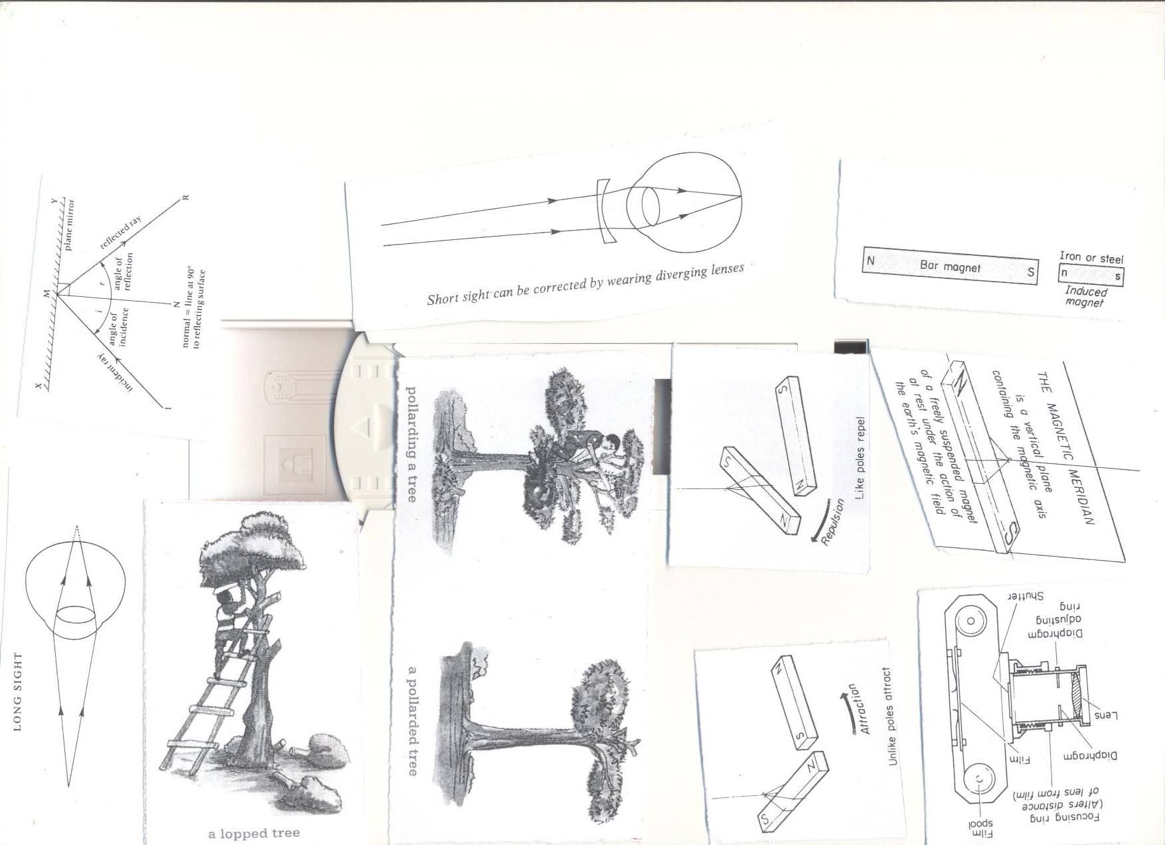

**Advantages of Starting and managing a school/home wood project.**

* Production of food for the family.
* Source of income.
* Practicing the science learnt in class.
* Trees provide shelter.
* Trees are source of wood fuel.

**Consideration when starting a tree and crop growing project.**

* Site-near your home.
* Soil drainage.
* Nearness to the water source.
* Fertility of the soil.
* Security.
* Accessibility.
* Nearness to the home/school.

**Factors considered when choosing crops or trees for planting.**

* Those which mature faster
* Those that give high yields.
* Those that are not easily attacked by disease
* Those which are multipurpose.

**Preparing wood for different purposes and proper storage**.  
**Uses of wood**

* For charcoal.
* For fire wood.
* For medicine.
* For timber.
* To make electricity and telephone poles.
* For increase/produces a pleasant smell when burnt.

**Wood for firewood.**

* It is split, dried and then kept in a shed.
* Trees store much water inside their cells.
* When split water evaporates from it.  
  **Wood for electricity and telephone poles.**
* Poles are treated with chemicals known as wood preservatives.  
  A strong salt can act as a **wood preservative.**
* The bark is first removed then soaked.  
  **Wood for timber**
* Trees are cut into different pieces.
* The pieces are put under shade to dry at slow pace.  
  **Seasoning.**  
  It is the putting of pieces of timber under shed to dry at slow pace.  
  If timber is dried under direct sunshine it gets twisted/out of shape.  
  The twisting of the pieces of timber is referred to as **warping.**  
  **Reasons for seasoning timber.**
* To prevent it from splitting.
* To prevent it from warping/bending.

**Record keeping**

It the gathering and storage of information about farm activities.

**Farm records:**

The**se** are written information showing different out puts and inputs on a farm.

**Types of records kept on a farm.**

1. Inventory records e.g. farm tools, farm machinery,
2. Production records
3. Health records
4. Breeding records
5. Feeding records
6. Income and expenditure records.

**Importance of keeping farm records.**

1. To know the income and expenditure and avoid losses.
2. To know whether they are making profits or losses**.**
3. Identify areas of development and investment.
4. To budget for the farm.

**Young farmers, club.**

It is a club in a school in which members learn practical skills about keeping animals and growing crops.

**Promotion of Young farmers club.**

* Some schools have gardens where they practice farming.
* They organize trips to agriculture research stations.

QUESTIONS.

1. What is agro forestry?
2. Suggest any one importance of keeping animals and growing crops on the same piece of land at the same time?
3. Suggest one method of properly harvesting trees.
4. Why is it important to treat wood for electric poles before planting them?
5. How are young farmers clubs important in schools?
6. Why is it important to keep records on farms?
7. Give any one reason why it is important to keep trees.
8. Write down any one disease that affects bananas.
9. How important are the following farm practices important on a farm.
10. Thinning b) staking c) pruning
11. How are vermins different from vectors?
12. Why is it important for farmers to plant their crops in nursery beds?
13. State any three crops that can planted in a nursery bed.
14. State one thing done to seedlings in a nursery bed that are about to be transplanted.
15. Why watering seedlings important when they are in a nursery bed
16. Mention any one characteristic of exotic trees.

**Topic 8: POPULATION AND HEALTH**

**VOCABULARY**

* **Health concerns**
* **Community**
* **Health surveys**
* **Demography**
* **Health data**
* **Population.**

**Community Health and social problems**

**Community**

It is a group of people living or working together having common needs, interests and problems.

**Health**

Health is a state of being physically, socially, economically and mentally well but not necessarily without sickness.

**Community Health**

* It refers to the essential health conditions in which individuals and families within a community live.

**Examples of communities**

1. A school
2. A town
3. A village

**Examples of common health and social problems in communities;**

1. Smoking
2. Alcohol and drug abuse
3. Poor sanitation standards
4. Malnutrition
5. Disease outbreak
6. Anti-Social behavior

**Types of common sickness in a home.**

1. Immunisable diseases
2. Deficiency diseases
3. Communicable diseases
4. Self-inflicted diseases
5. Sexually Transmitted diseases
6. Hereditary (genetic) diseases

**IMMUNISABLE DISEASES**

These are diseases which can be prevented through immunization.

**Immunisable diseases are in two categories;**

1. Childhood immunisable diseases e.g. polio, measles, tuberculosis, tetanus, whooping cough (pertussis), diphtheria, hepatitis B, Haemophilus Influenza b.
2. Non childhood immunisable diseases e.g. typhoid, meningitis, cholera, yellow fever, small pox, German measles (rubella) e.t.c.

**DEFICIENCY DISEASES**

These are diseases that are caused by lack of some food values in our daily diet.

**Examples of deficiency diseases**

|  |  |
| --- | --- |
| **Deficiency disease** | **Due to lack of** |
| Night blindness | Vitamin A |
| Beriberi | Vitamin B1 |
| Pellagra | Vitamin B2 |
| Scurvy | Vitamin C |
| Rickets | Vitamin D |
| Infertility | Vitamin E |
| Poor blood clotting (haemorrhage) | Vitamin K |
| Goitre | Iodine |
| Marasmus | Carbohydrates |
| Kwashiorkor | Proteins |
| Anemia | Iron |

**COMMUNICABLE DISEASES**

These are diseases which can be spread from one infected person to a healthy person.

They are caused by **germs**

**Examples of communicable diseases**

|  |  |  |  |  |
| --- | --- | --- | --- | --- |
| **Bacteria** | **Virus** | **Protozoa** | **Worm infections** | **Fungal** |
| Gonorrhoea | HIV/AIDS | Malaria | Round worms | Athletes foot |
| Syphilis | Measles | Sleeping sickness | Tape worms | Ring worm |
| Trachoma | Polio | Amoebic dysentery | Flat worms |  |
| Diphtheria | Influenza |  | Thread worms |  |
| Bacillary dysentery | Common cold |  | Hook worms |  |

**SELF INFLICTED DISEASES**

These are diseases which people get due to poor health life styles. E.g. Smoking, alcoholism, over eating, lack of exercises, prostitution etc.

**Examples of self-inflicted diseases;**

1. Lung cancer
2. Sexually Transmitted Infections.
3. Emphysema
4. Obesity

**SEXUALLY TRANSMITTED DISEASES (VENEREAL DISEASES)**

These are spread through having unprotected sexual intercourse with infected persons.

**Examples**

1. HIV/AIDS
2. Gonorrhoea
3. Syphilis
4. Genital warts
5. Candida

**HEREDITARY (GENETIC) DISEASES**

These are diseases that are passed on from parents to off springs through genes.

Examples include;

1. Sickle cell anemia
2. Diabetes
3. High blood pressure

**Causes of sicknesses in the home and community**

1. Poor disposal of human and industrial wastes.
2. Alcohol and drug abuse.
3. Poor nutrition
4. Some diseases are inherited from parents eg sickle cell.

**Controlling common sicknesses in a home and community**.

1. Proper sanitation.
2. Family planning
3. Good nutrition.
4. Brushing the teeth after every meal
5. Doing daily physical exercises.

**How to avoid health and social problems.**

1. Proper sanitation
2. Proper waste disposal
3. Keep our homes and water sources clean.
4. Proper feeding.
5. Avoid drug abuse
6. Abstain from sex if not married

**Methods of preventing diseases in the community.**

* Immunization
* Through proper nutrition
* Personal hygiene
* Boiling water for drinking.
* Good food hygiene.
* Proper rubbish disposal.

**How young people can avoid social and health problem**

1. Avoiding bad peer groups.
2. Form clubs such as young farmers club, drama and music.
3. Join church choirs
4. Participating in sports activities such as football, netball, swimming and athletics.
5. Attending youth seminars and conferences on morals, drug abuse, HIV/AIDS
6. Using their leisure time to learn practical skills e.g. weaving, tailoring, and computer use.

**Life skills of avoiding social and health problems**

1. Critical thinking
2. Decision making
3. Problem solving
4. Self-awareness
5. Effective communication
6. Creative thinking

**ANTISOCIAL BEHAVIOURS.**

These are unacceptable behaviours in the society.

**Delinquency** is a bad act performed by a juvenile and is punishable by law.

**Juvenile delinquency** is a bad act performed by a juvenile and is punishable by law.

**A Juvenile** is person below 18 years

**A delinquent** is a young person who commits an act punishable by law.

**EXAMPLES OF ANTISOCIAL BEHAVIOURS**.

* Lying, Truancy, Stealing, Arson (fire setting), Sex offences, Wandering, Telling lies.
* Fighting, Teasing in school/bullying, Murder, Drug abuse. E.g. smoking.
* Child prostitution, Raping, Aggression/violence

**CAUSES OF ANTISOCIAL BEHAVIOURS.**

* Disturbed homes.
* Bad peer influence
* Poor social environment.
* Poor home atmosphere like fighting by parents.
* Over strictness by both parents and teachers.
* Unfulfilled expectations.
* Pampering children.
* Failure to enforce rules in the community.
* Poor family back ground.
* Poor social environment.

**Effects of antisocial behaviours.**

* Many delinquent children may become adult criminals.
* Individuals suffer from pain, injury and death.
* Sex offences may result into sexually Transmitted Diseases.
* Fire setting leads to destruction people’s property.
* Drug abuse may be a bad example to the children.
* Leads to School dropout.
* Causes Shame to parents.
* May lead to Death.
* The family may disown the child.
* Weaken the custom, religion and organization.

**How to prevent and control antisocial behaviours.**

* All parents should create stable families.
* Parents should take children through counseling and guidance lessons.
* Children should join youth clubs and societies.
* Children should avoid bad peer groups.
* Children should be exposed to sex education.
* Punish wrong doers and praise good behavior.
* Equal treatment should be given to all children.
* Elders should be exemplary.
* Children should engage in gainful activities during free time
* Avoid setting too high standards of behavior.
* Children should join youth and sports clubs and societies.

**VIOLENCE**

This is a state in which a person is aggressive and has destruction behaviour.

**Types of violence**

* Sadism: an extreme motive to harm others.
* Masochism: an extreme motive to harm oneself

**SEXUAL DEVIATIONS**

-It is an abnormal sexual practice.

**Give the forms of Sexual deviations:**

* Bestiality
* Homosexuality,
* Masturbation,
* Oral sex
* Lesbianism,
* Incest
* Fellatio

**Reasons why people practice sexual deviations.**

* For personal satisfaction
* As an effect of drugs.
* As an effect of pornography consumption
* Bad peer influence.
* As a result of broken homes

**Ways of avoiding sexual deviations.**

* Avoid bad peer groups
* Avoiding drug abuse
* Through guidance and counseling.
* Avoid watching pornography.
* Avoid incentives from strangers.
* Join gainful clubs during leisure.

**Population and health concerns.**

**What is population?**  
This is the number of people living in an area or country

**Health concerns.**

These are health problems that affect us and need immediate solutions.

**Population and health concerns.**

* Poor sanitation.
* Anti-social behavior.
* Poor water supply.
* Inadequate food.

**Poor sanitation.**  
It is the improper disposal of human waste and other waste products into the environment.  
**Indicators of poor sanitation.**

* Poor ventilation of houses.
* Bushes around homes.
* Poor disposal of faeces and urine.
* Sharing houses with animals.

**The following should be observed when constructing a dwelling house.**

* It must be constructed downhill.
* Ten metres from the latrine and **30**m from the water source.
* Below the water level.
* In a home there should be a **rubbish pit** to hold refuse.  
  **Activities or solutions to poor sanitation.**

1. Construct rubbish pits in a home
2. Construct pit latrines
3. Sweeping the compound
4. Picking rubbish around homes.
5. Cut grass around our homes short
6. Build well ventilated houses
7. Avoid sharing houses with domestic animals.

**Poor water supply**  
It is when the community receives little or dirty water for use.

**Water associated diseases;**

Categories of water associated diseases.  
**i. Water borne diseases**  
These are diseases spread through drinking contaminated water.  
**Examples include**:

* Cholera
* Typhoid
* Bilharzia
* Polio
* Dysentery.
* Hepatitis.
* Diarrhoea.  
  **ii. Water contact diseases**  
  These are diseases which spread when our bodies get into contact with contaminated water.  
  **Examples of water contact diseases**
* Bilharzia
* Swimmer’s itch
* Ear, eye and nose infections  
  **Water cleaned diseases**  
  These are diseases we get when we don’t have enough water to use.  
  **Examples of water cleaned diseases include;**
* Scabies.
* Impetigo.
* Trachoma
* Conjunctivitis
* Eczema. **Water habitat vector diseases**

These are diseases which spread by vectors which spend part of their life cycle in water.

**Examples of water habitat vector diseases include;**

* Malaria.
* Bilharzia.
* River blindness.
* Dengue fever.
* Yellow fever.  
  **Ways of making dirty water safe for drinking**  
  -Boiling.  
  -Use chemicals like chlorine, calcium chloride, potassium permanganate.  
  **Processes at national water sewerage co-operation. (NWSC**)
* Sedimentation, Filtration, Coagulation, Chlorination.

**Activities to address poor water supply.**

1. Construct wells.
2. Cut bushes around wells
3. Fencing the water sources
4. Treating water

**Inadequate food**This is the situation in which a family or community members lack enough food

**Causes of inadequate food**

* High population increase.
* Laziness and inability to grow crops.
* Poverty.
* Ignorance of good farming methods.
* Drought.
* Wars.
* Floods.
* Poor attitude towards farming
* Pests and diseases.

**Food security**

It is having enough food for future use.

**Effects of malnutrition in people**

* Chronic fatigue.
* Low concentration at work.
* Poor spirit of doing things.
* Loss of interest at work

**Activities to address inadequate food supply.**

* Seek advice on good methods of farming from agricultural officers.
* Construct valley dam to trap water for irrigation during drought.
* Avoid draining wetlands to avoid floods.
* Introducing agriculture schools.
* Digging should not be given as punishment in schools.
* Grow crops which are resistant to diseases.

**Activities to address health concerns.**

* **Care for a home**

A home is a place where people stay and live.

**How to care for a home**

* Slash tall grass around homes
* Drain stagnant water around our homes.
* Construct a pit latrine
* Have a rubbish pit

**Healthy life styles;**

These are

**Examples of healthy life styles include;**

* Doing physical exercises.
* Resting after meals
* Bathing daily.
* Eating a balanced diet.
* Going for medical checkups.

**Importance of resting after meals**

* Digestion of food is carried out smoothly.
* The brain rest and gets refreshed.
* The body is able to repair worn out cells.

**Reasons for doing daily physical exercises**

* For body flexibility.
* Strengthen body muscles.
* For proper functioning of the body organs and systems
* Reduce excess fats in the body.

**Health education.**

It is the making of the community get aware of the matters concerning diseases and how to prevent them.   
**Ways of educating people**

* Through Songs, plays, storytelling.
* Through Radios, newspapers, talks
* School pupils pass information to their parents, brothers, sisters and relatives.

**Having a family budget.**

**A family budget.**

It is an advance plan of how the expected family income is to be spent.

**Advantages of family budgeting**

i. It helps to cater for all family needs.

ii. It helps to avoid over spending.

iii. It avoids debts.

**Collecting information/data on human population.**

**Demography**

This is the study of the changing numbers of births, deaths and diseases in a community.

Information can be collected from hospitals and by going to homes.

**Importance of demography**

* To plan for the community services e.g. health centres, markets and water.
* The government is able to know the general health of people.

**Housing information**

This is the finding out of the number of people who sleep in permanent or temporary houses to estimate the poverty line of the people.

**Available health services**

The government needs information on these services to be able to deliver medical services quickly and monitor the health of its population

**Information available on health services include**

* Immunization.
* Family planning.
* Treatment of infections.
* Provision of water.
* Control of epidemic diseases.

**Immunization**  
The introduction of vaccines into the body to produce anti bodies against certain diseases.  
**Collecting information on immunization**  
Information includes.

* Number of immunization centers.
* People involved in carrying out immunization.
* Days and time on which immunization is done.

**Importance of immunization**

* To protect children against the childhood immunisable diseases.
* To boost the immunity.
* Reduce the rate at which children die / reduces infant mortality rate.

**A child health card**.  
It is a document given by the government to every child with information about his/her immunisation.

**Importance of a child health card.**

* To know the date of the next dose.
* To monitor the growth(looking at the growth curve)
* It shows the child’s name, sex, date of birth, birth order, mother’s name, mother’s occupation, father’s name and where the family lives.

**Collecting information on available health services**.

**Advantage of collecting information on available health services**.   
-It helps in quick delivery of medical services.  
-Control of epidemic diseases.  
-It helps the government to monitor the health of people.

**Health surveys**

A health survey is a strategy of finding out health problems and solve them.

The information obtained from a healthy survey is called health data

The health survey is carried out by village health committee and government officials.

**Nature of questions asked.**

1. What are the common sicknesses in the community?
2. What kind of treatment is given for each sickness?
3. What are the Causes of the sickness

**A health club**

It is an association of members in a school or community who voluntarily wish to promote community health.

**Activities of health clubs include;**

* Promotion of personal hygiene in a community/school.
* Educating members of the community about sanitation.
* Encourage the community to participate in community basic health programmes.
* Caring for those in poor health.
* Getting health information from technical personnel and distributing to the community.

**TOPICAL QUESTIONS**

1. State any one type of common sickness in a community.
2. What is a health parade?
3. State one cause of common illiness in our communities.
4. Why is it important to collect information about immunization in our community?
5. State any one activity done during a health survey.
6. How are health clubs useful in our community?
7. Cite any one importance of health surveys in our community.
8. Why is it importance of health education to children ion schools?
9. Write down any two examples of water borne diseases.
10. What are anti social behaviours?
11. Give any two examples of antisocial behviours.
12. How can antisocial behaviours be controlled in our community.
13. Write any two indicators of poor sanitation in a home.
14. Briefly explain the term health.
15. State any two ways we can contribute towards the reduction of proper functioning of our health.

-END-